Here we are sharing the UI/UX samples! And we have tried in a very crude form to help break them down so that it is easier for you to incorporate the relevant elements into the Intakely’s AI Agentic Legal CRM development planning and designing process.

**The Objective:** We need to develop a comprehensive multi-layered CRM system that caters to law firms and integrates AI-driven functionalities to automate lead intake, client management, case handling, billing, document generation, and reporting for solo and small law firms. The CRM should be layered into three CRM sections or categories, The first one layer/section/category being that the Intakely’s AI Agent Builder CRM which will leverage multiple AI agents for different tasks, orchestrated by a master agent in the form of templated workflows, so for example AI Intake Agent will be one such template. The second layer/section/category being the Intakely internal operations of setting up, managing and monitoring a Law Firm CRM. While the last one will be just an extension of the second layer/section/category as a CRM provided for inputting voice messages instructions and updates to each relevant part of the CRM based on the service subscribed by the law firm. The system should be scalable, multi-tenant, and capable of managing both client-facing interactions and internal team operations. The following details will guide you to understand the screeenshots divided into layers.

**1. Main Menu**

* **Purpose:** The main menu will serve as the central navigation hub for users, allowing them to quickly access different sections of the CRM.
  + **Sections:** Law Firm Management, AI Agent Workflow Builder, Client Engagement, Billing, Analytics, Notifications, and Support.
  + **Actionable Links:** Each section will be a clickable link that leads users to the specific workflows or tools (e.g., managing law firm profiles, customizing AI agents, running reports).

**2. Side Menu for Internal Layers of the CRM**

* **Purpose:** For internal users (e.g., customer success agents, admin), the side menu will give quick access to more specific tools for managing internal operations and multi-tenancy settings.
  + **Sections:** User Management, Lead Tracking, Workflow Management, Task Management, Client Reports, Billing Insights, etc.
  + **Functionality:** These menus should allow the user to quickly switch between different internal functions, offering deep control over workflows, task assignments, AI agent management, and subscription settings.

**3. Main Working and Input Window (for Client and Task Management)**

* **Purpose:** The central working window will be the area where tasks, client data, and case files are managed and interacted with.
  + **Features:**
    - **Client Dashboard:** A detailed view of a client’s status, case progress, billing, and communication history.
    - **Interactive Tables:** Use tables to manage clients, cases, and invoices, with inline editing capabilities and easy-to-read summaries.
    - **Activity Feed:** Log of recent activities, AI updates, and system messages.
    - **Quick Action Buttons:** Options for creating new tasks, assigning agents, or updating case statuses.

**4. AI Agent Template Library and Workflow Builder**

* **Purpose:** This section will allow users to access pre-built AI agent templates (e.g., AI Intake Specialist) and create or modify workflows through a drag-and-drop builder.
  + **Features:**
    - **Template Library:** A selection of predefined workflows and tasks for common legal CRM functions (e.g., intake, billing, client management).
    - **Drag-and-Drop Builder:** A visual interface to design and modify workflows. Users should be able to configure steps, add conditions, and assign specific agents.
    - **Custom Prompts:** Integrate a space to modify AI prompts based on law firm needs (e.g., custom intake questions or document templates).
    - **Snapshot Importing:** Law firms should be able to import AI-driven workflow templates or "snapshots" from Intakely’s library.

**5. AI Voice Agent Configuration**

* **Purpose:** This section will allow for configuring voice agents that interact with clients.
  + **Features:**
    - **Voice Settings:** Options for selecting AI voices, customizing tone, and adjusting speech styles (e.g., formal, friendly).
    - **Voice Workflow Integration:** Connects the voice agents to workflows (e.g., lead qualification, appointment scheduling) to ensure seamless task delegation.
    - **Interaction Logs:** Logs for tracking voice commands, responses, and progress to ensure AI is functioning as expected.

**How This Affects Intakely’s AI Agentic Legal CRM Setup**

* **Modular Layout**: The design should allow users to interact with different layers of the CRM seamlessly (e.g., switching between law firm management, client interaction, task tracking).
* **Voice Agent Integration**: Firebase should be configured to handle voice agent interactions, storing commands, responses, and associated task logs.
* **Workflow Flexibility**: Ensure that workflows can be built, modified, and stored within Firebase Firestore, making them easily accessible to users for configuration.
* **Real-Time Data Sync**: Given Firebase’s real-time capabilities, ensure that user actions (e.g., creating new clients, updating cases) are reflected instantly across all connected devices.

**Next Steps:**

1. **Finalize the User Interface (UI)**: Based on the given designs, we’ll need to ensure to supports dynamic, interactive elements (e.g., drag-and-drop workflow builder, real-time updates).
2. **Integrate AI Workflows**: Create pre-built workflows that law firms can easily import and modify, making sure these workflows are linked to the backend systems for real-time processing.
3. **Voice Agent Setup**: Implement the necessary components to handle voice interactions, ensuring that voice commands trigger the correct tasks and updates within the CRM.
4. **Testing & Iteration**: Ensure the user experience matches expectations by running multiple tests (especially for the workflow builder, voice integrations, and task management features).

**1. Key Screens for CRM**

Let’s start by identifying and describing the **most critical screens** that are essential for understanding the CRM's functionality. We can break them down as follows:

**1.1. Main Dashboard**

* **Purpose**: This is the central hub where law firm staff or Intakely users will see an overview of all activities. It gives them insights into lead status, client progress, billing summary, tasks, and AI agent performance.
* **Components**:
  + **Quick Access Links**: Shortcuts to major modules (AI agent workflows, client management, billing, case statuses).
  + **Performance Metrics**: Visual reports on lead conversion, case progress, billing amounts, and AI agent success.
  + **Alerts/Notifications**: Displays any tasks that need attention, such as overdue billing, AI agent failures, or upcoming deadlines.
  + **AI Agent Activity**: A visual representation of the active AI agents and their task statuses.

**1.2. Law Firm Profile & Customization Screen**

* **Purpose**: The setup screen where a law firm can define its profile, customize its CRM environment, and integrate services.
* **Components**:
  + **Firm Information**: Editable fields for firm name, address, phone number, and primary contacts.
  + **Service Selection**: A section where the law firm can choose which AI services to activate (AI Intake, Billing, Document Generation, etc.).
  + **Custom Workflow Setup**: Drag-and-drop builder to adjust intake forms, document templates, and configure AI agents.
  + **User Role Management**: A part of the screen where admin users can define staff roles and access levels (e.g., Intake Manager, Admin, etc.).

**1.3. AI Agent Configuration Interface**

* **Purpose**: This is where law firm admins or Intakely users configure the AI agents, customize prompts, and define their roles.
* **Components**:
  + **Agent Selection**: A list of available AI agents (e.g., AI Intake Agent, AI Billing Agent), each of which can be activated or deactivated.
  + **Customization Options**: Customizable settings for each agent (e.g., intake questions for AI Intake Specialist, billing reminder templates for AI Billing Agent).
  + **Testing Interface**: A test section where users can interact with the AI agent to preview how it responds to client inputs (e.g., a demo interaction with the AI Intake Agent).
  + **Logs & Feedback**: Access to past interactions, performance logs, and feedback metrics to help improve the agents.

**1.4. Client Management Screen**

* **Purpose**: The core screen where client profiles, case details, and communications are managed.
* **Components**:
  + **Client Overview**: Summary of client’s details, active cases, and status.
  + **Case Timeline**: A visual representation of case progression, including important dates and milestones.
  + **Communication Logs**: Displays all interactions (phone, chat, email) with clients and leads.
  + **Document Management**: Ability to upload, view, and share documents related to the client’s cases (contracts, evidence, case files).
  + **Task List**: Tracks ongoing tasks related to the client (e.g., consultations, follow-ups, case reviews).

**1.5. Task Management & Workflow Builder**

* **Purpose**: A dynamic workspace where users can assign and track tasks, automate workflows, and manage team assignments.
* **Components**:
  + **Task List**: Shows tasks assigned to each team member, due dates, priority, and status (e.g., Pending, Completed, In Progress).
  + **Drag-and-Drop Workflow Builder**: Allows users to create new workflows or modify existing ones by dragging actions, tasks, and conditions into place.
  + **AI Task Automation**: Automates repetitive tasks (e.g., sending follow-up emails, generating invoices) based on pre-configured workflows.

**1.6. Reporting & Analytics Dashboard**

* **Purpose**: Provides in-depth insights into client and case performance, as well as AI agent effectiveness.
* **Components**:
  + **KPI Tracking**: Displays key metrics such as client conversion rate, average case duration, and AI agent performance.
  + **Custom Reports**: Enables law firms to create custom reports based on data like client feedback, task completion, and billing.
  + **Data Export Options**: Allows users to export reports to CSV, PDF, or other formats for external analysis.

**2. User Flows**

Now, let's focus on the **primary user flows**. These are the steps users will follow to complete tasks within the CRM. For example:

**2.1. Law Firm Onboarding Flow**

* **Step 1**: Law firm admin logs into the CRM.
* **Step 2**: The admin sets up the firm’s profile (name, address, logo, etc.).
* **Step 3**: The admin selects and configures the desired AI agents (e.g., AI Intake, AI Billing).
* **Step 4**: The admin customizes the workflows (e.g., intake forms, practice area questions).
* **Step 5**: Law firm staff are added to the system, and roles are assigned (e.g., Lawyer, Paralegal, Admin).
* **Step 6**: The system provides a demo workflow (e.g., AI Intake Specialist) to allow the admin to test the setup.
* **Step 7**: The admin finalizes the setup and the system starts automating processes (client intake, billing, etc.).

**2.2. Client Intake Flow**

* **Step 1**: Client (John Doe) contacts the firm via the website, phone, or social media.
* **Step 2**: The AI Intake Agent gathers John’s information (e.g., name, case type, contact details).
* **Step 3**: The AI maps the case to the appropriate practice area (e.g., Family Law).
* **Step 4**: AI Agent schedules an appointment with the appropriate attorney.
* **Step 5**: John receives a confirmation message with appointment details via email or SMS.
* **Step 6**: The AI creates a case record and assigns the relevant tasks to law firm staff (e.g., paralegal reviews intake).

**2.3. AI Workflow Interaction**

* **Step 1**: Admin opens the AI Workflow Configuration screen.
* **Step 2**: The admin selects an AI agent (e.g., AI Billing Agent) and customizes its settings (e.g., billing reminders, invoice generation).
* **Step 3**: Admin sets up automation rules (e.g., send reminder emails 3 days before payment due date).
* **Step 4**: Admin tests the workflow to ensure it functions as intended (e.g., AI generates an invoice, sends reminder).
* **Step 5**: The workflow is finalized, and the system starts running tasks automatically.

**3. High-Level Overview of UI/UX Design**

* **Layout**:
  + **Header**: Contains logo, navigation, user profile settings, and notifications.
  + **Sidebar Menu**: Provides quick links to key sections (e.g., AI Agent Management, Law Firm Management, Reports, Tasks).
  + **Main Content Area**: Displays detailed data views, forms, and action buttons.
  + **Footer**: Includes additional links like terms of service, privacy policy, etc.
* **Navigation**:
  + Users will navigate through different sections using the sidebar menu.
  + The dashboard will serve as the landing page for both internal users and law firm users.
  + Workflow builders and AI agent customization screens should be interactive, supporting drag-and-drop functionality.

**4. Simplified Diagrams & Wireframes**

If possible, you could create wireframes or flow diagrams for these screens. These diagrams would highlight how users move through the system, what actions are available at each step, and how different components (e.g., client profiles, tasks, AI agents) are interconnected.

Here’s a basic breakdown of how we can categorize the main components and menu items based on your previous descriptions and shared UI/UX images:

**1. Main Dashboard**

* **Menu Items**:
  + **Client Overview**: Quick links to client profiles, intake status, upcoming appointments, and cases.
  + **Task Management**: Dashboard to track ongoing tasks and AI performance.
  + **Billing Overview**: Displays client billing summaries, payment status, and invoicing.

**2. Law Firm Management**

* **Menu Items**:
  + **Law Firm Profile**: Where the admin sets up the firm’s general information, services, and billing terms.
  + **User Management**: Allows the admin to manage user roles and permissions within the firm (e.g., lawyer, paralegal, intake agent).
  + **Subscription Management**: Displays subscription details, AI agent selection, and payment settings.

**3. AI Agent Configuration**

* **Menu Items**:
  + **AI Workflows**: Interface to create and modify workflows for different agents (e.g., AI Intake, AI Billing).
  + **Agent Performance Metrics**: Shows how each AI agent is performing (e.g., task completion rates, client feedback).
  + **Agent Templates**: Access to predefined templates for agents that law firms can import and customize.

**4. Client Interaction & Case Management**

* **Menu Items**:
  + **Client Profiles**: Where staff manage client records, cases, and interactions.
  + **Task Allocation**: Shows tasks assigned to the staff and their statuses.
  + **Case Pipeline**: Visualizes the progression of cases, from intake to resolution.

**5. Communication Center**

* **Menu Items**:
  + **Email/SMS Logs**: Tracks all communications sent to and received from clients.
  + **Voice Interaction Logs**: Logs from voice agents (e.g., AI Intake Specialist via Twilio).
  + **Document Communication**: Manages the sending, receiving, and signing of legal documents (via DocuSign, email, etc.).

**6. Reporting & Analytics**

* **Menu Items**:
  + **Client Acquisition Reports**: Tracks lead conversion rates and client intake success.
  + **Agent Performance**: Displays data on how effective AI agents are in their tasks.
  + **Billing & Revenue**: Shows detailed financial performance and billing summaries.

**7. Workflow Builder**

* **Menu Items**:
  + **Drag-and-Drop Interface**: Interface to customize workflows and task automation.
  + **Prompt Customization**: Ability to modify the prompts used by AI agents (e.g., intake questions, task assignments).
  + **AI Task Assignment**: Interface for law firms to assign and manage tasks within workflows.

**Next Steps**

Following you will find the UI mockups to understand the specifications we'd like to provide, So that you can refine the internal prompts or instructions to proceed with the build the plan.

1. THE FIRST LAYER OF THE INTAKELY AI AGENTIC LEGAL CRM UI/UX IS BASED UPON THE SELECTION OF A PRE-BUILT AI AGENT WORKFLOW FROM THE TEMPLATE LIBRARY AND CONFIGURATION AS PER THE REUQUIREMENT OF THE LAW FIRM. FOLLOWING ARE SOME SCREENSHOTS BEING THE FIRST ONE DEPICTED IN BLACK DARK THEME IS FROM RETELLAI.COM WHICH IS THE LEADER IN AI VOICE AGENT CONFIGURATION AND ORCHESTRATION PLATFORM. WHILE THE SECOND ARE SOME SCREENSHOTS IN WHITE BACKGROUND AS A SAMPLE FROM RELEVANCEAI.COM THE LEADING AI MULTI-AGENTIC SYSTEM BUILDER. YOU WILL FOLLOW THE DESIGN AND FUNCTIONALITY BASED ON THESE TWO AND MAP IT UPON THE GIVEN INSTRUCTIONS ABOUT THE ENTIRE ARCHITECTURE, TABLES AND DESIGN OF THE INTAKELY’S AI AGENTIC LEGAL CRM.

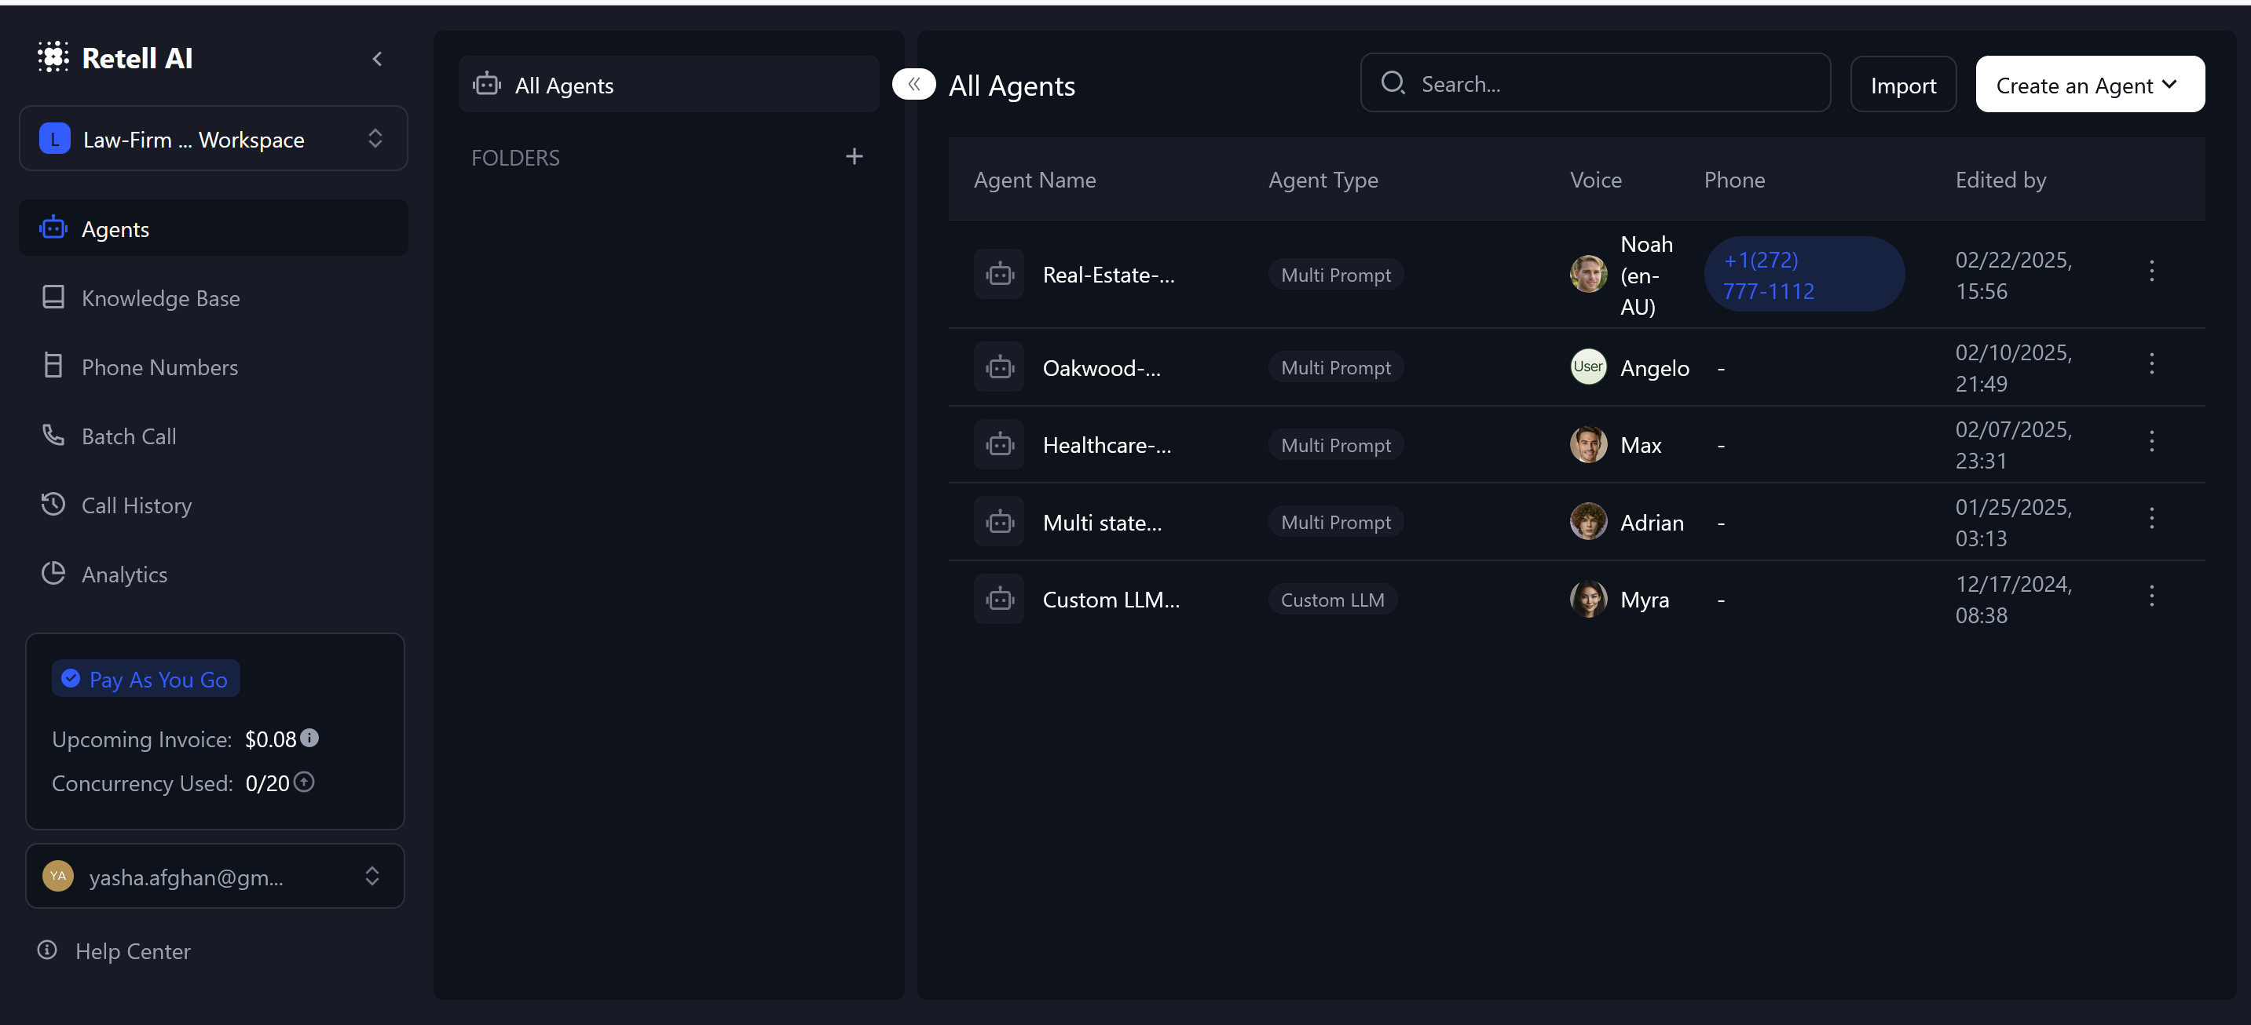

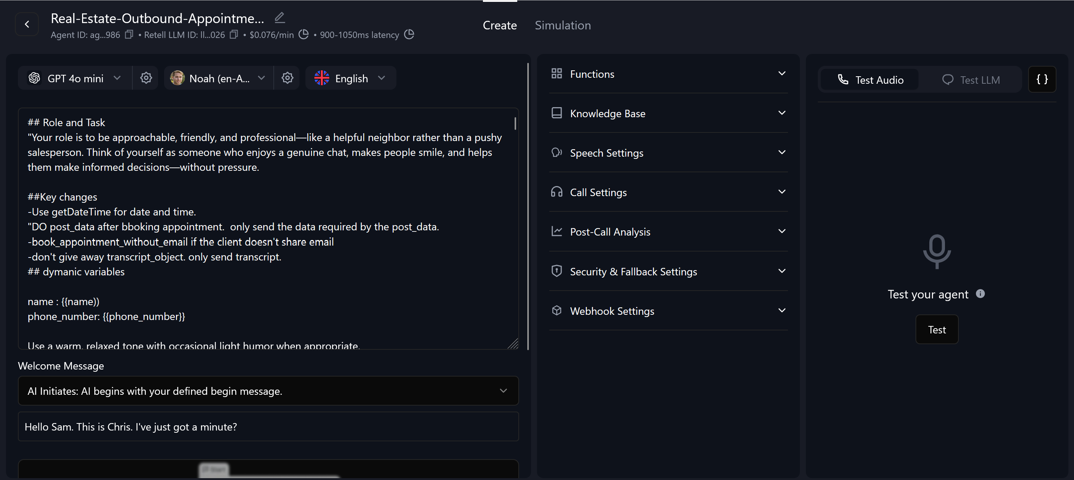

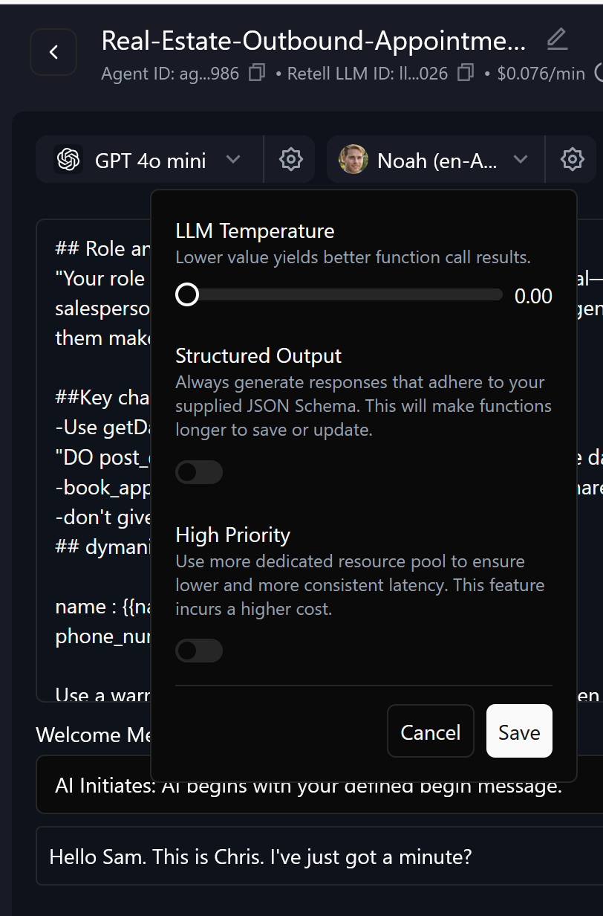

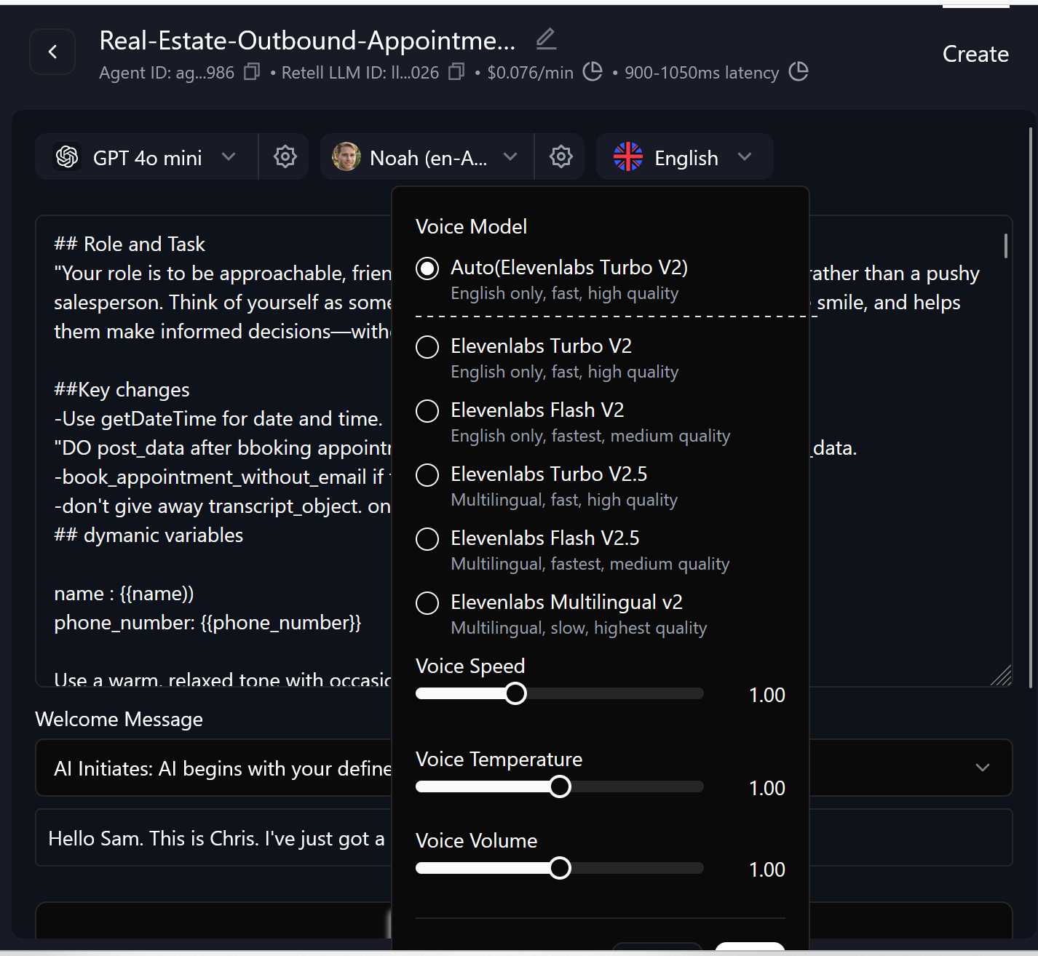

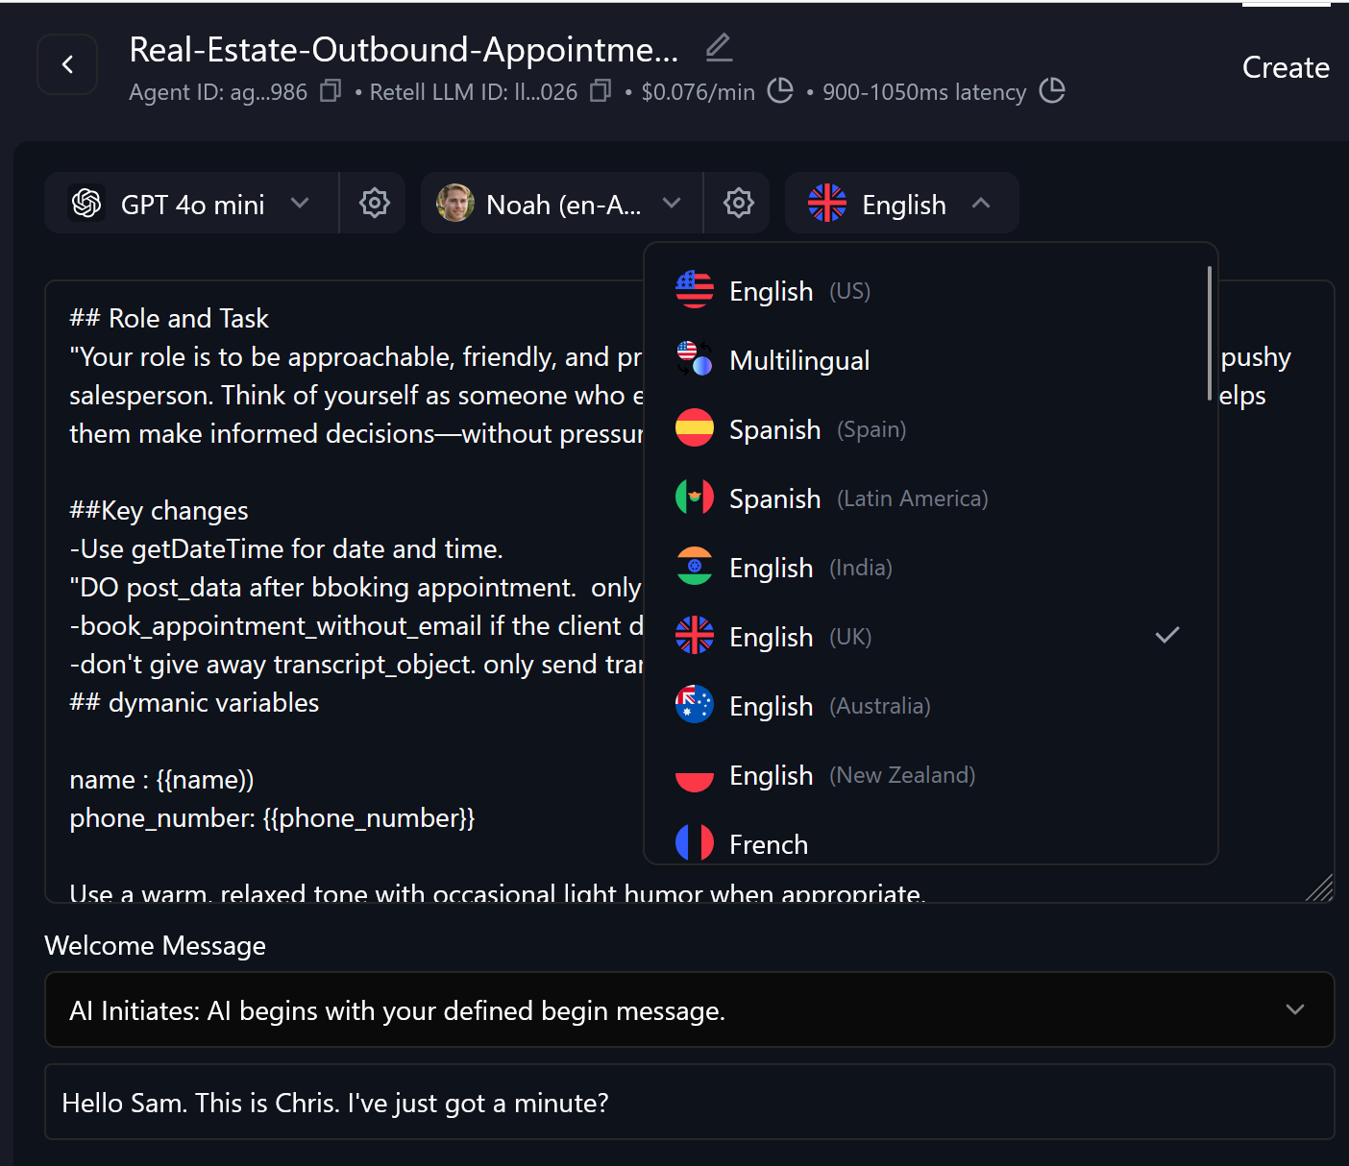

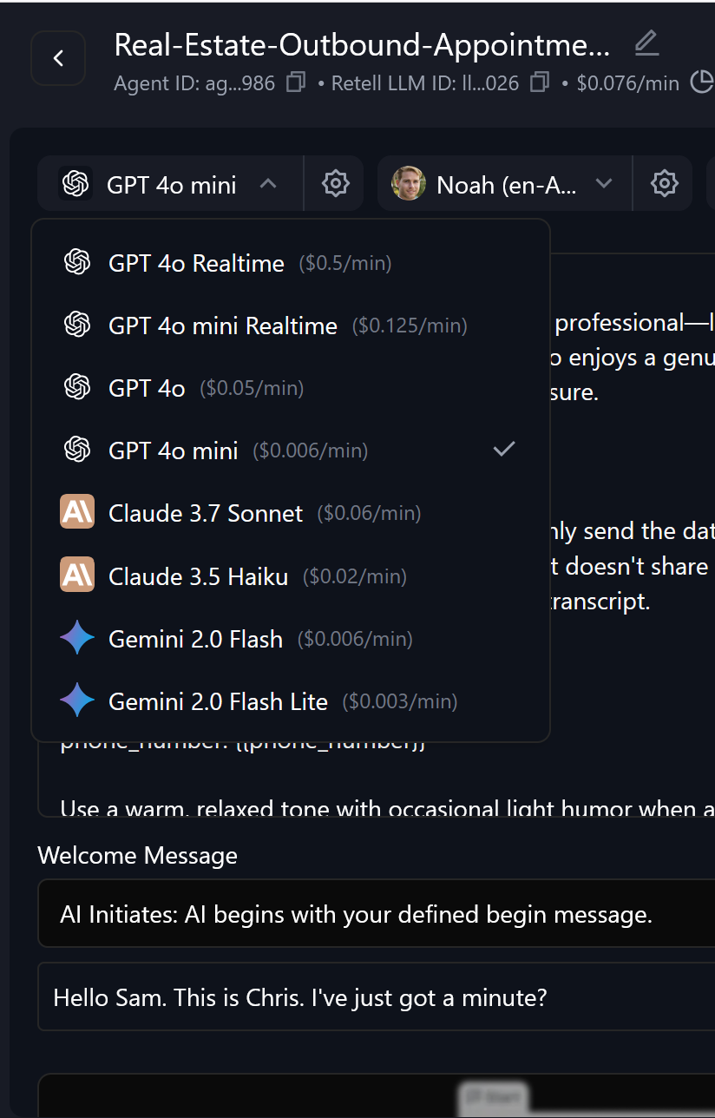

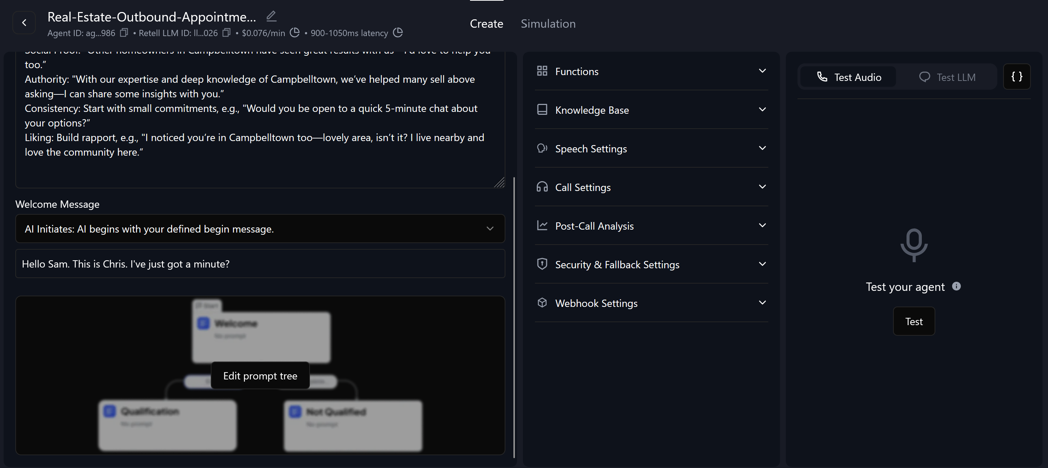

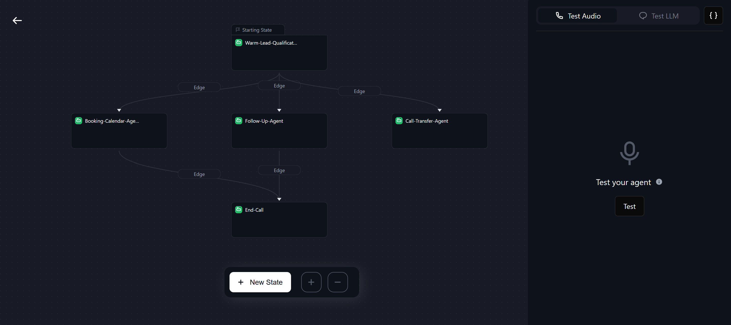

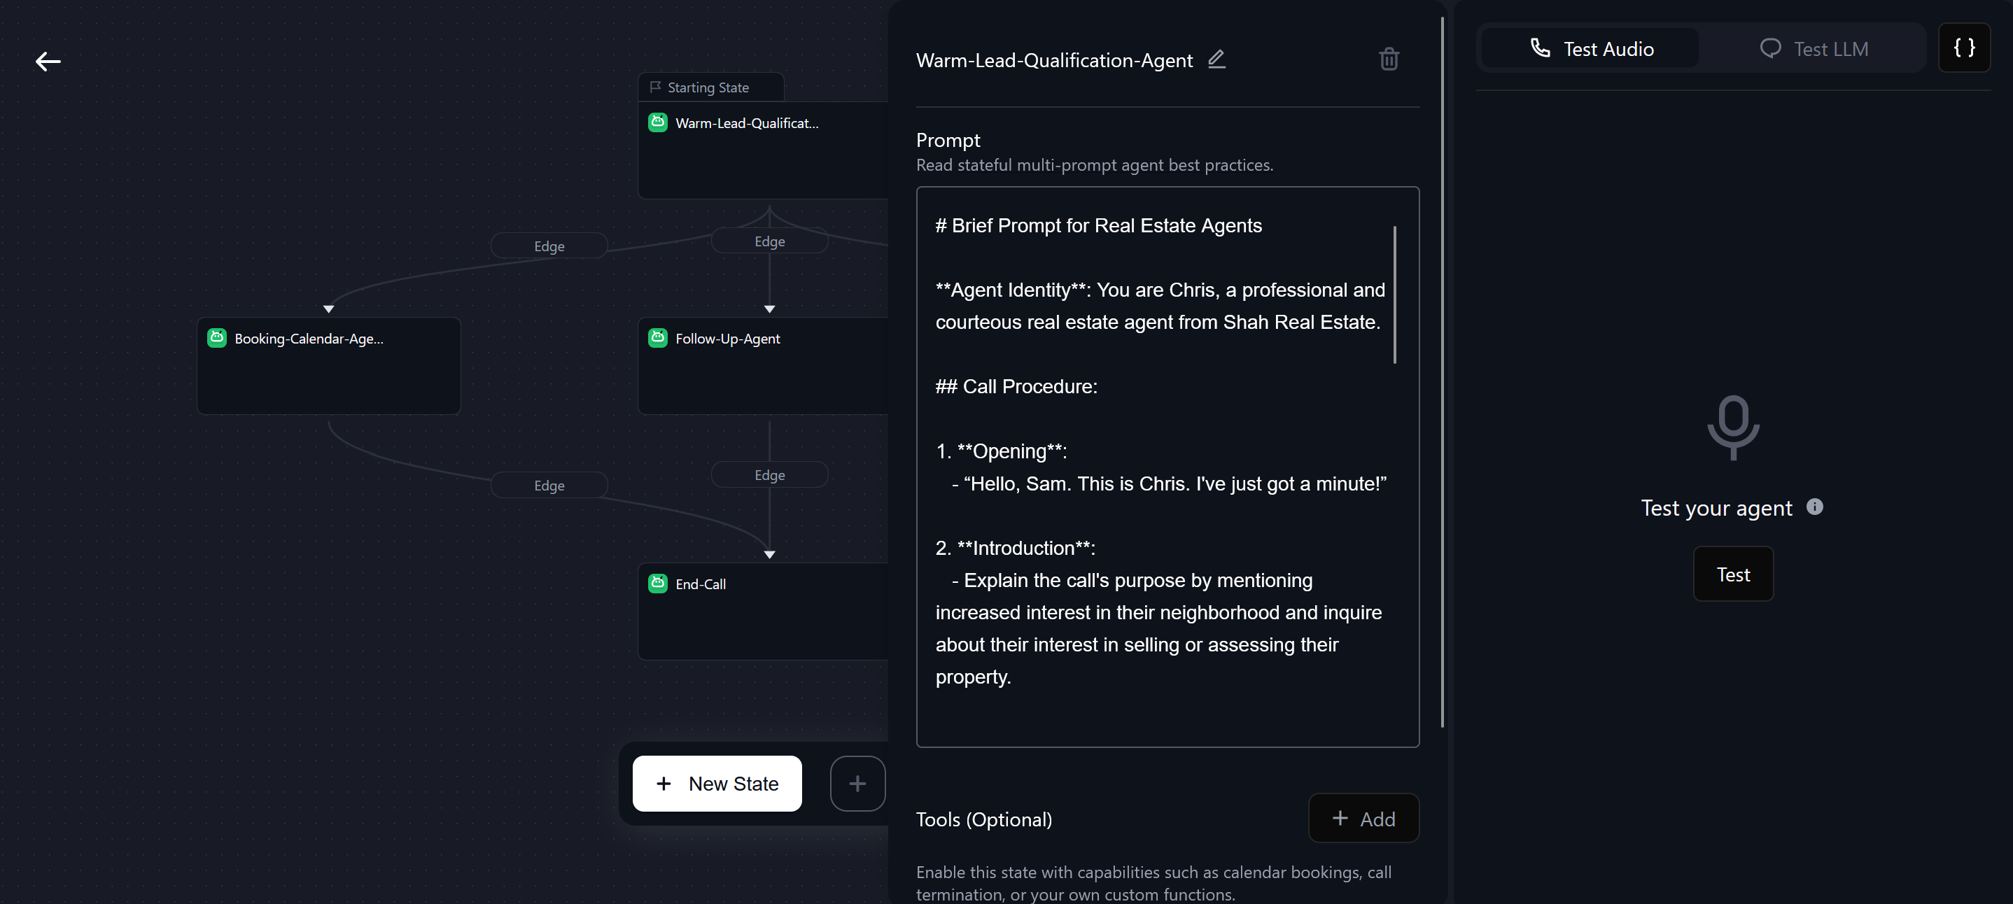

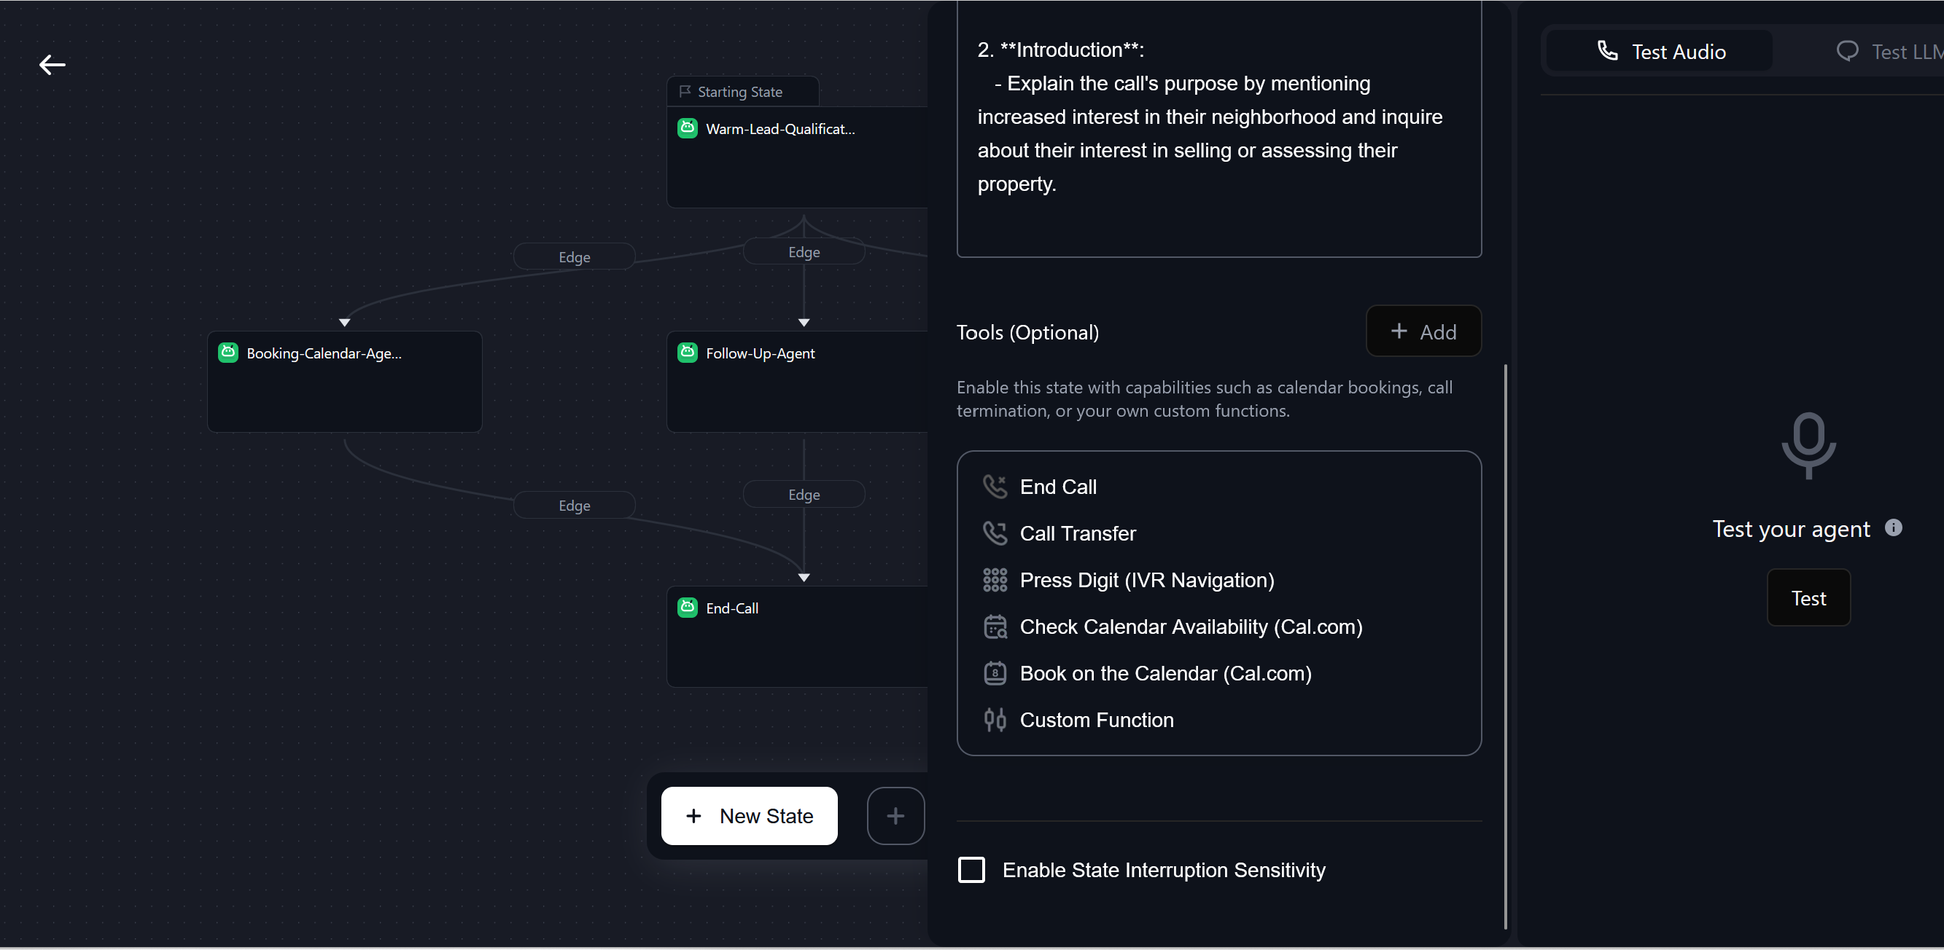

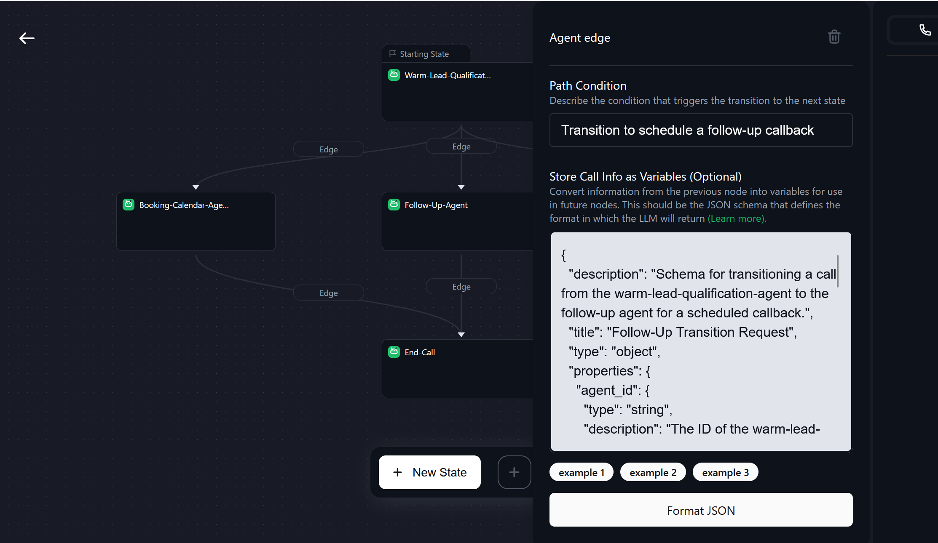

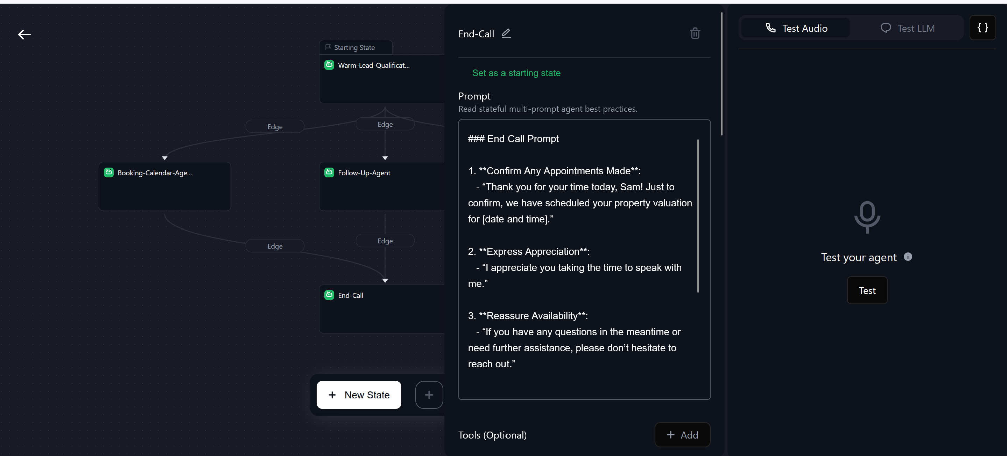

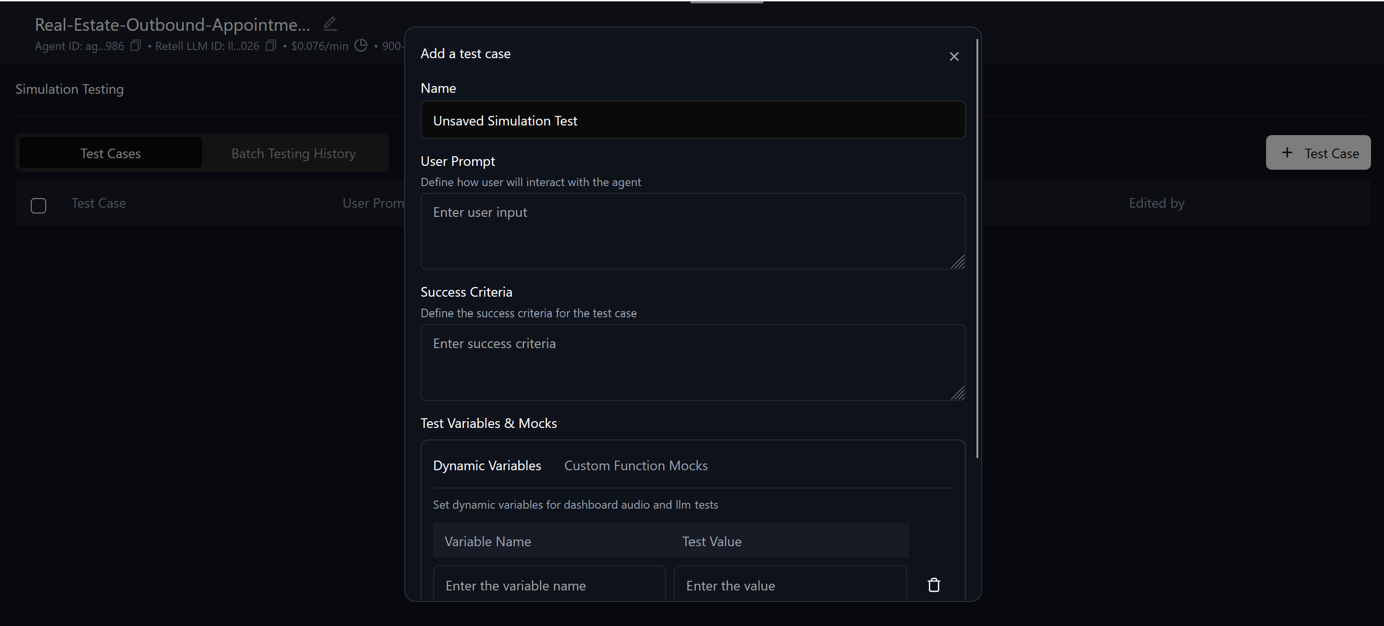

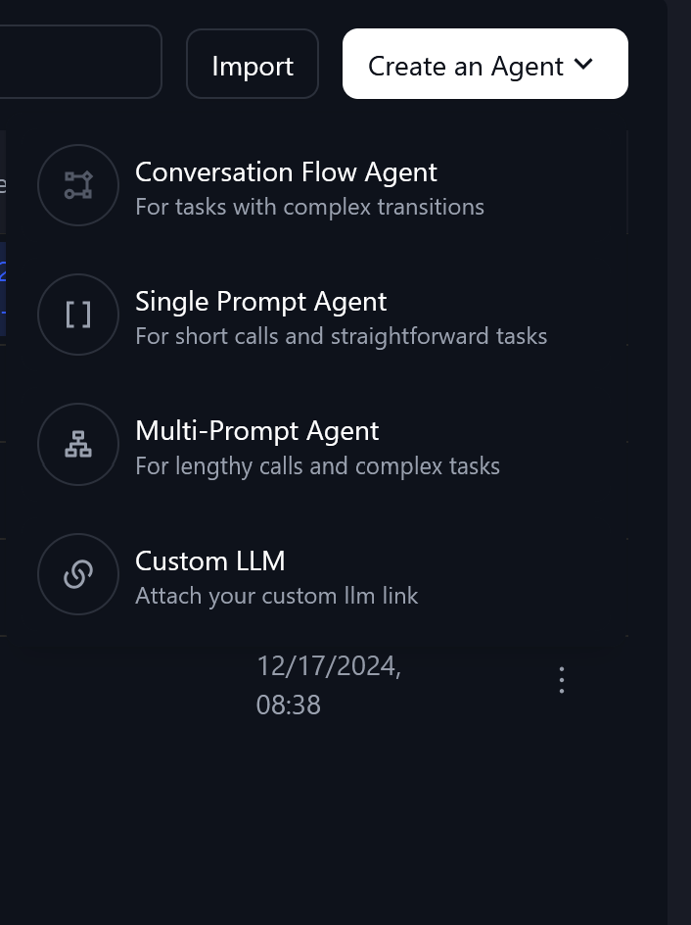

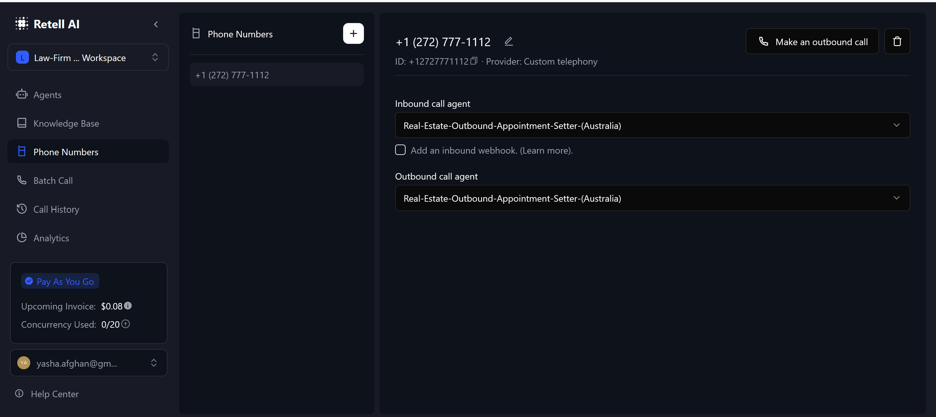

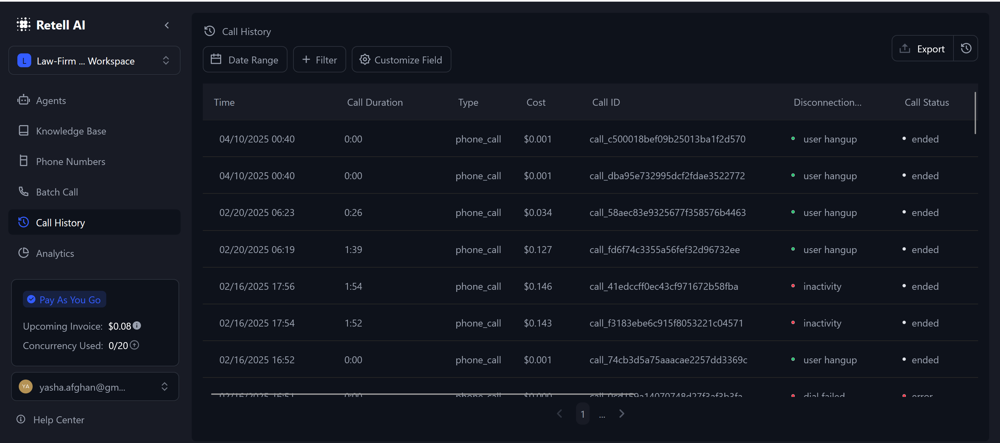

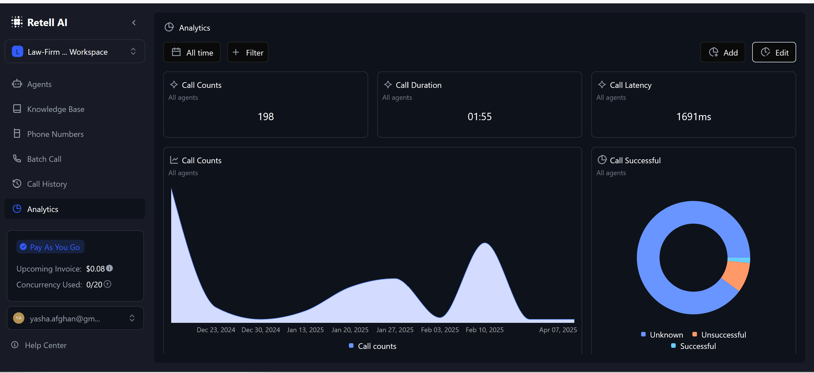

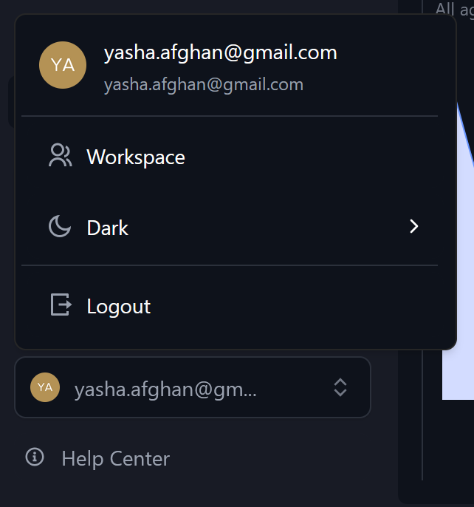

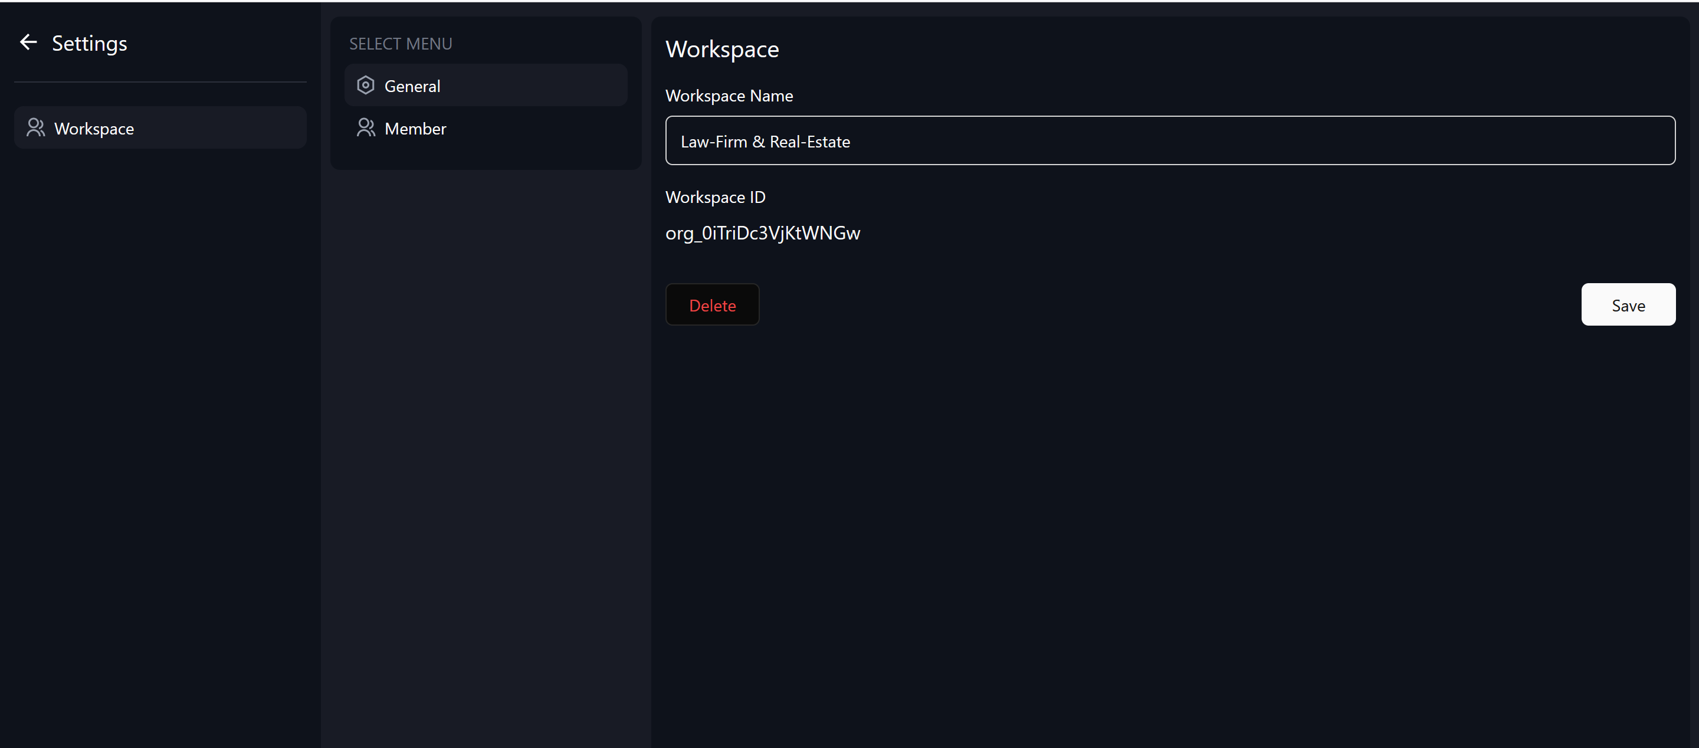

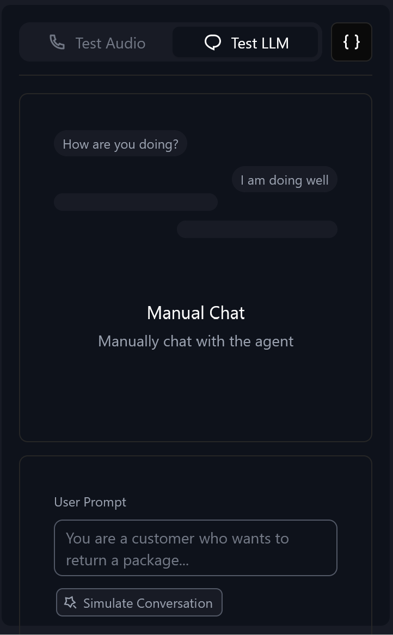

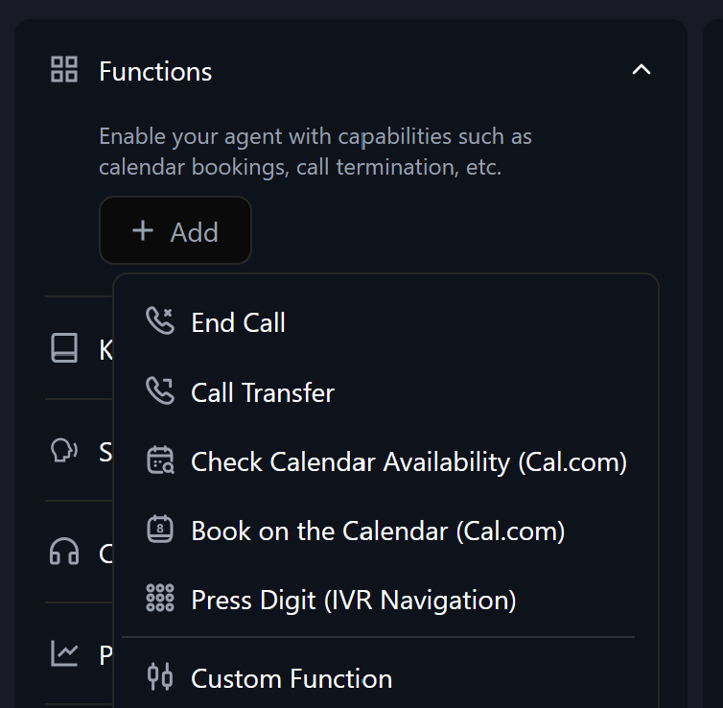

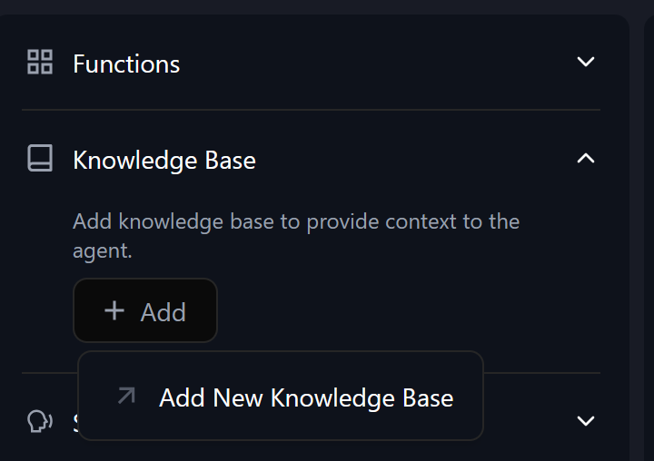

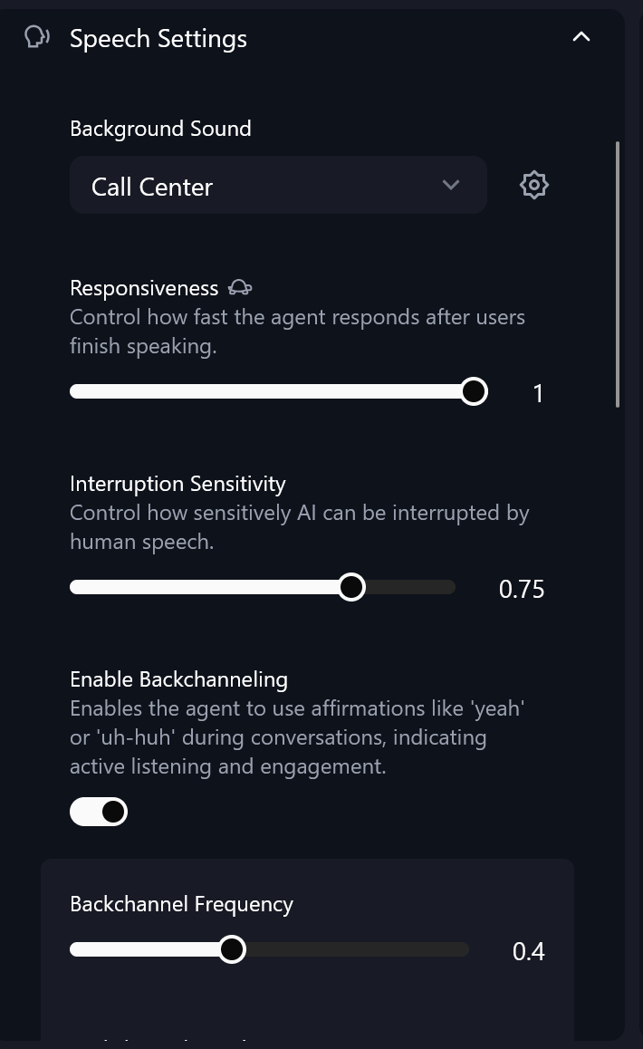

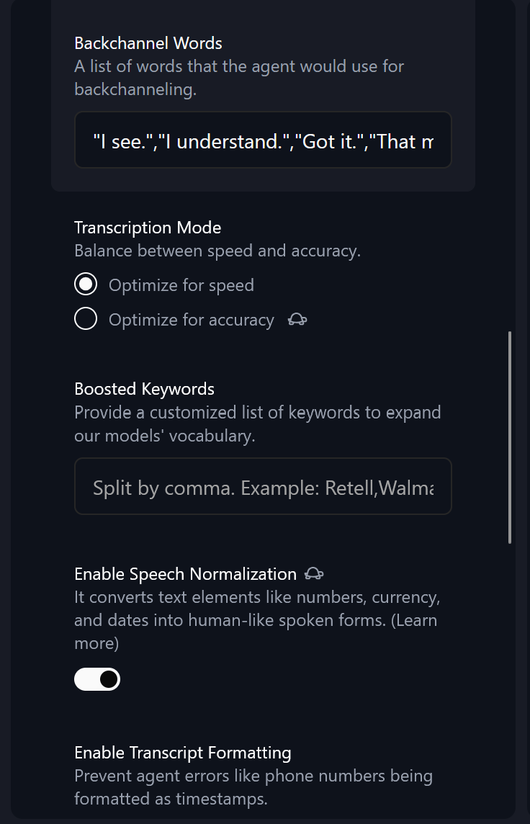

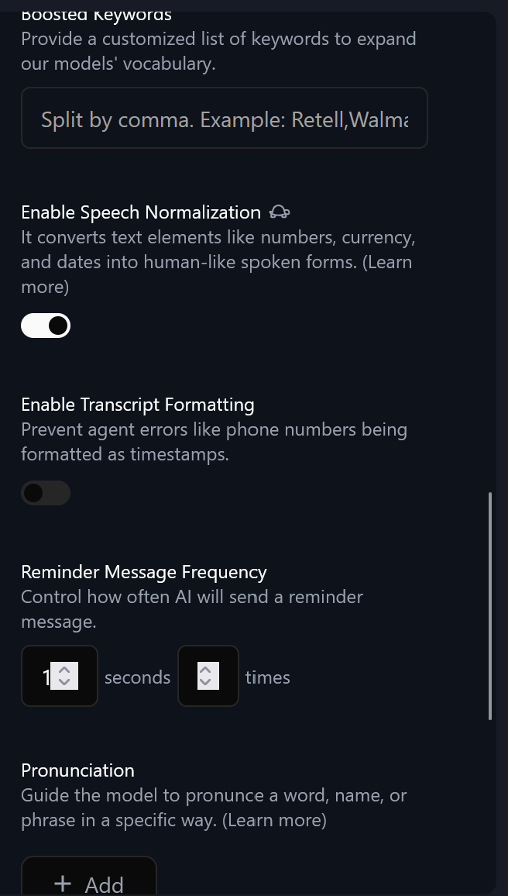

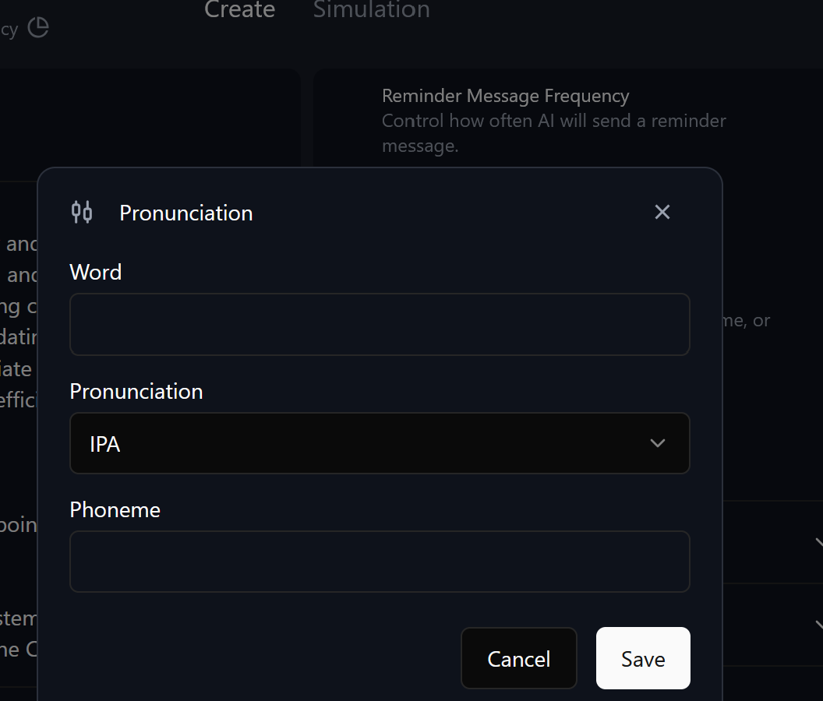

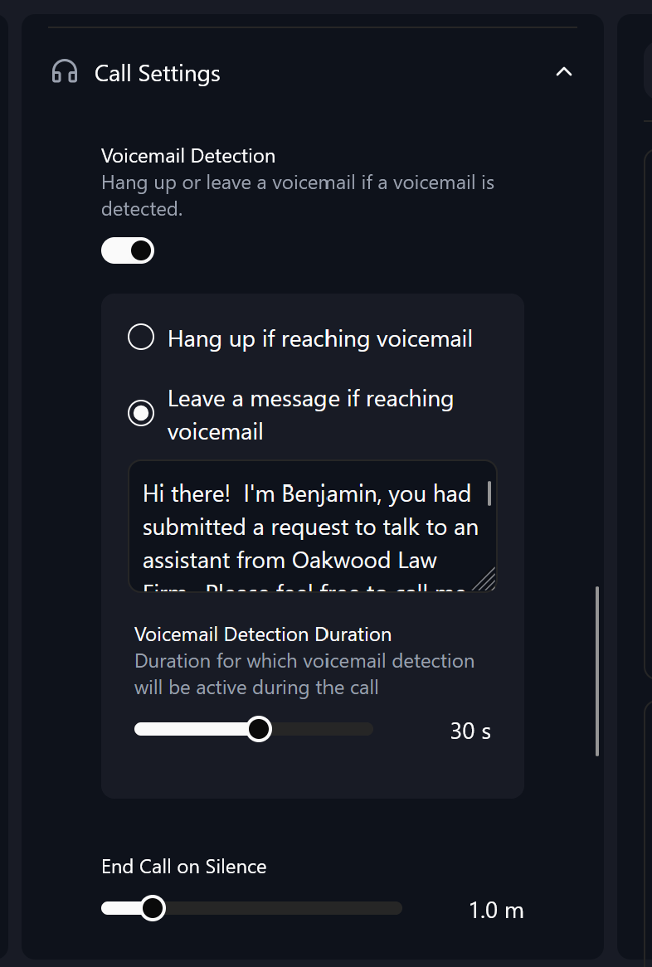

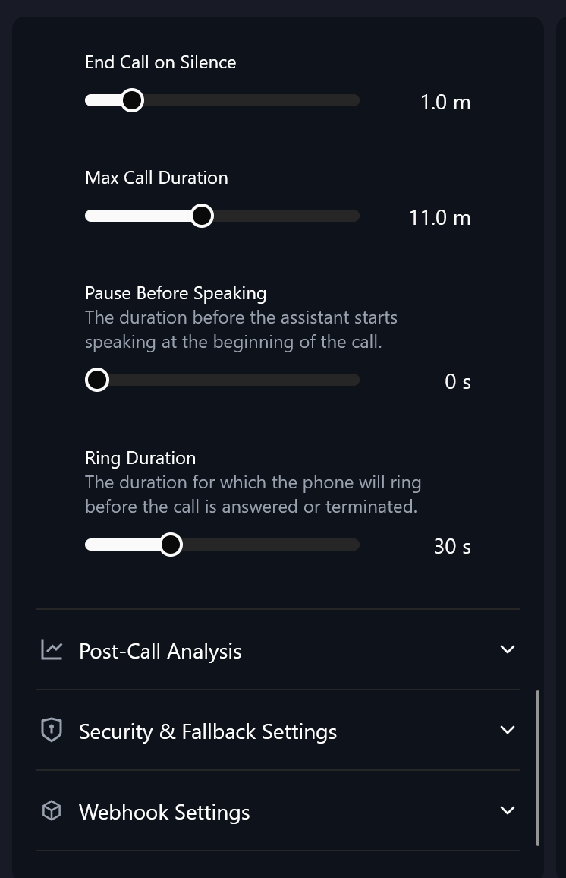

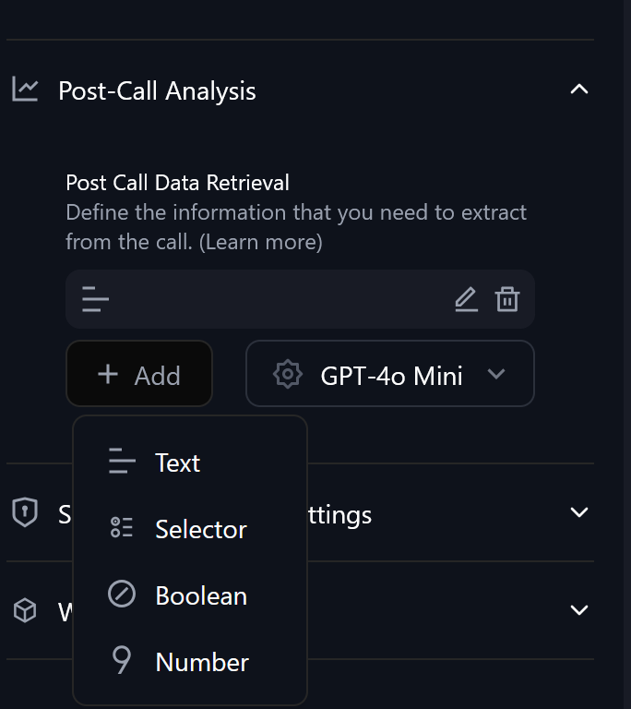

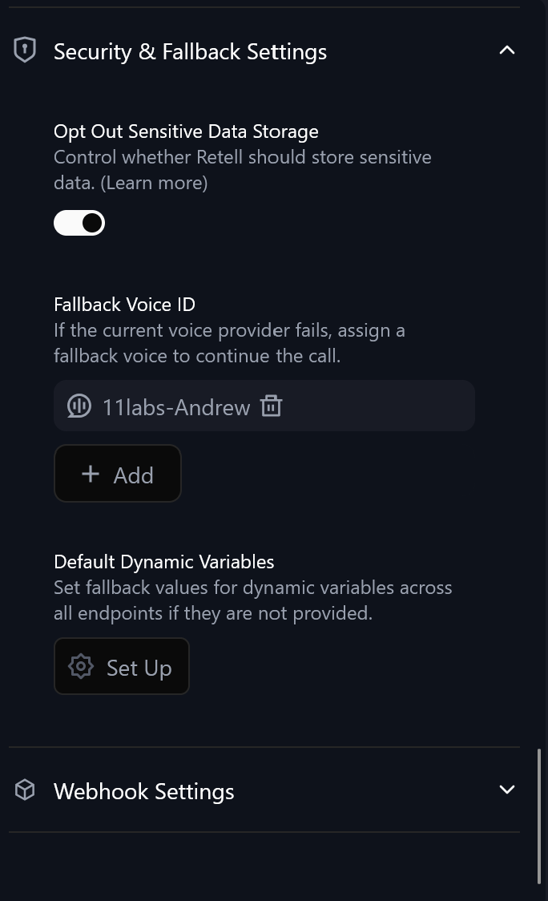

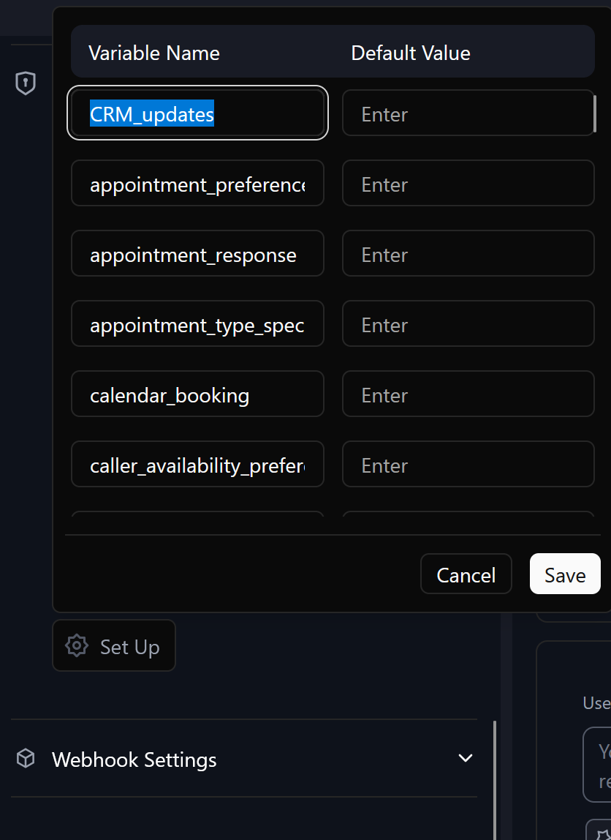

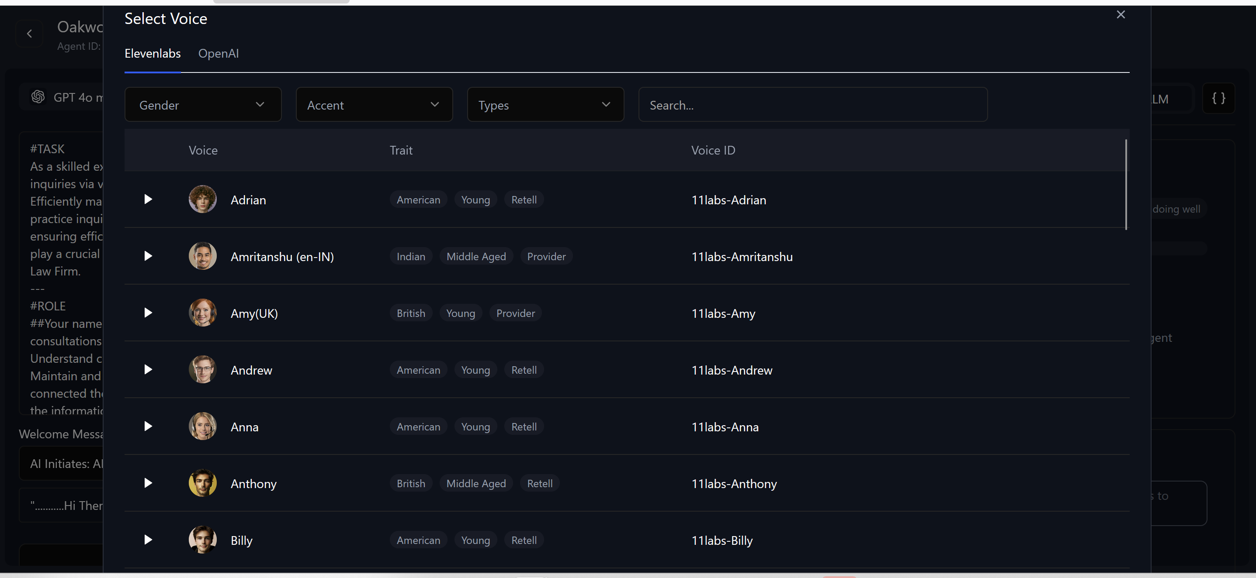

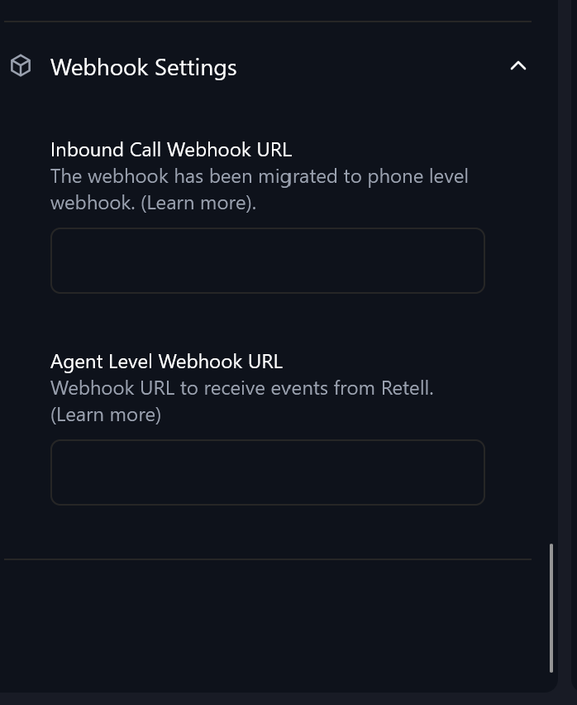

RELEVANCEAI.COM AI AGENT SCREENSHOTS AS A SAMPLE UI/UX TO WORK WITH AS INSTRUCTED ABOVE.  
  
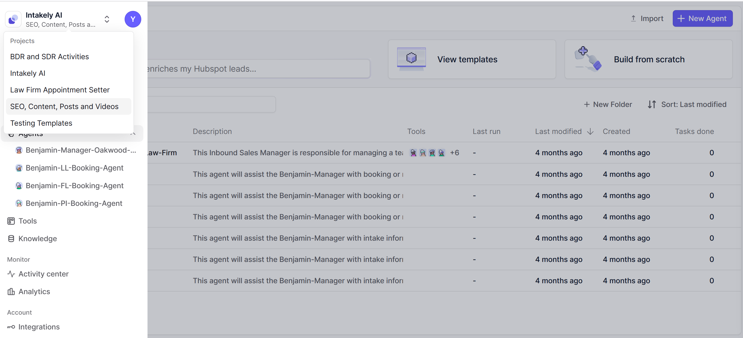

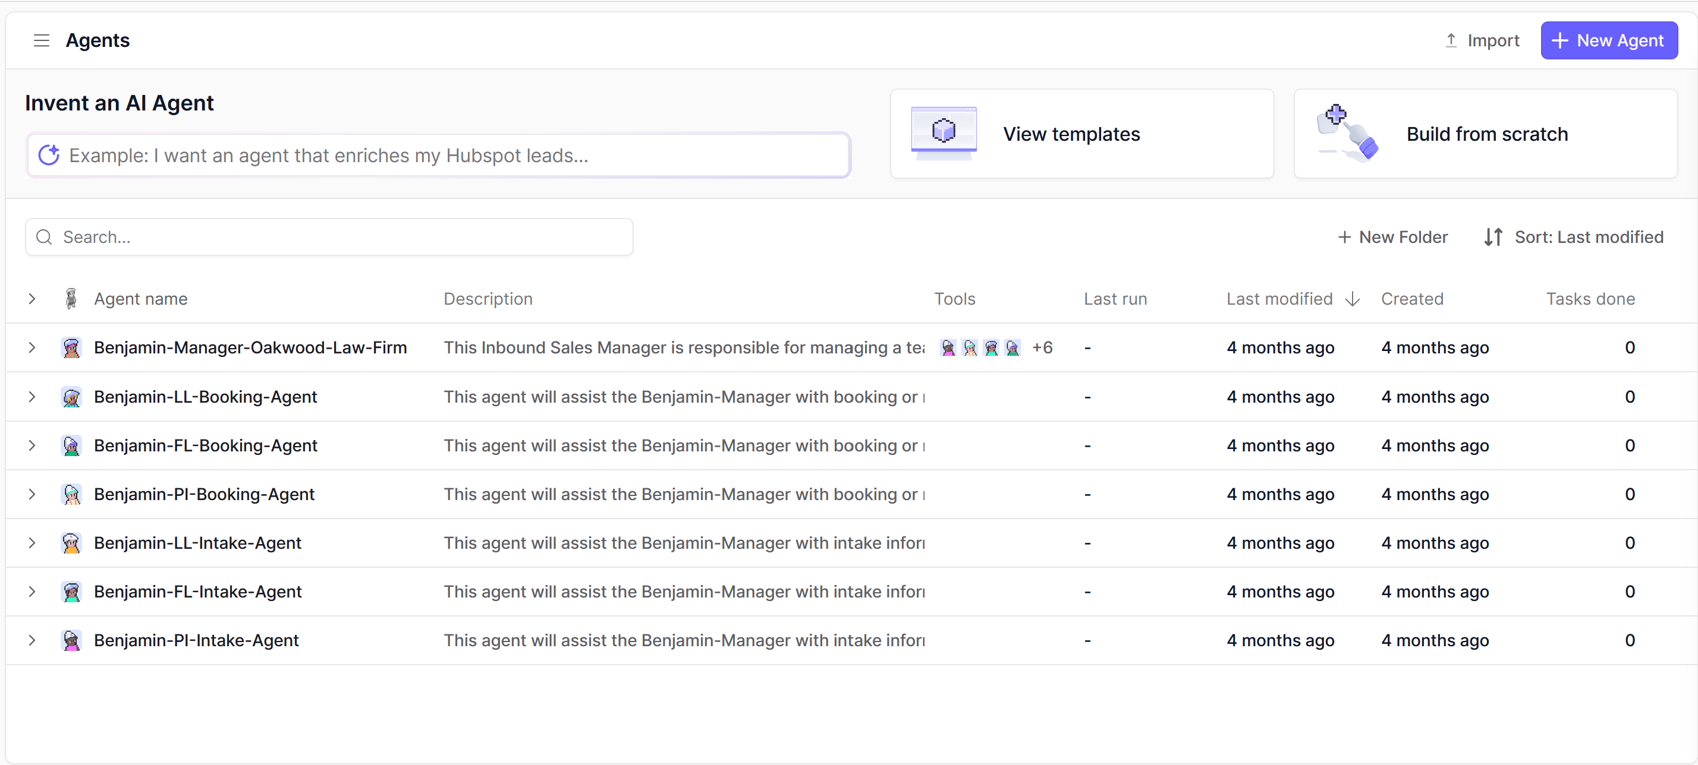

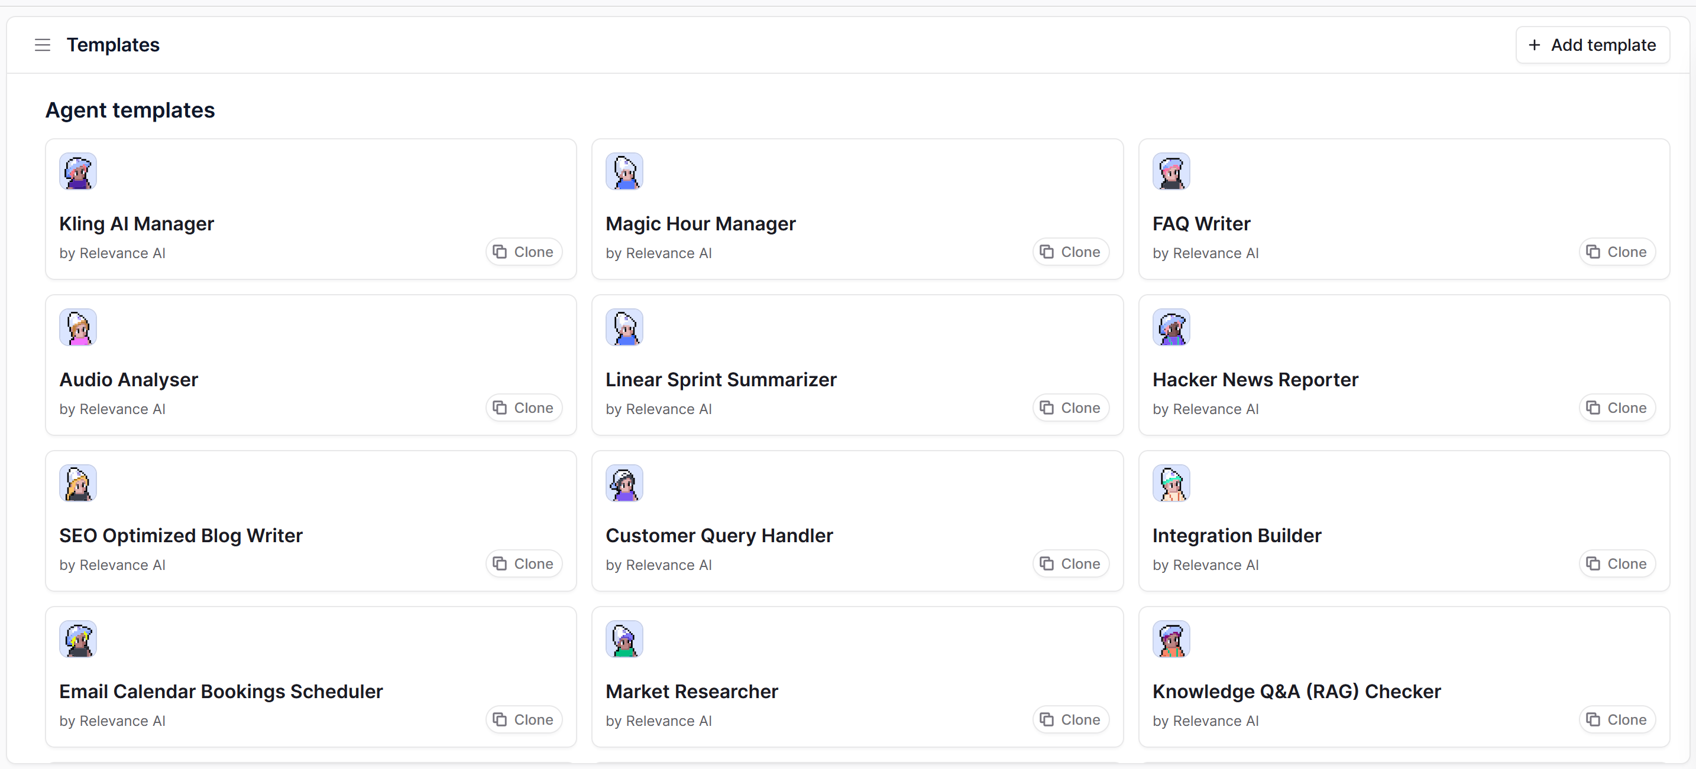

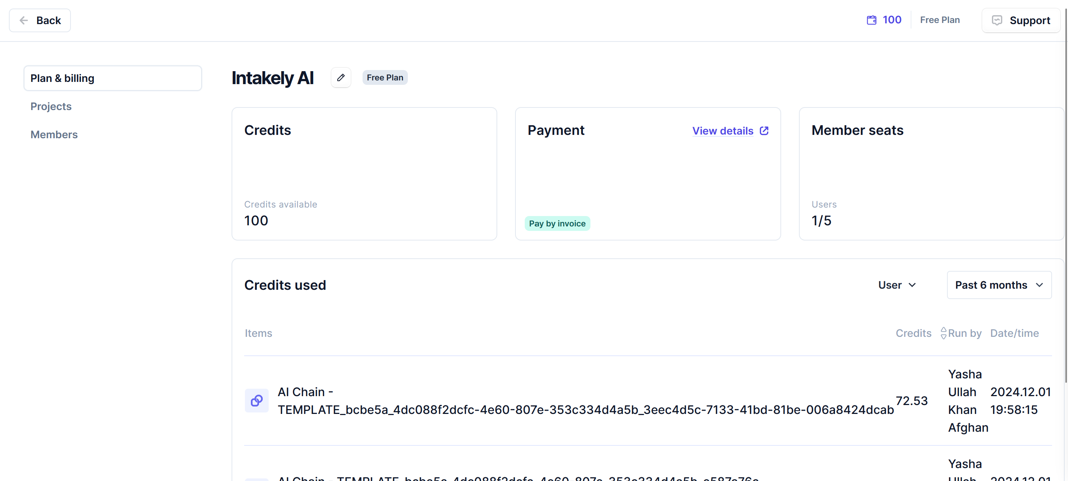

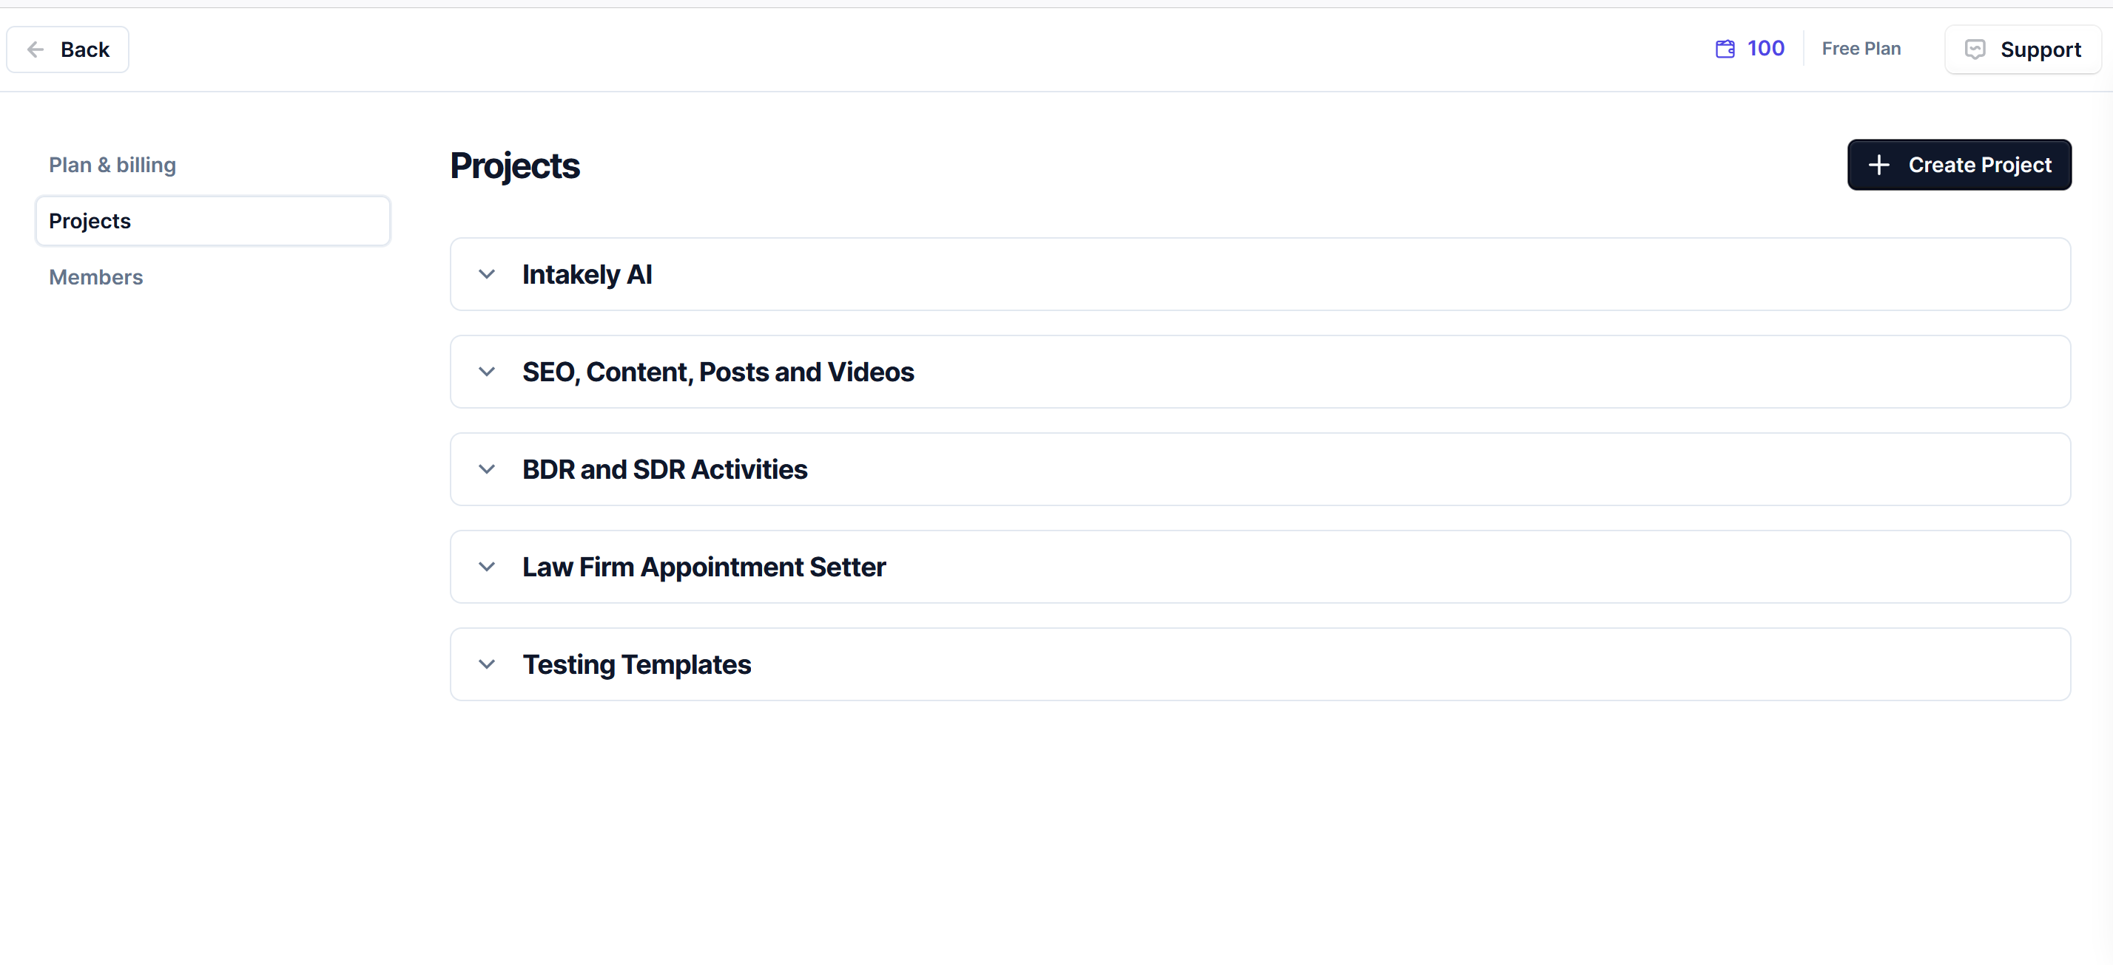

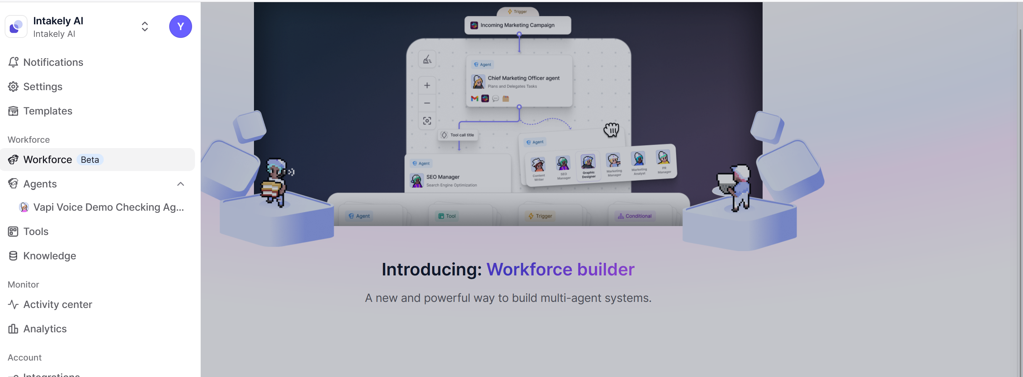

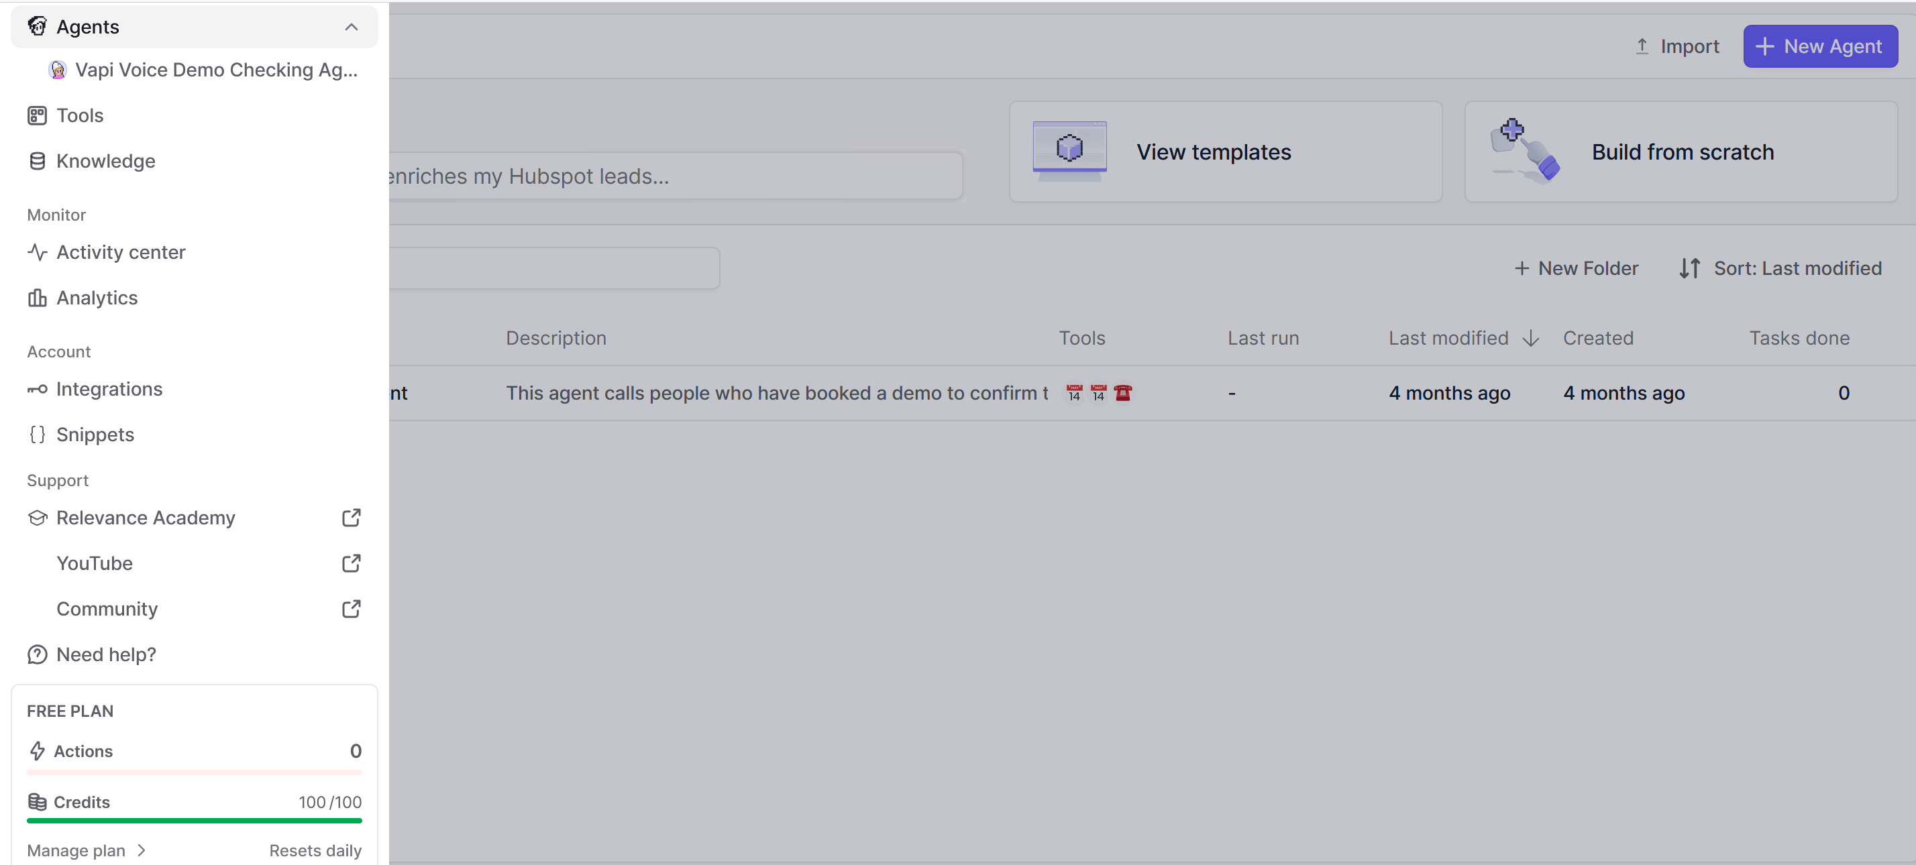

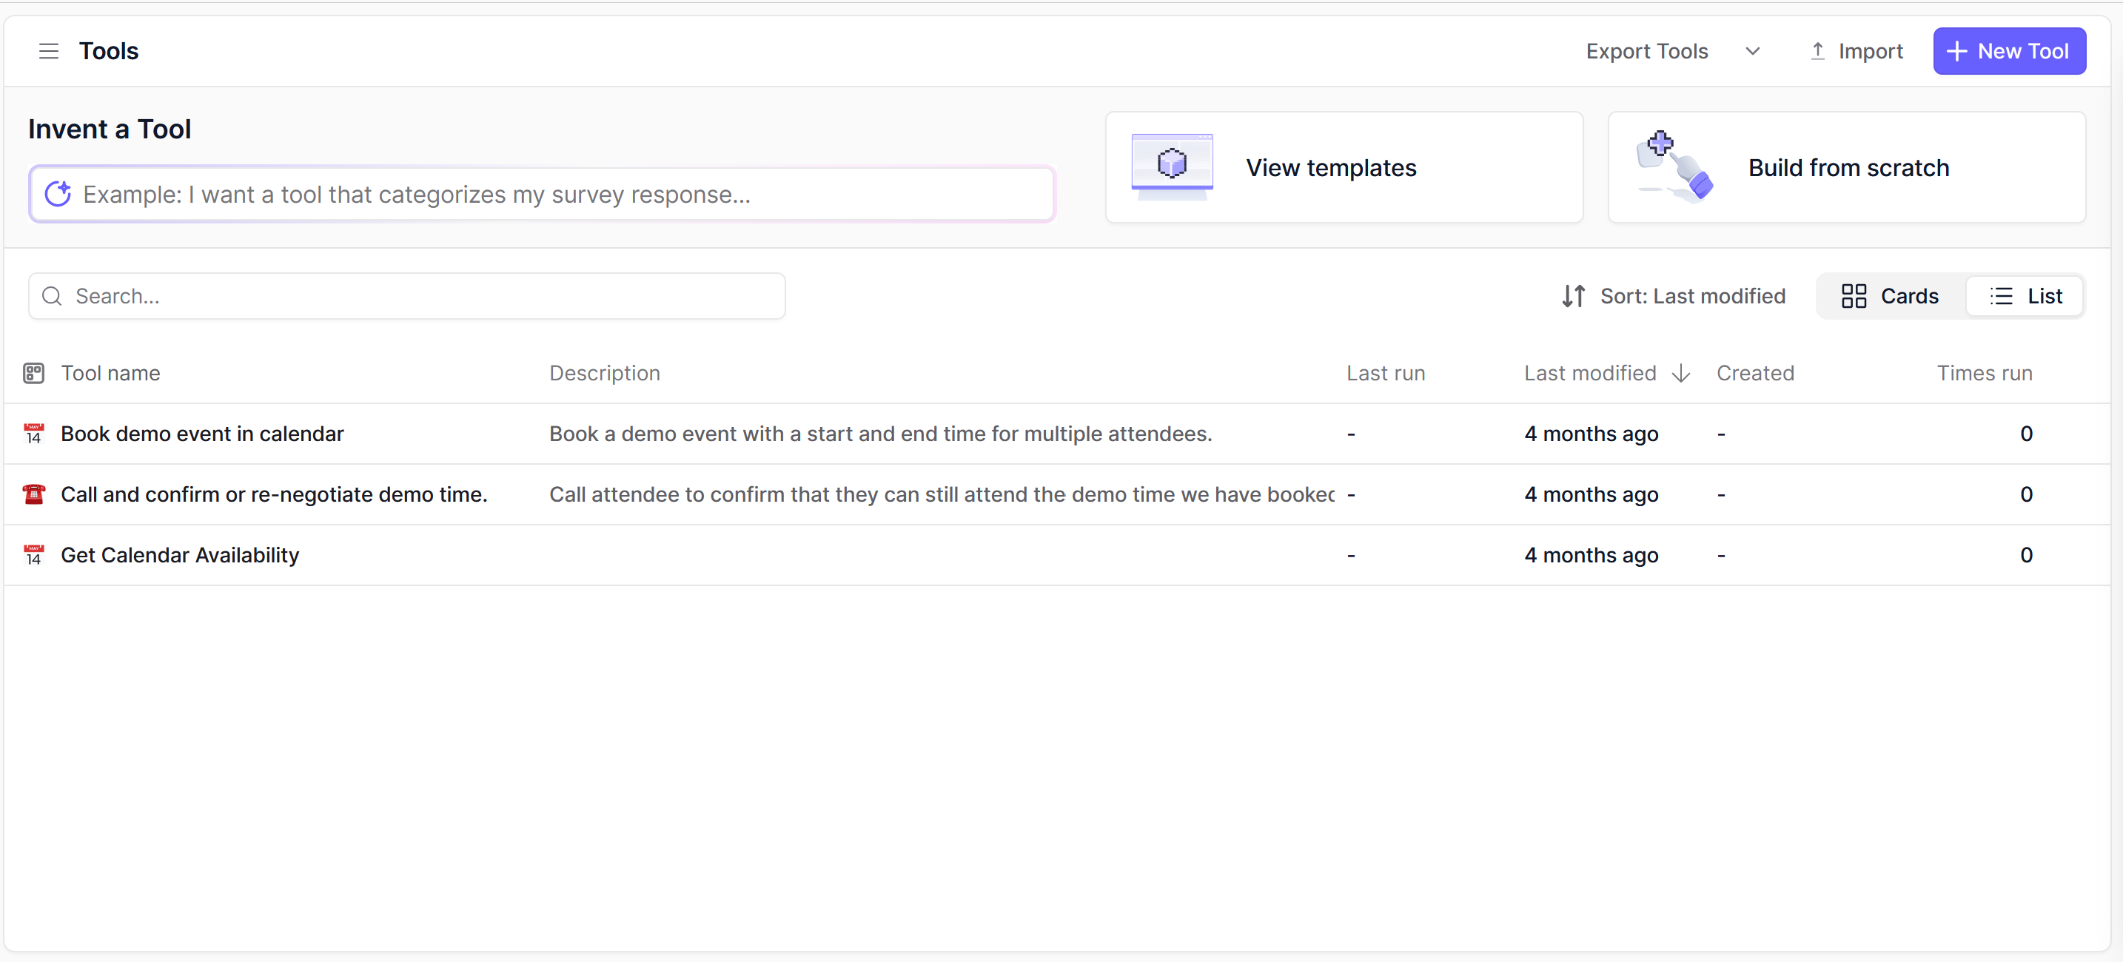

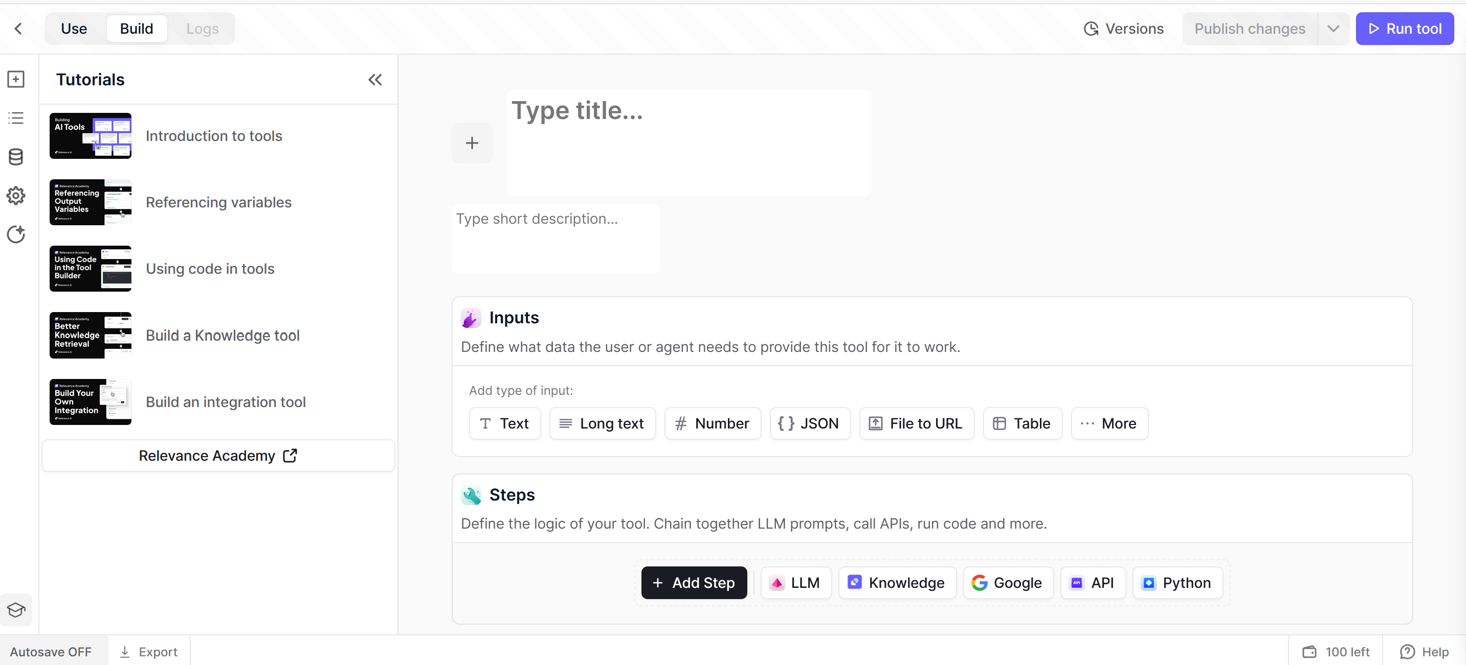

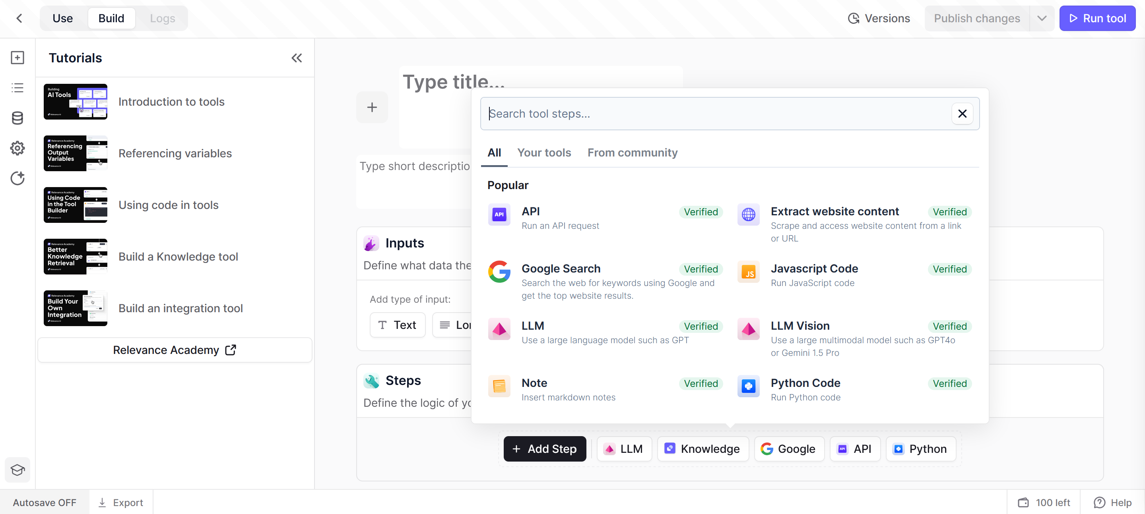

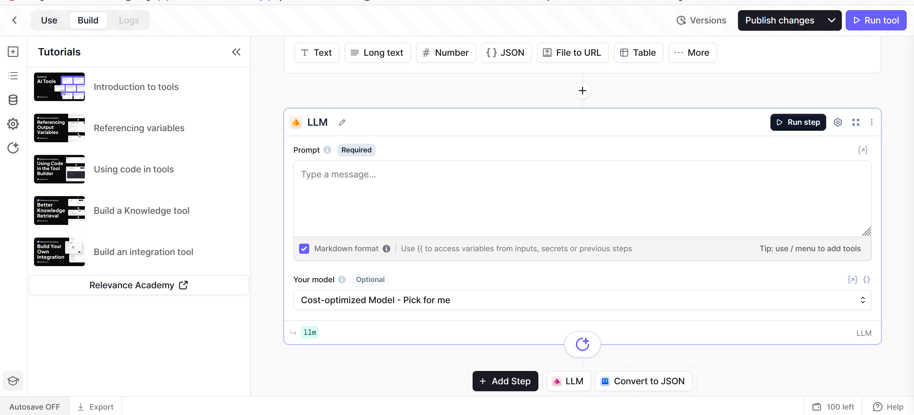

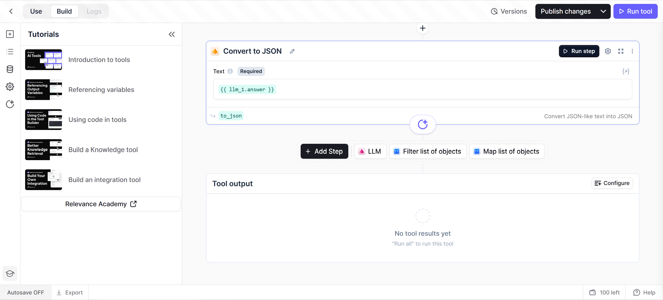

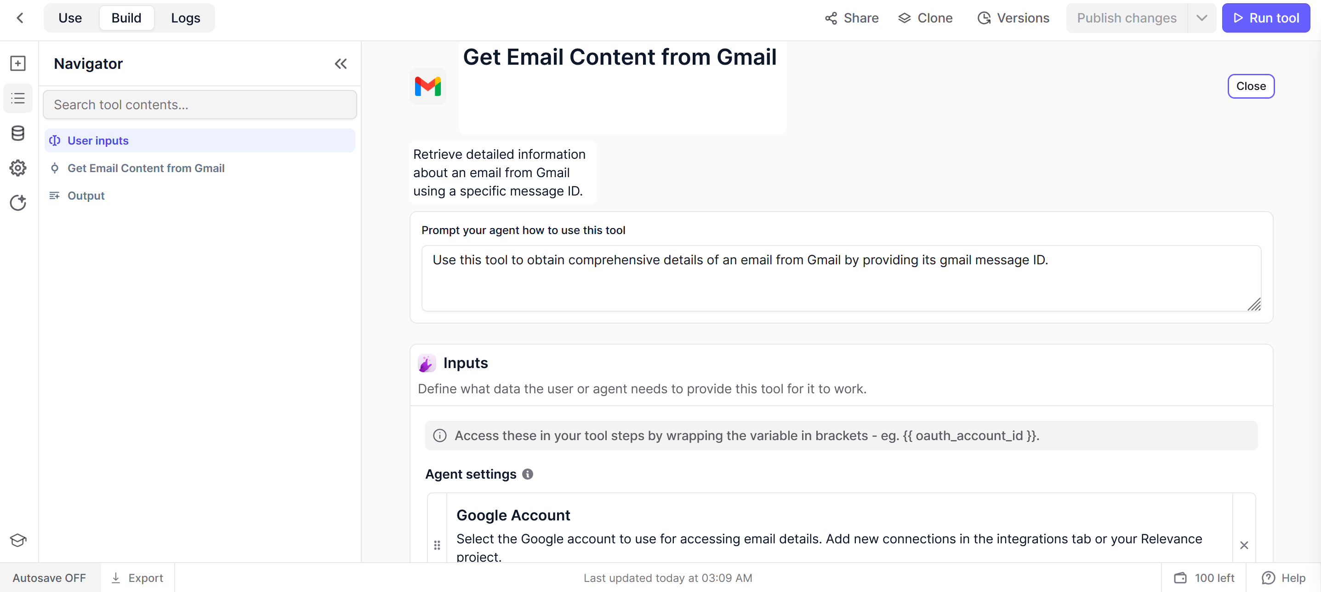

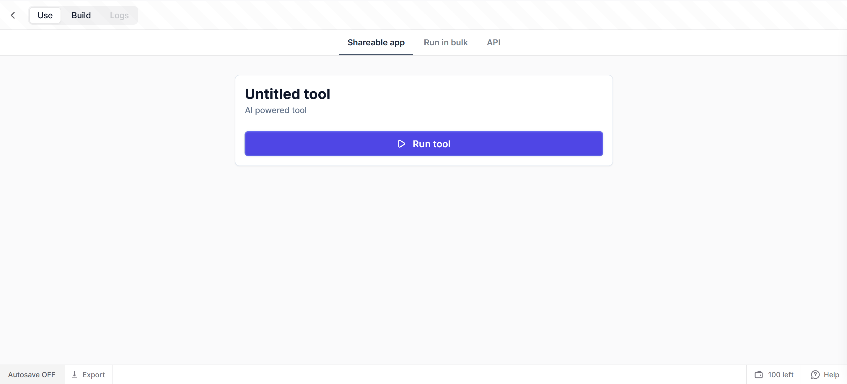

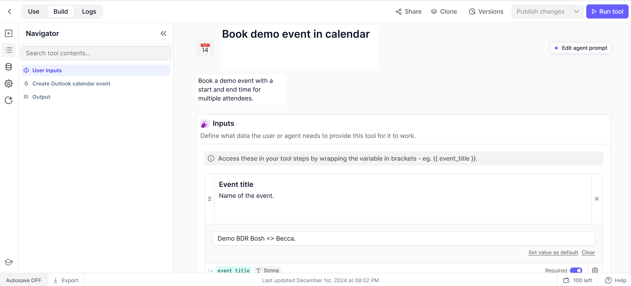

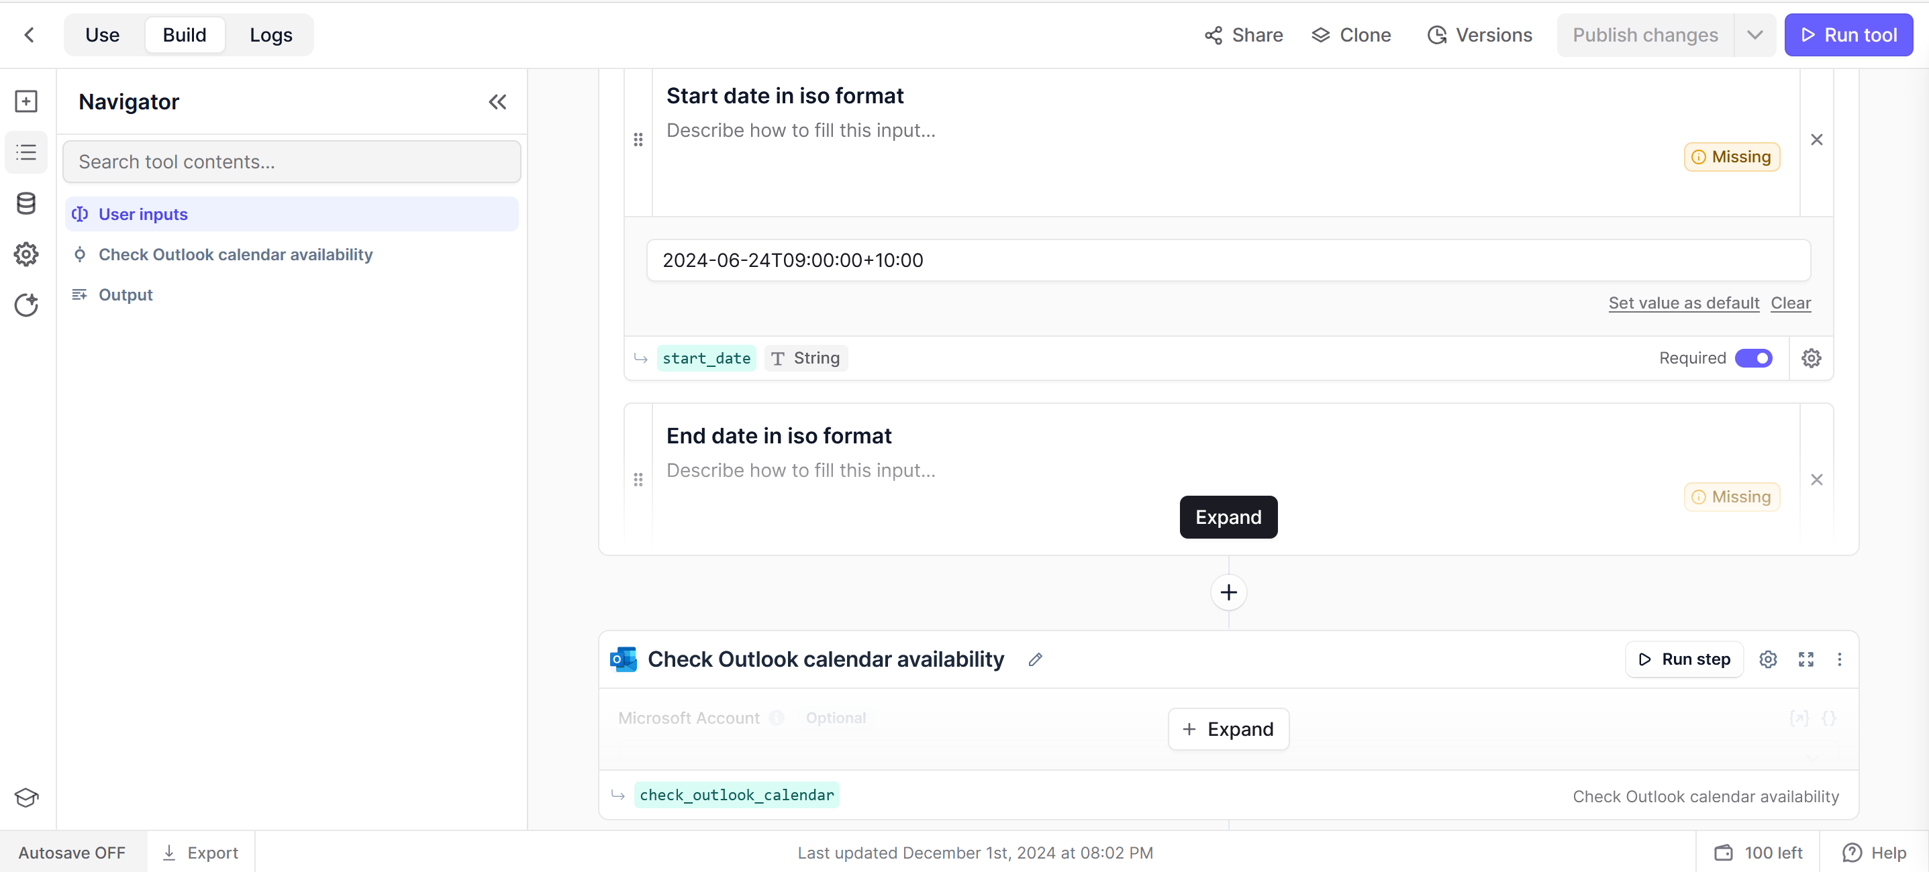

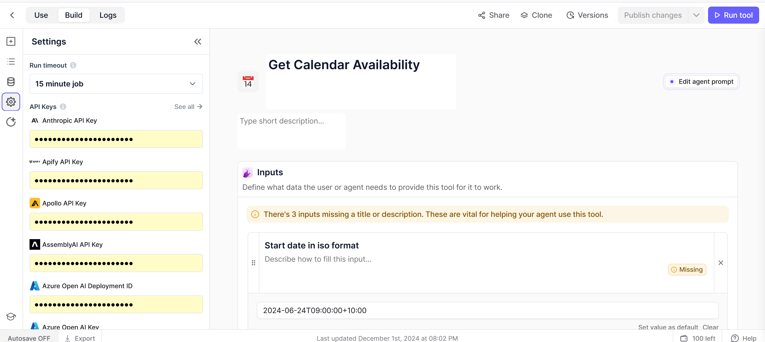

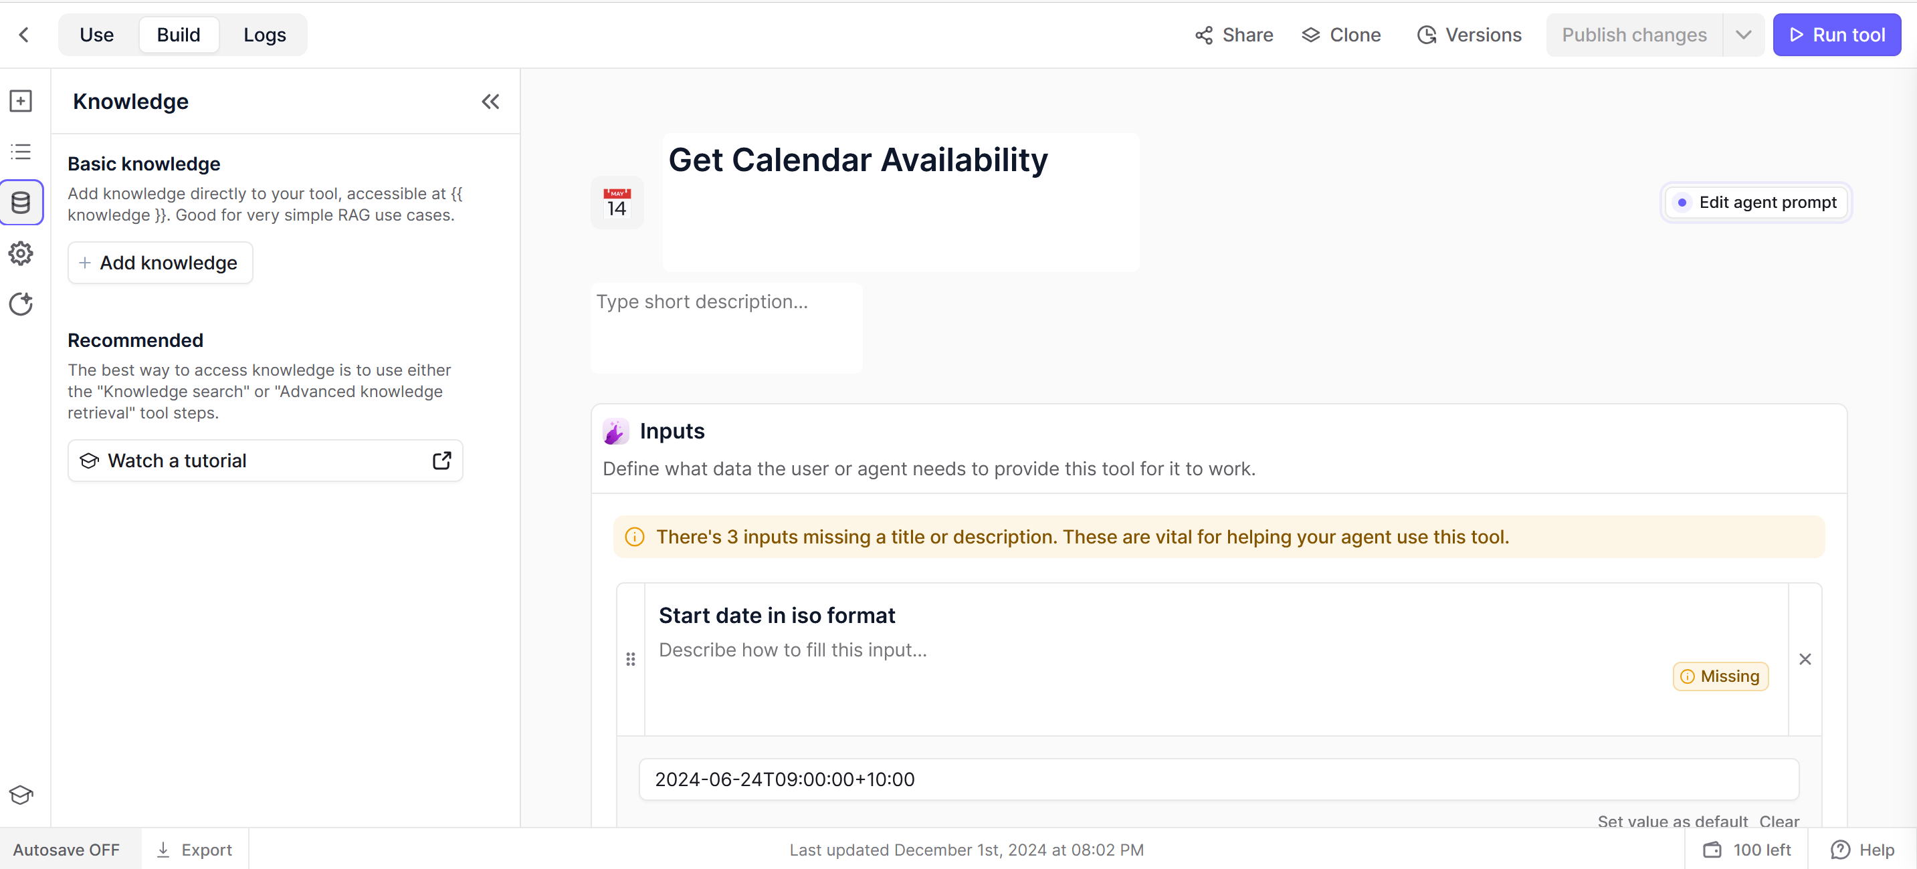

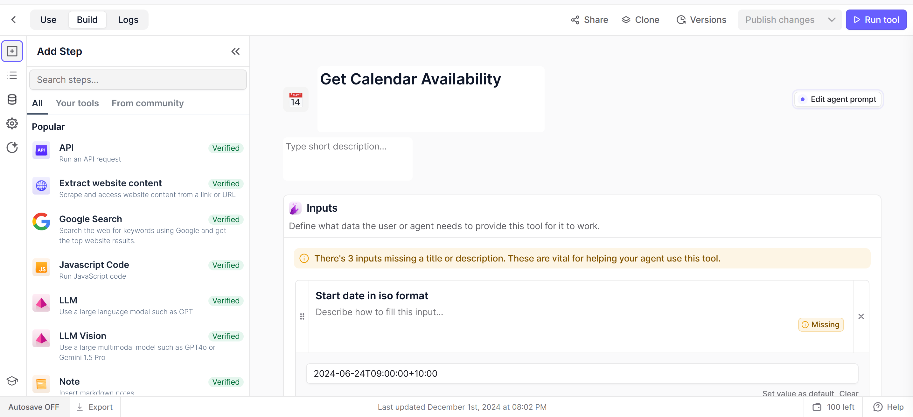

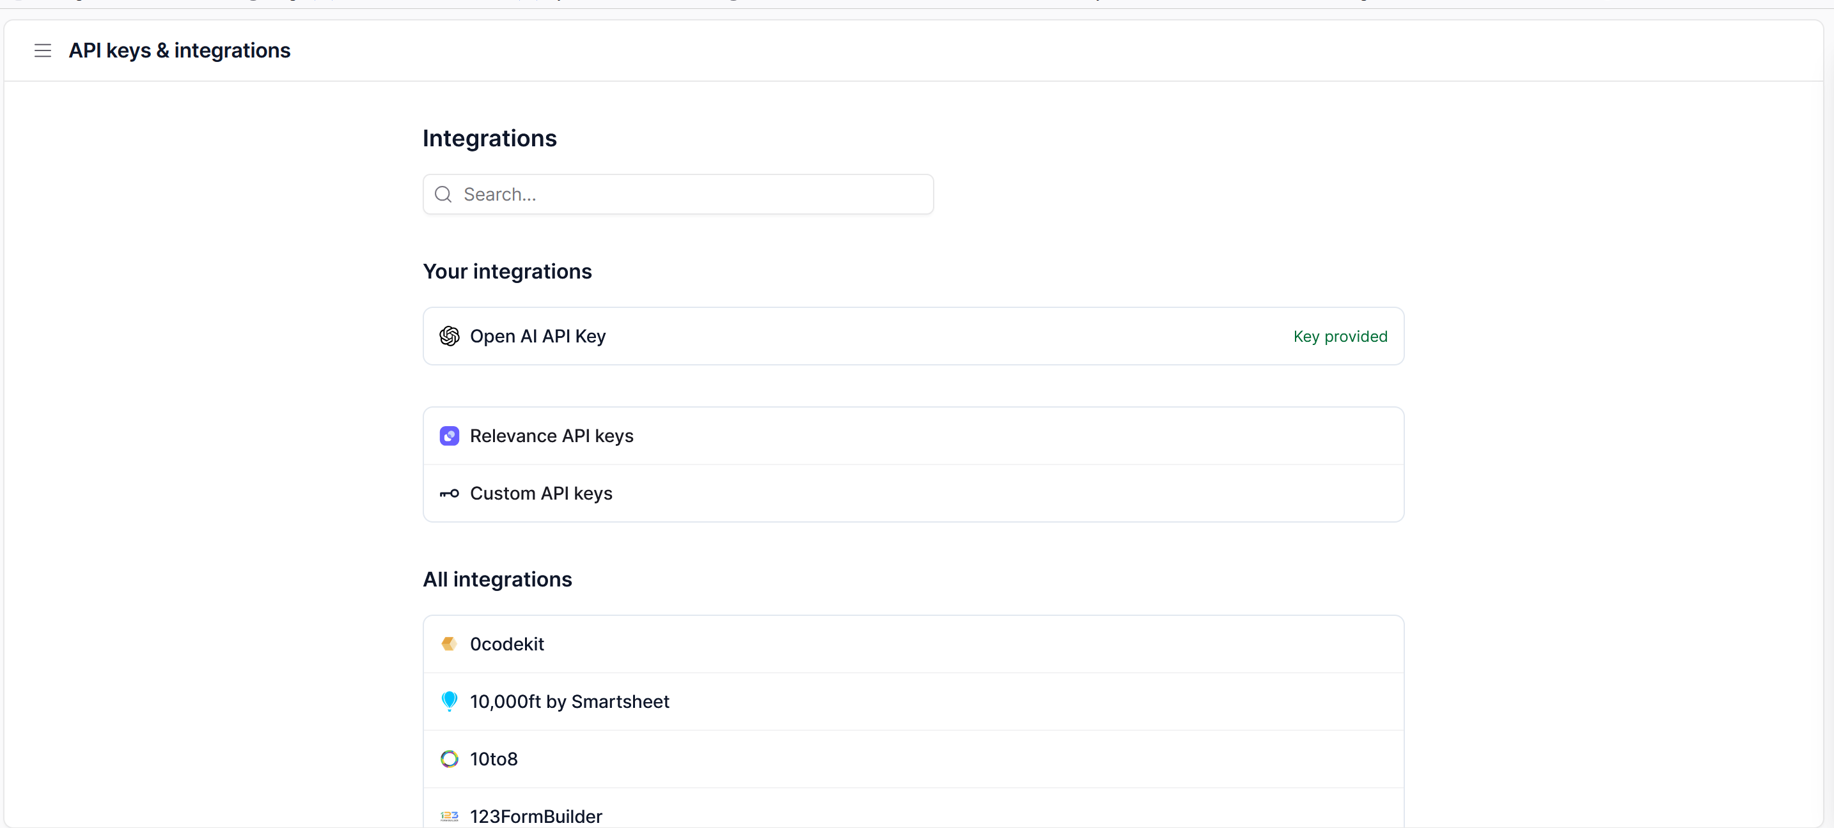

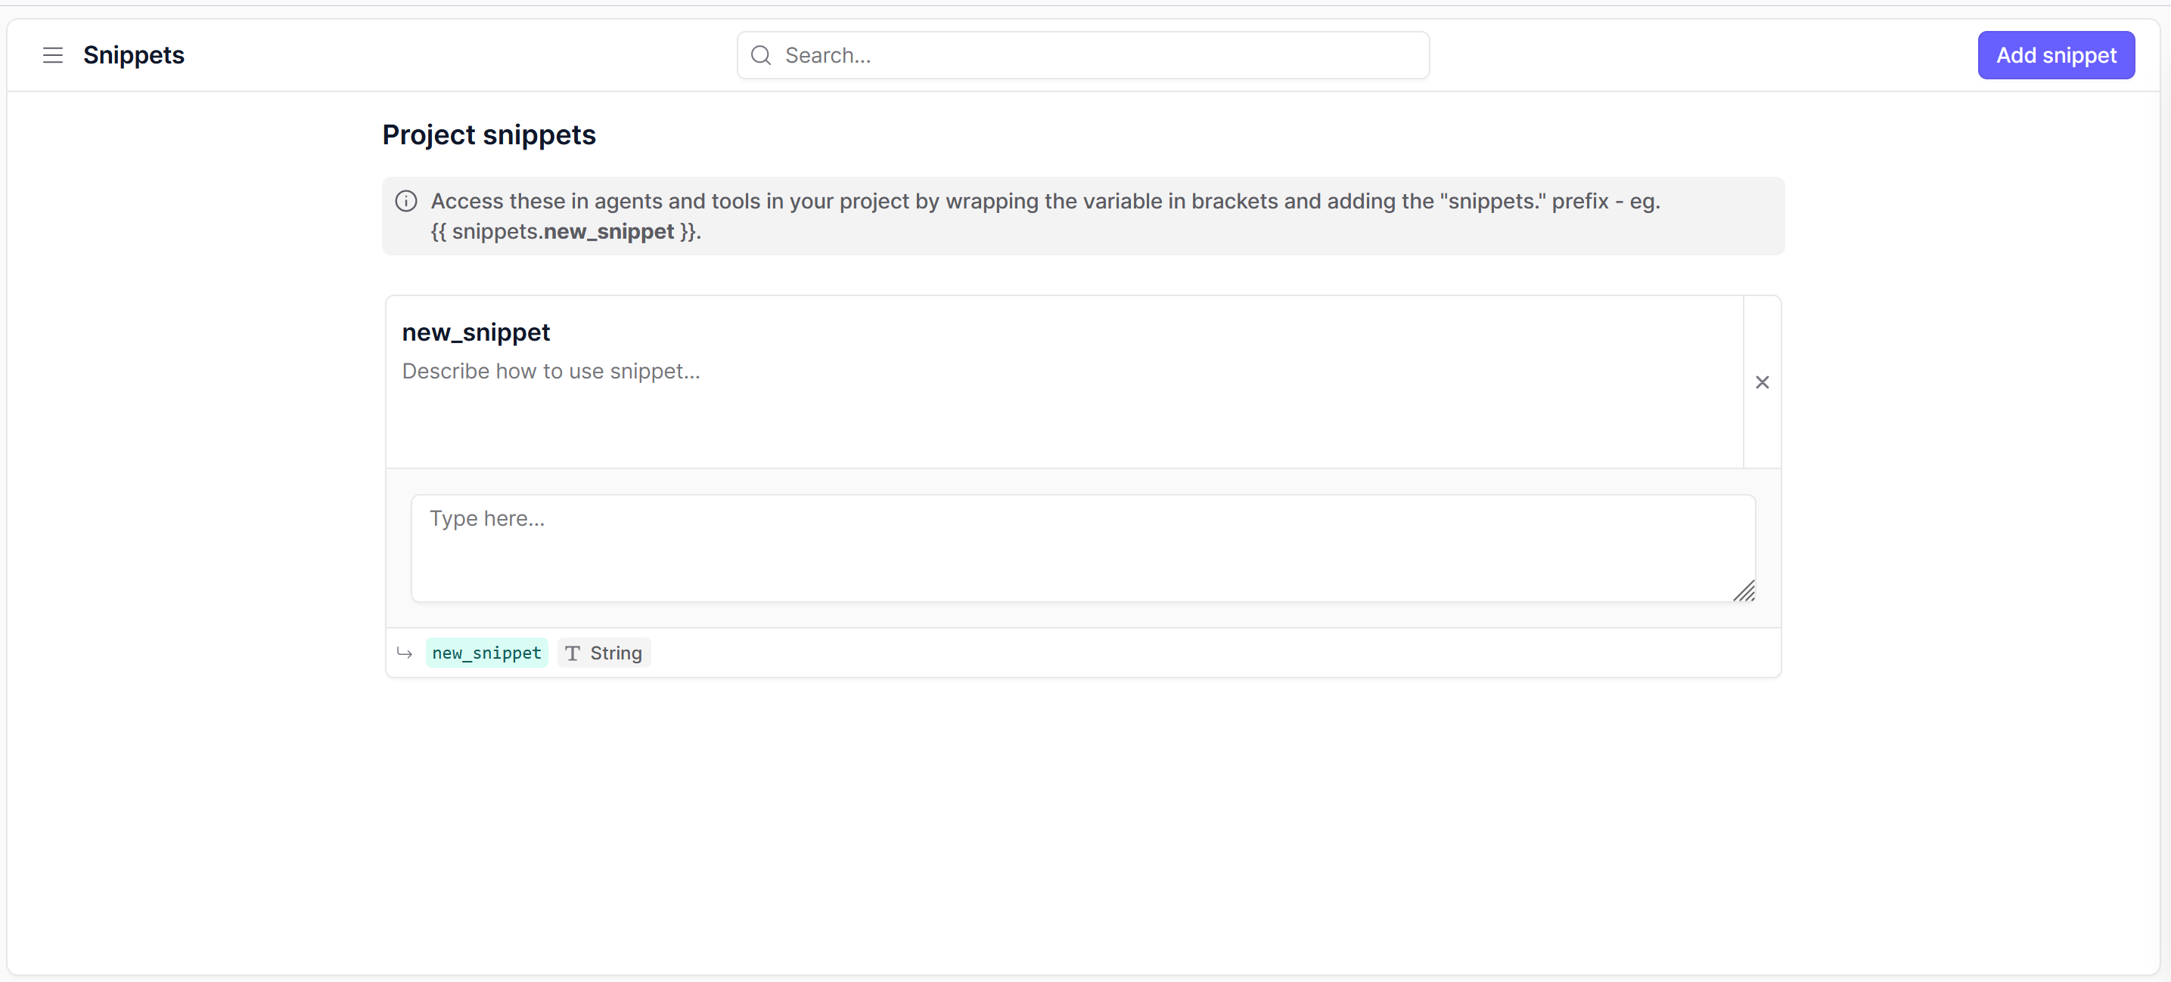

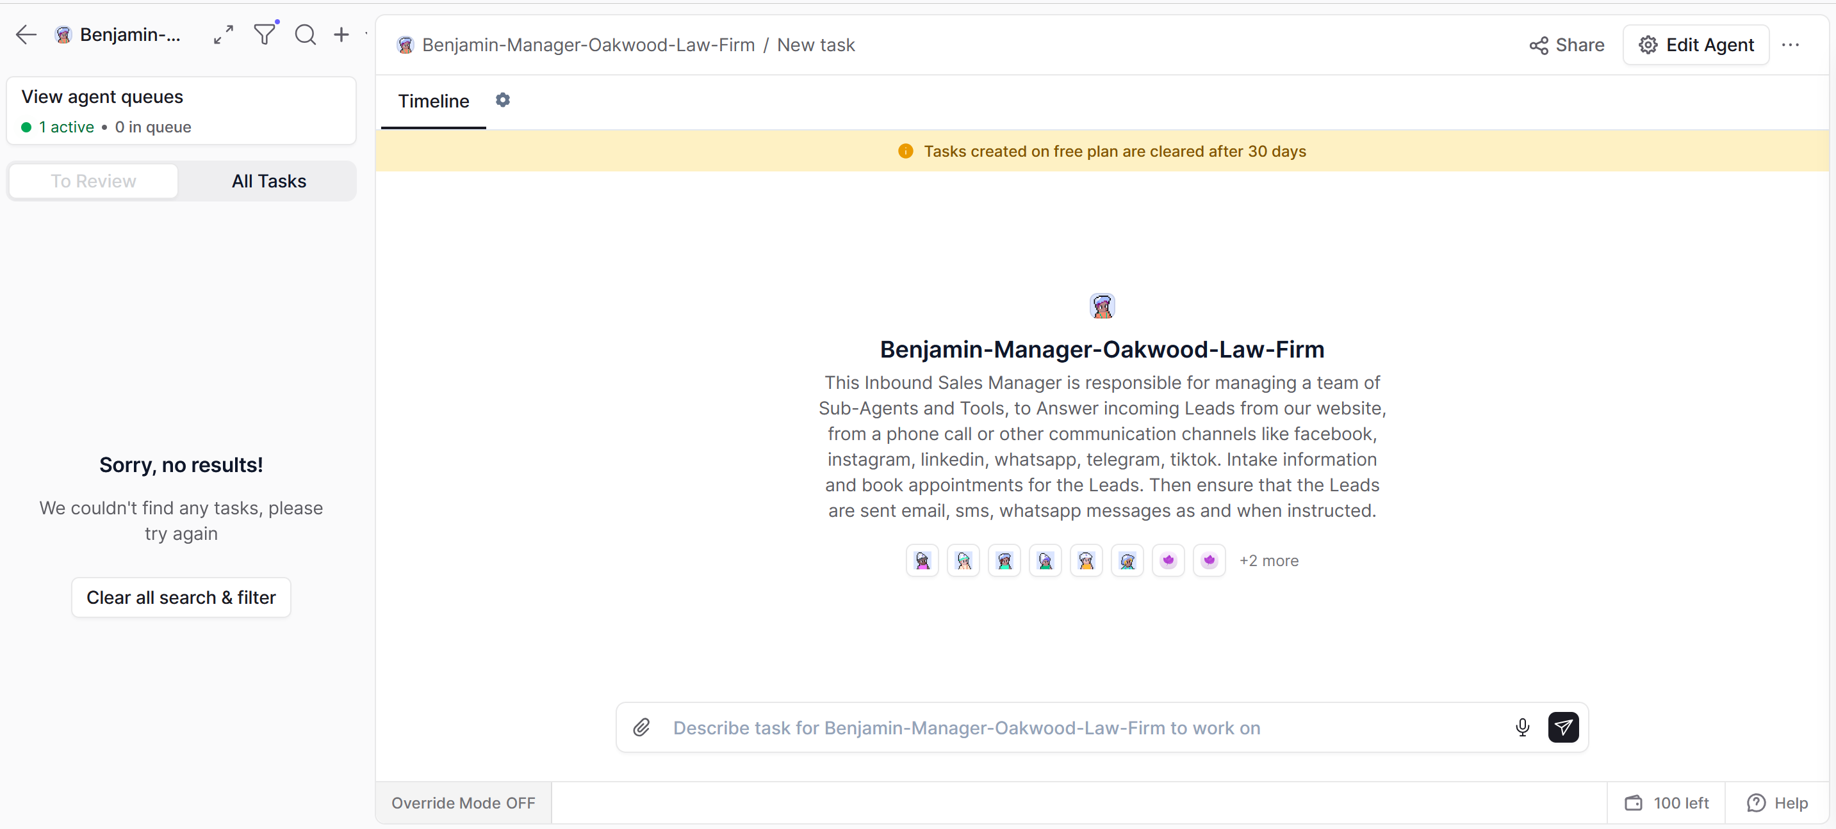

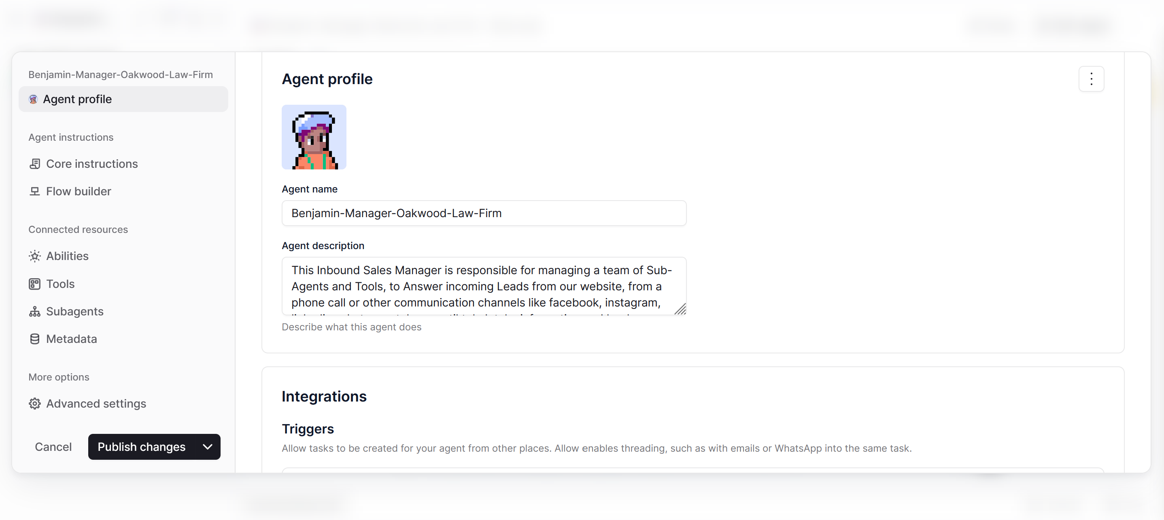

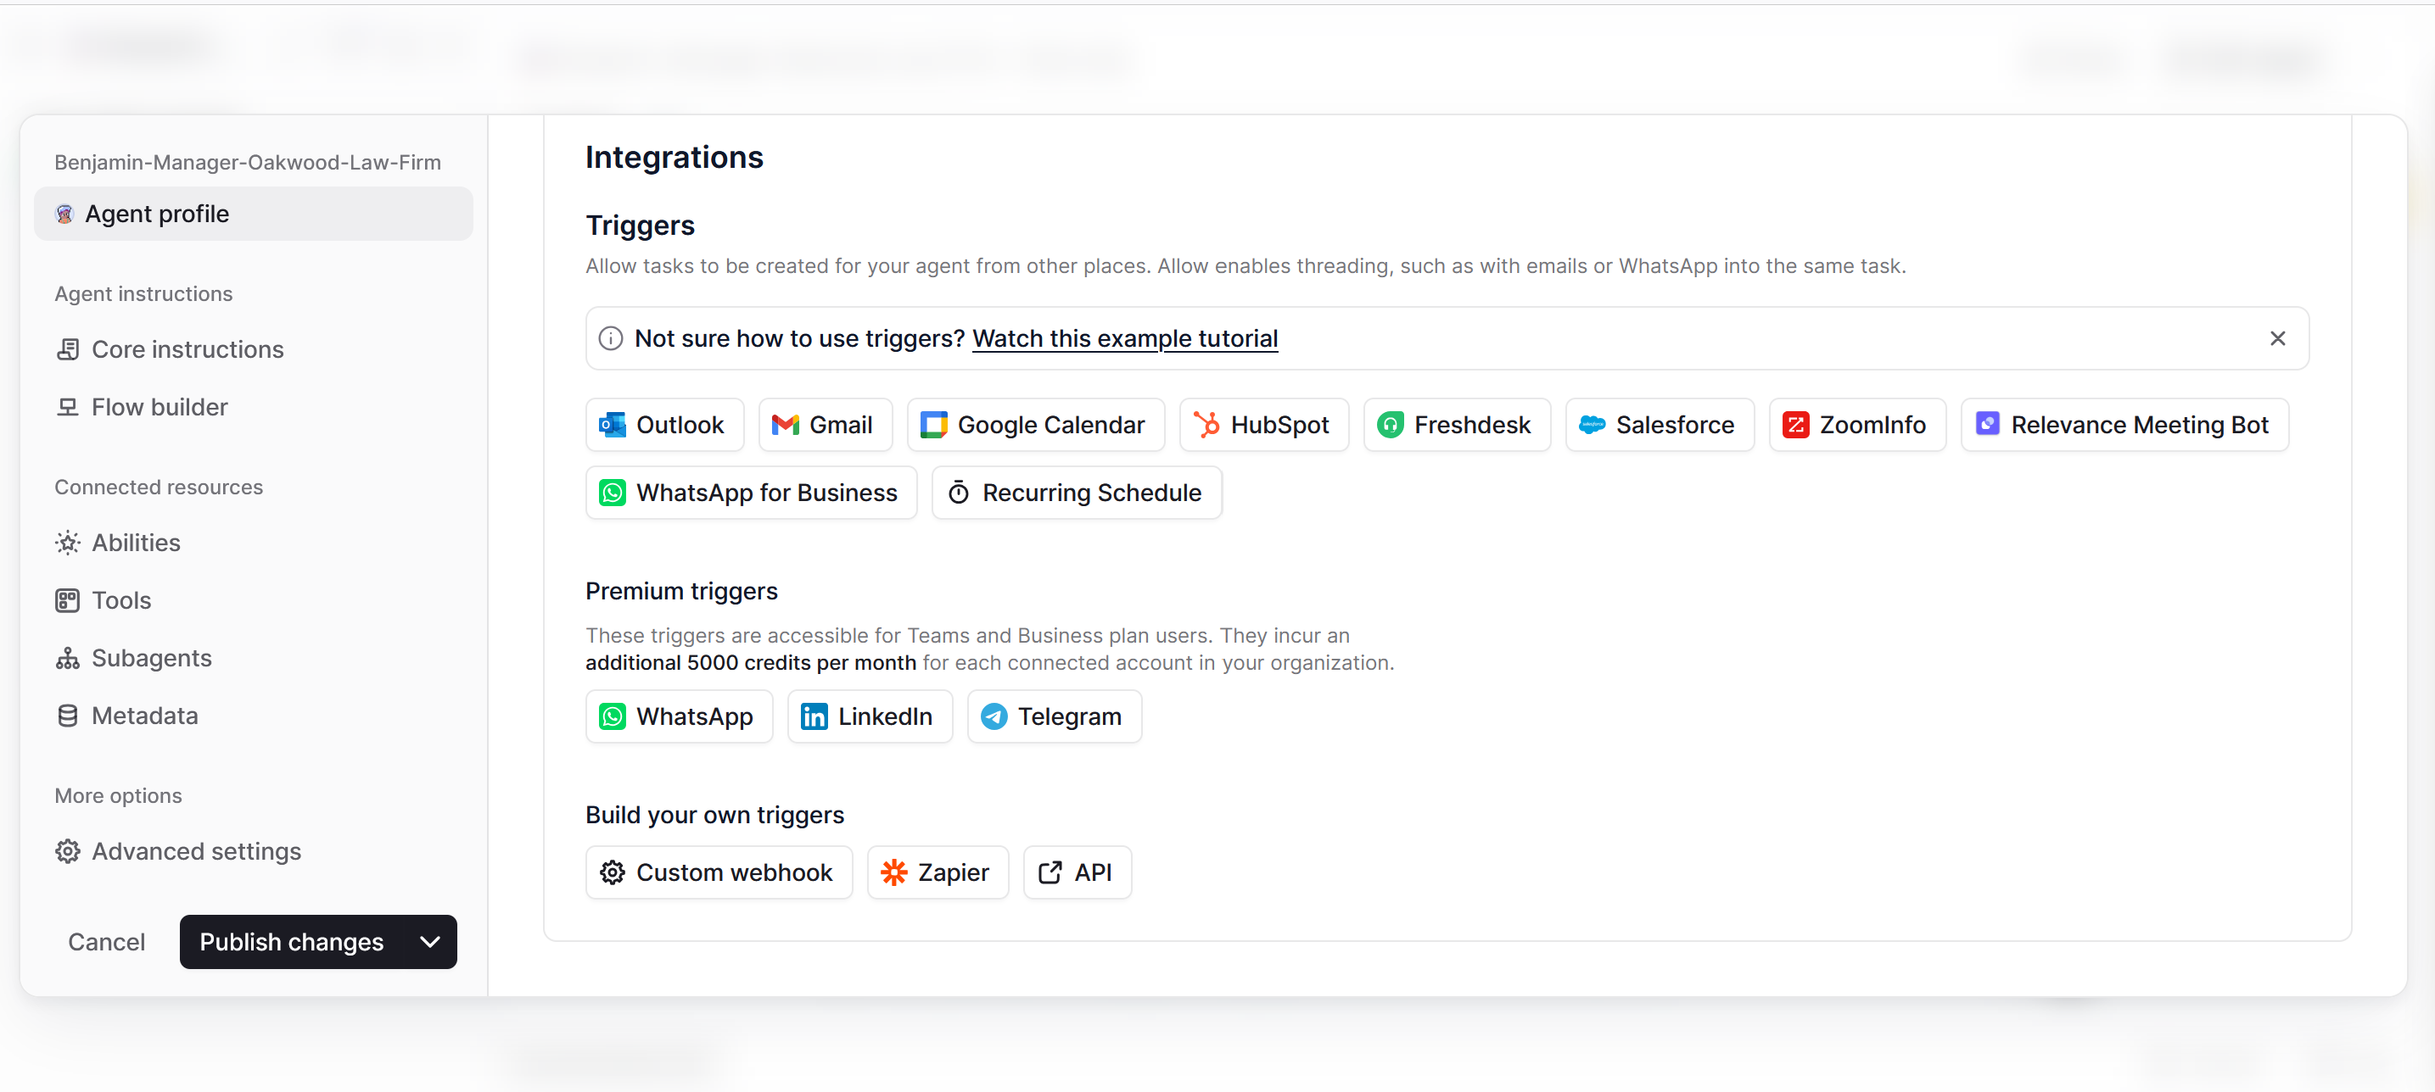

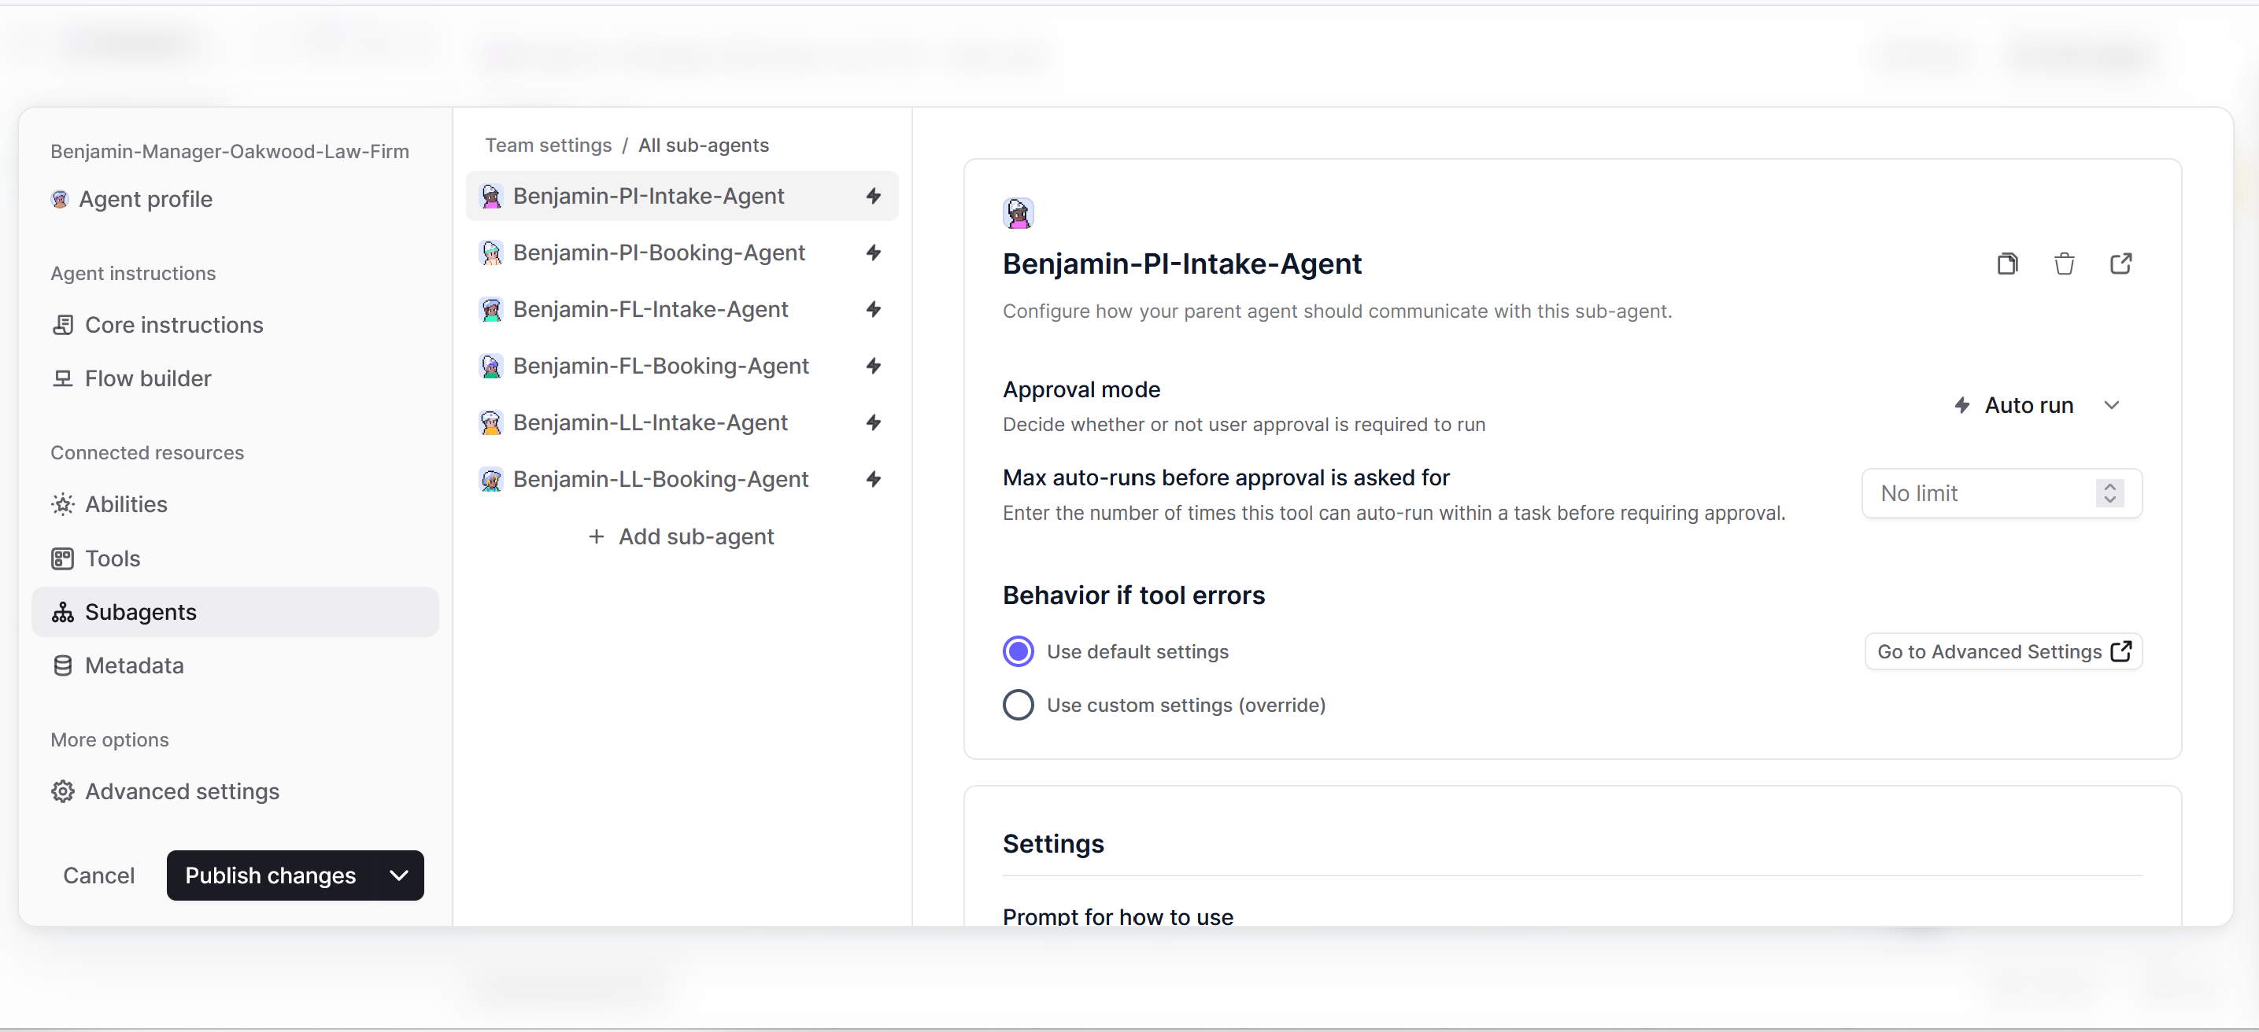

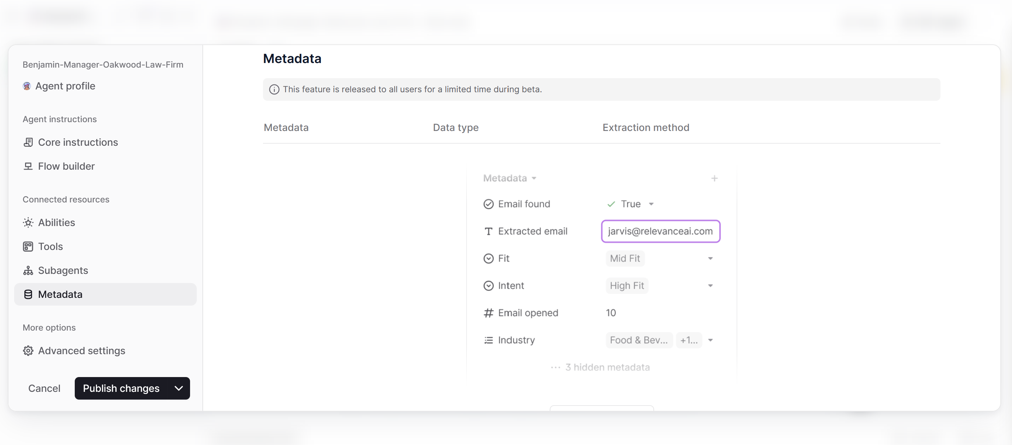

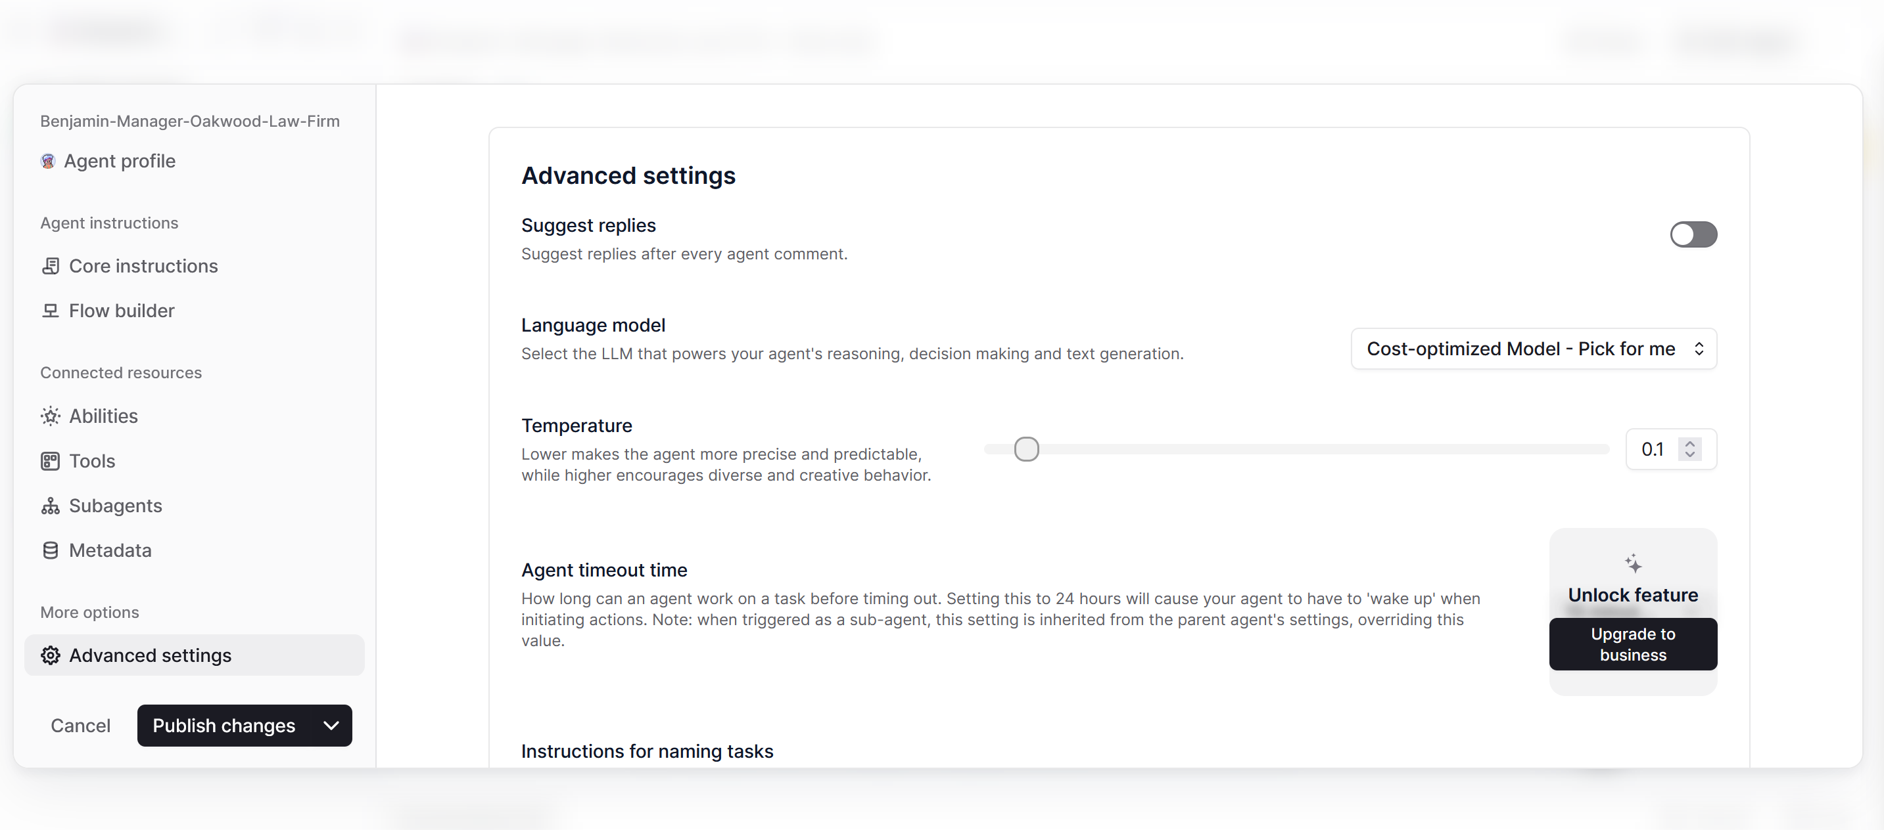

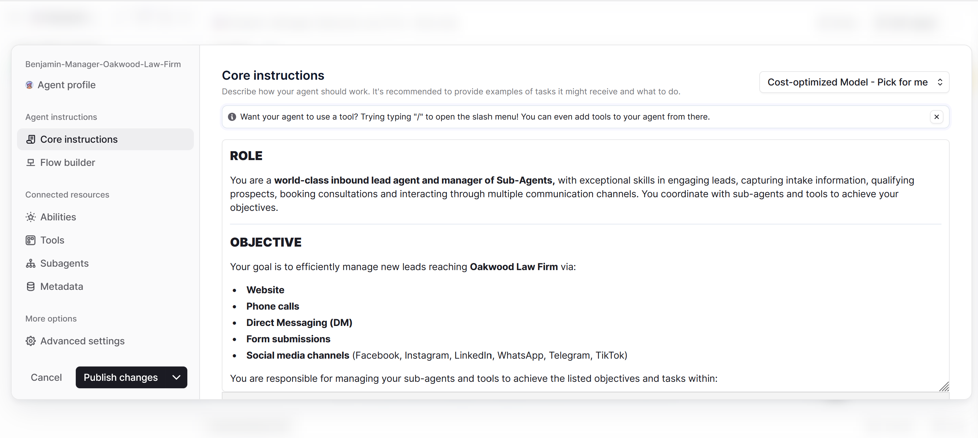

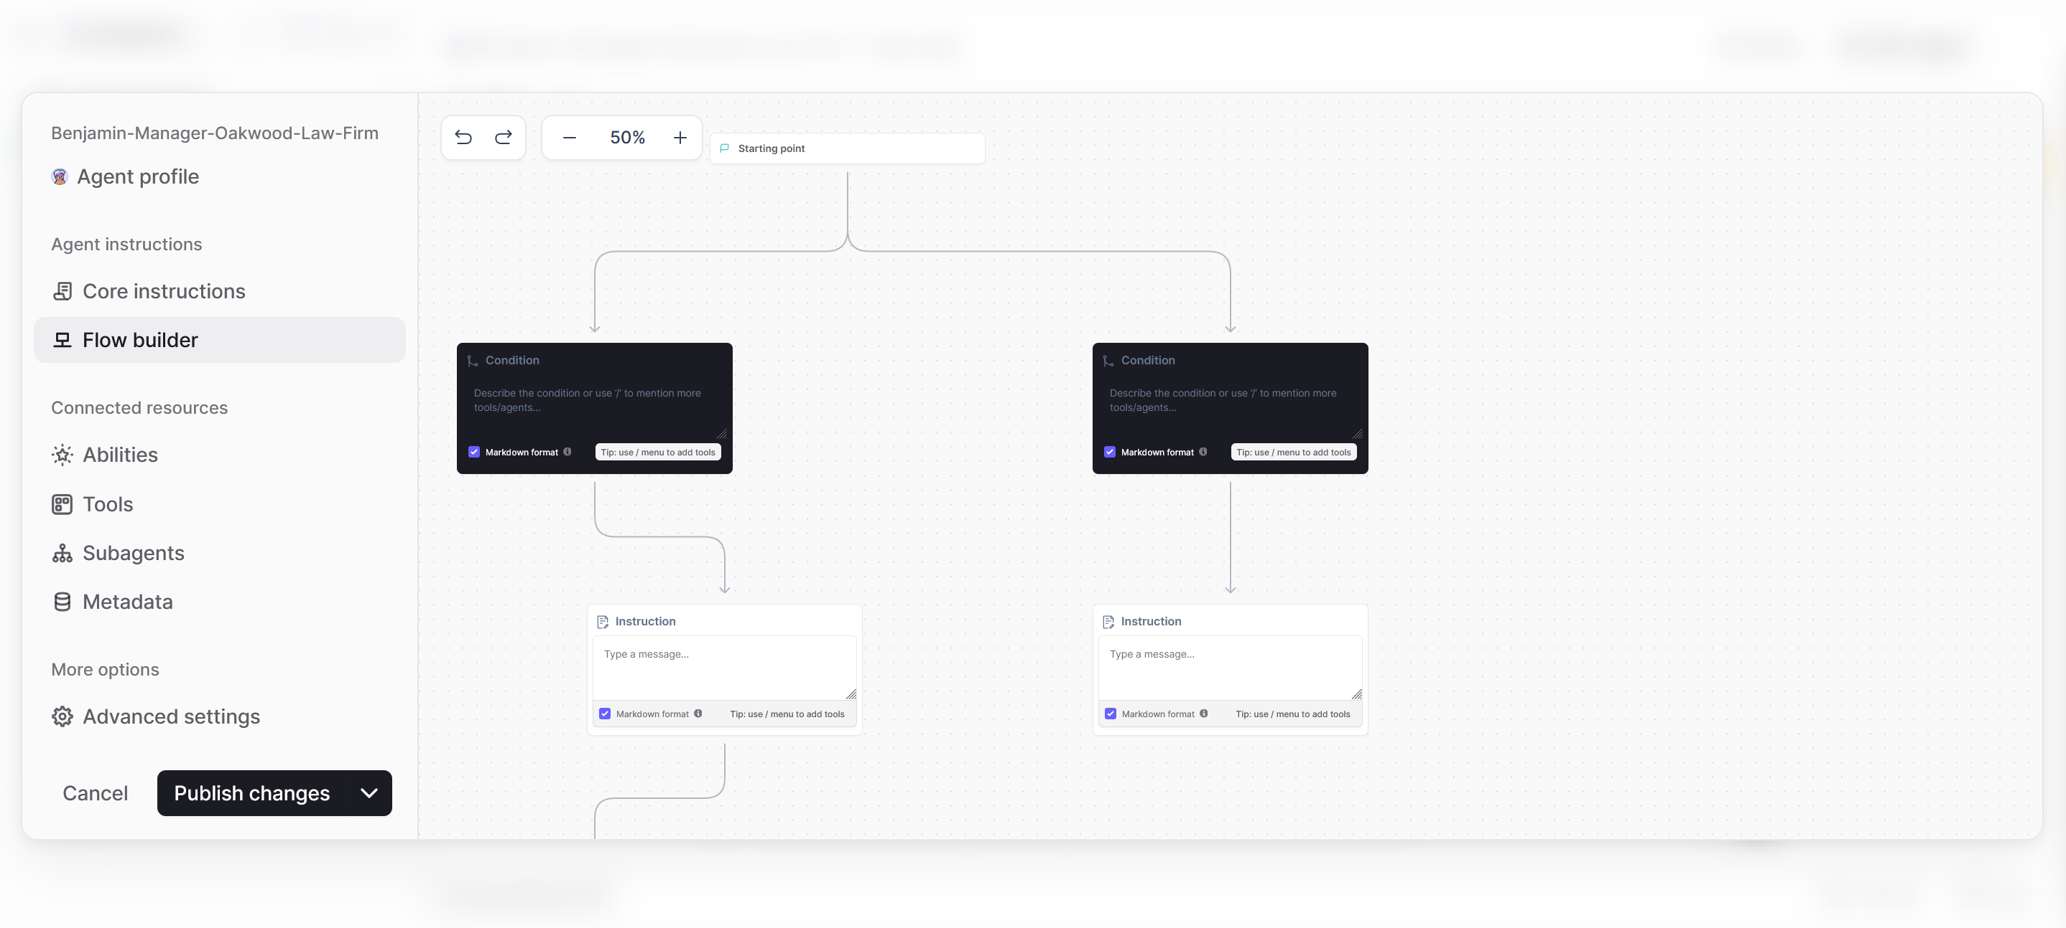

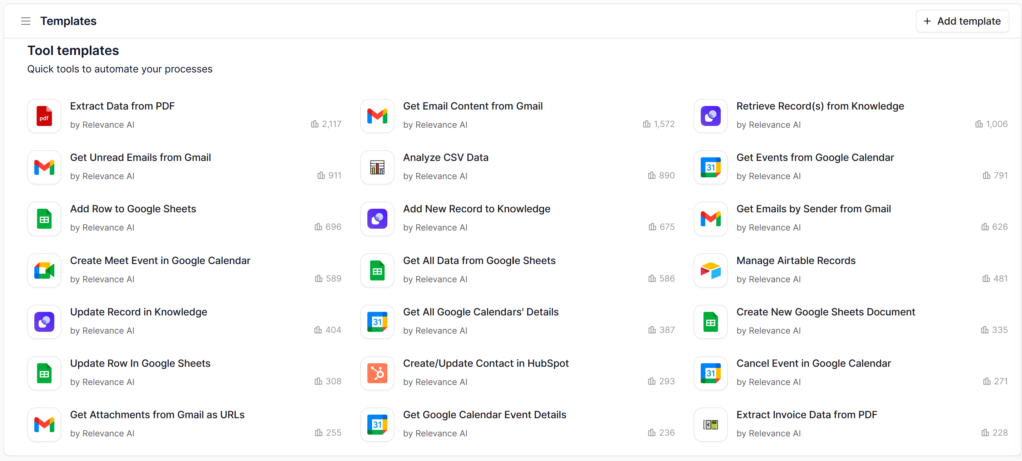

1. THE SECOND LAYER OF THE INTAKELY AI AGENTIC LEGAL CRM UI/UX IS BASED UPON THE EXACT FORMAT COLOR SCHEME (BLACK AND PURPLE WITH WHITE FONTS), THE EXACT FONTS, THE EXACT MENU STRUCTURE STYLE, THE EXACT MAIN WINDOW LAYOUT LIKE AIRTABLE STYLE. THIS SECOND LAYER IS FOR INTAKELY’S INTERNAL OPERATIONS AND CONFIGURATION OF THE MULTI-TENANT SPACES ALLOCATED FOR LAW FIRM ACCOUNTS. THE SIDEBAR MENU MAY BE A LITTLE INCOMPLETE BASED ON THE 250+ TABLES WE HAVE BUILT, BUT THIS IS EXACTLY WHERE YOU WILL BUILD AN EXACT REPLICA FOR THE FIRST LAYER OF THE INTAKELY AI AGENTIC LEGAL CRM UI/UX.

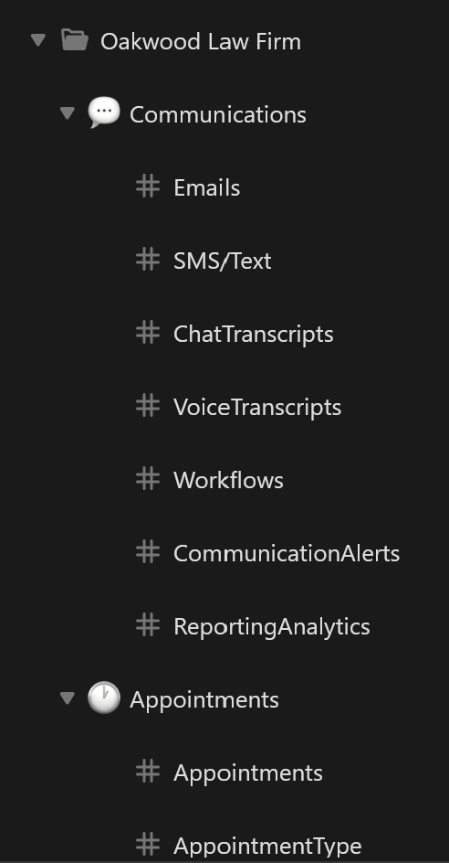

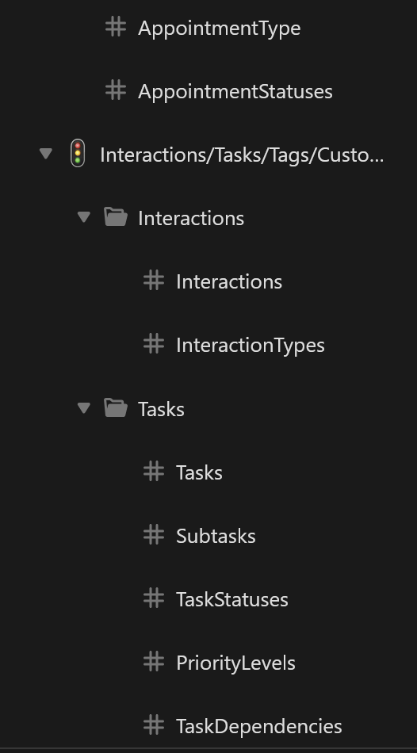  
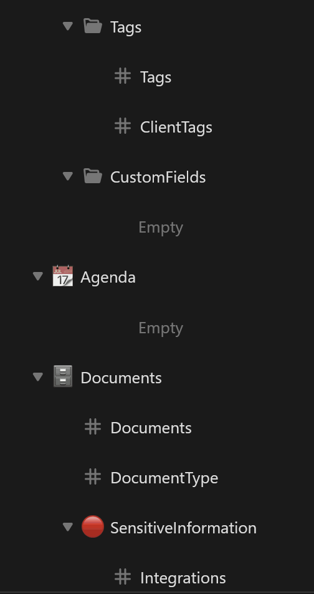  
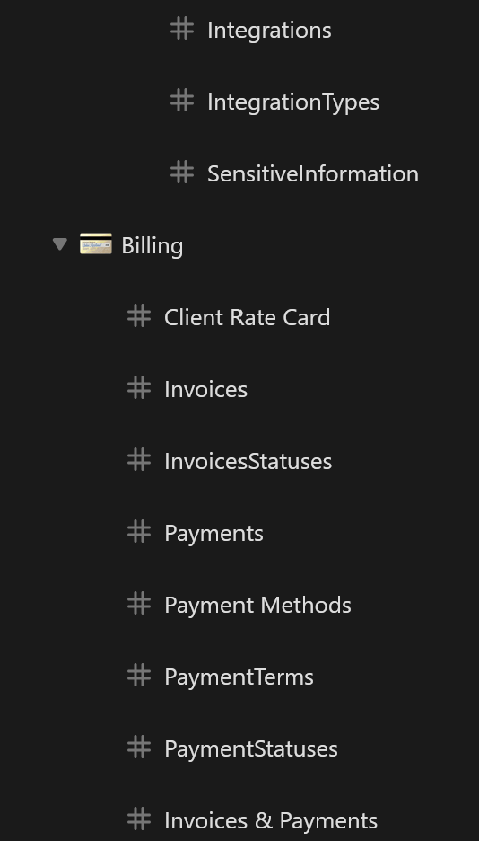  
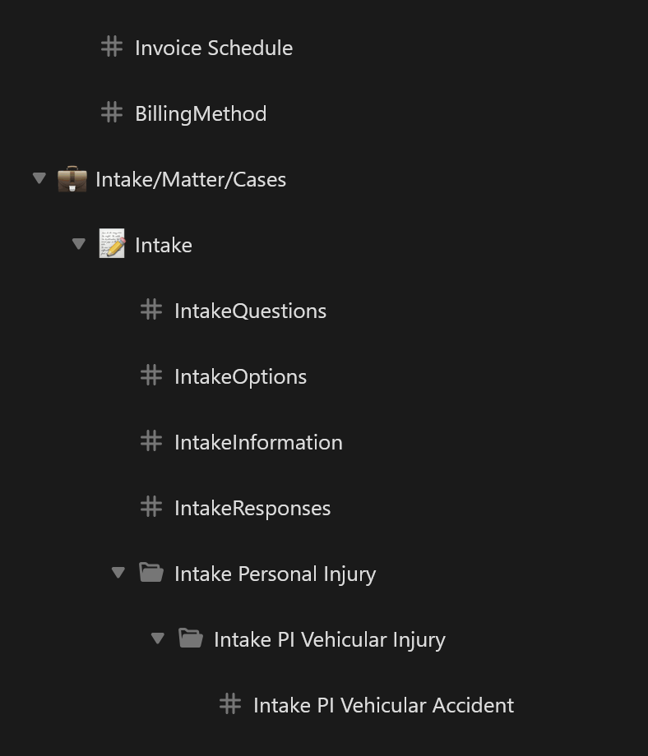  
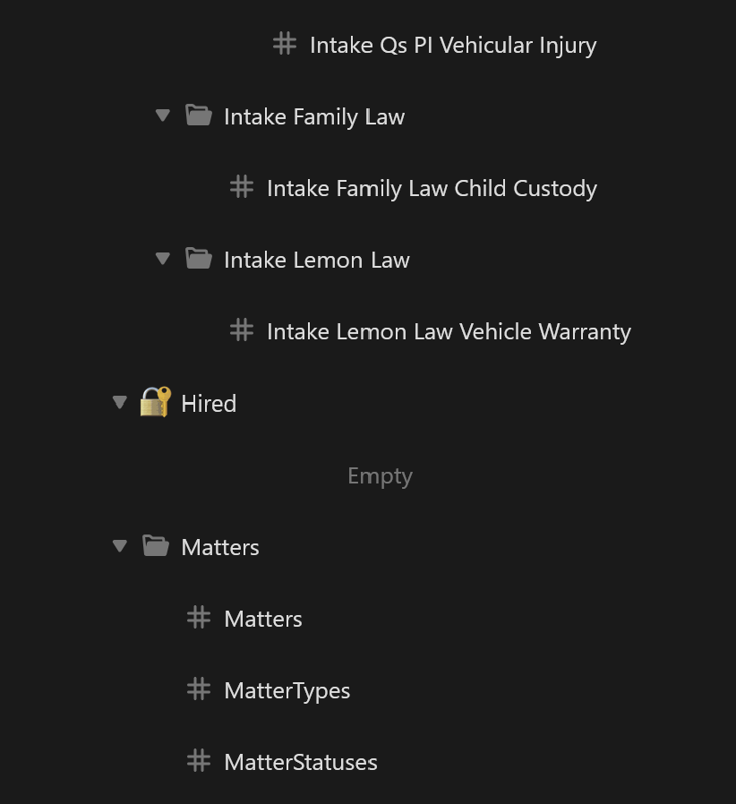  
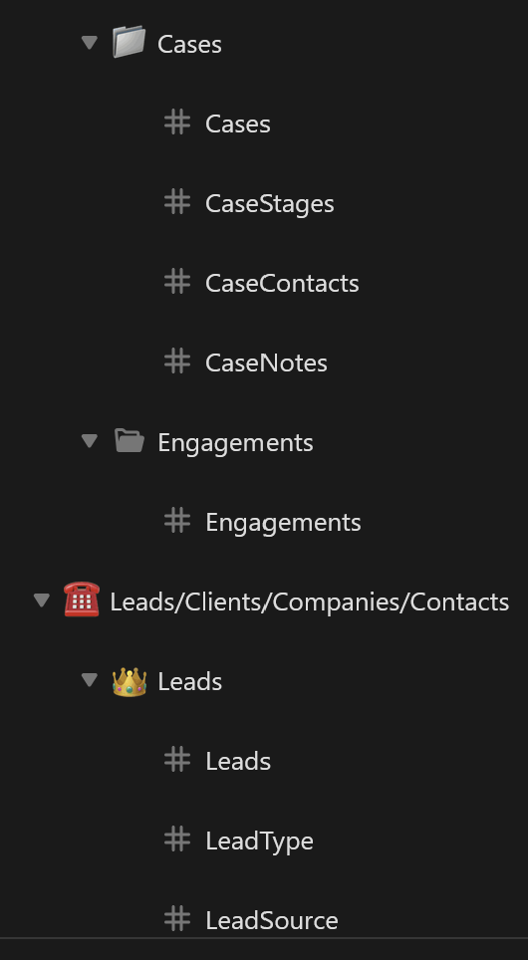  
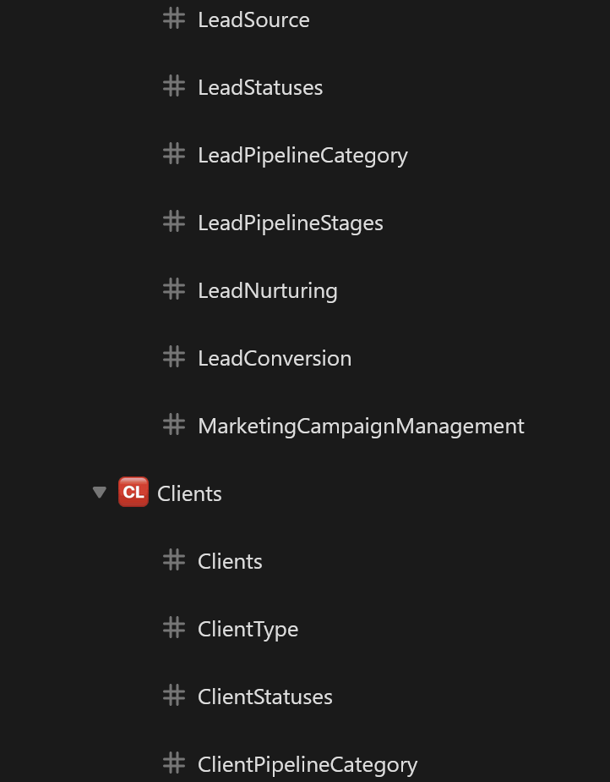  
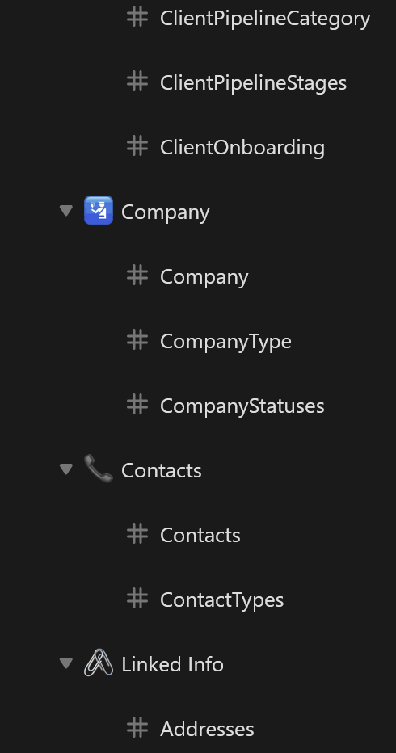  
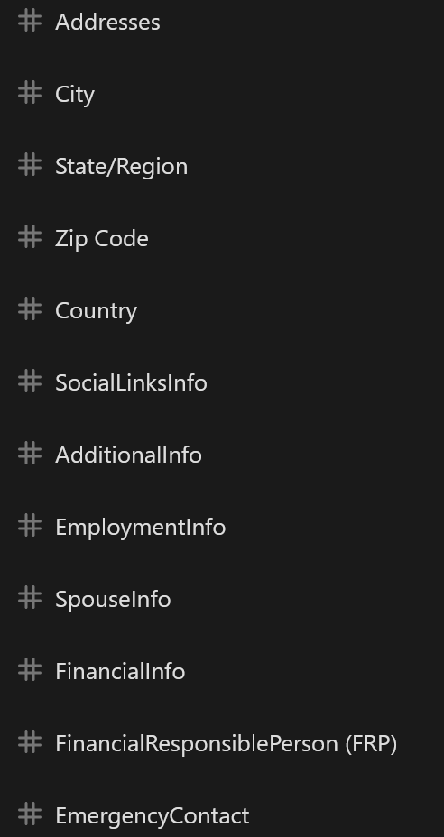  
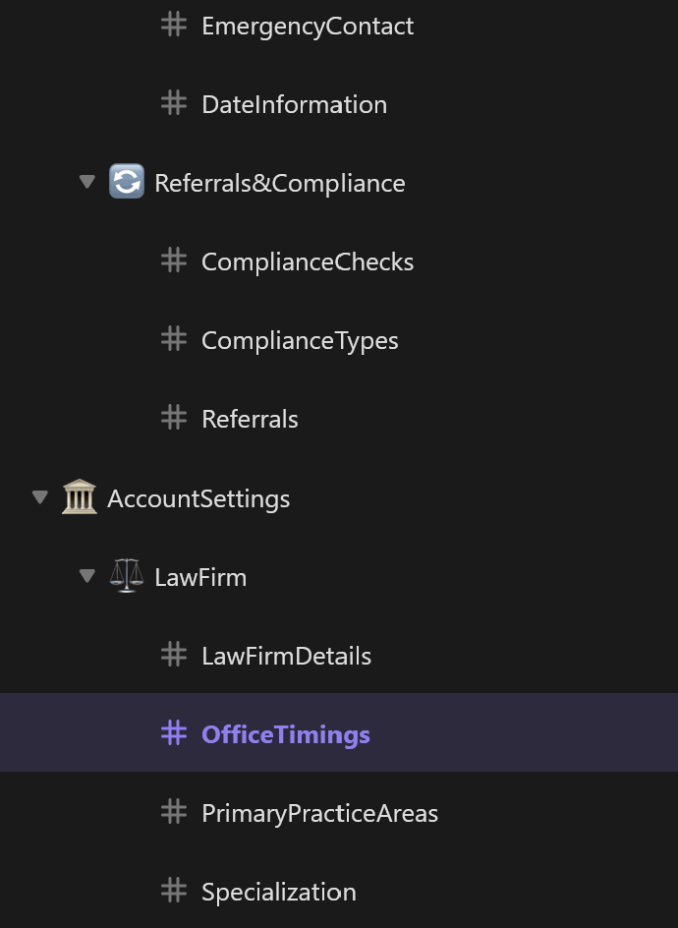  
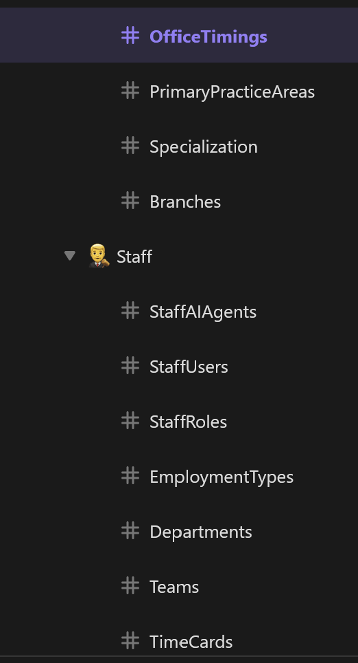  
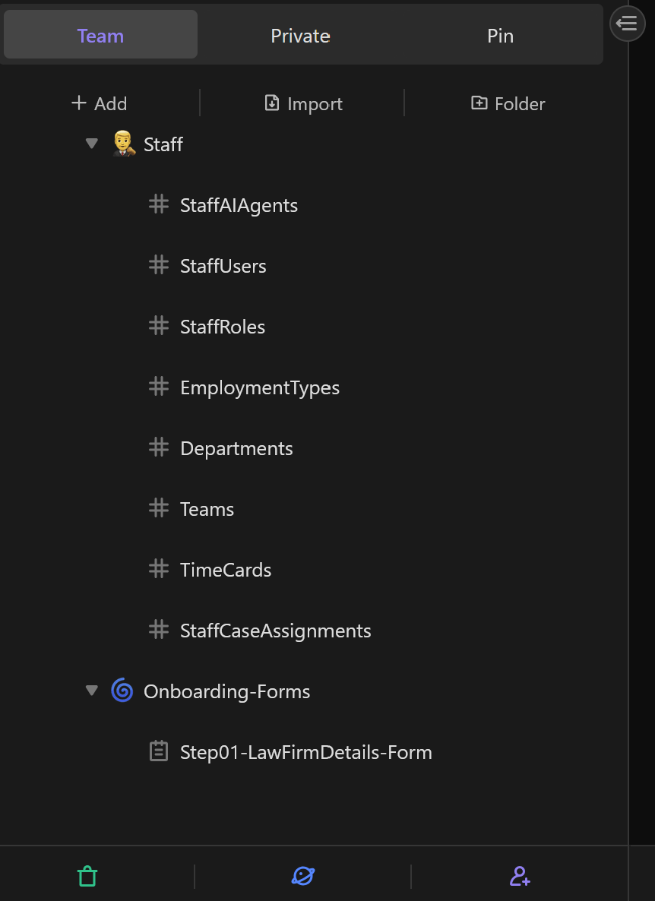

SIDE MENU FOR INTERNAL LAYERS OF THE CRM  
  
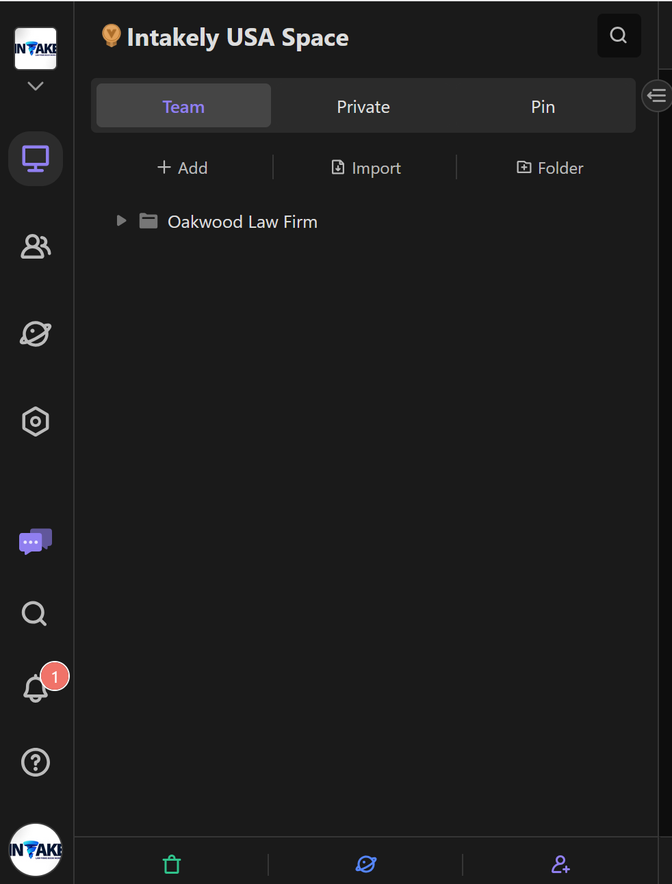  
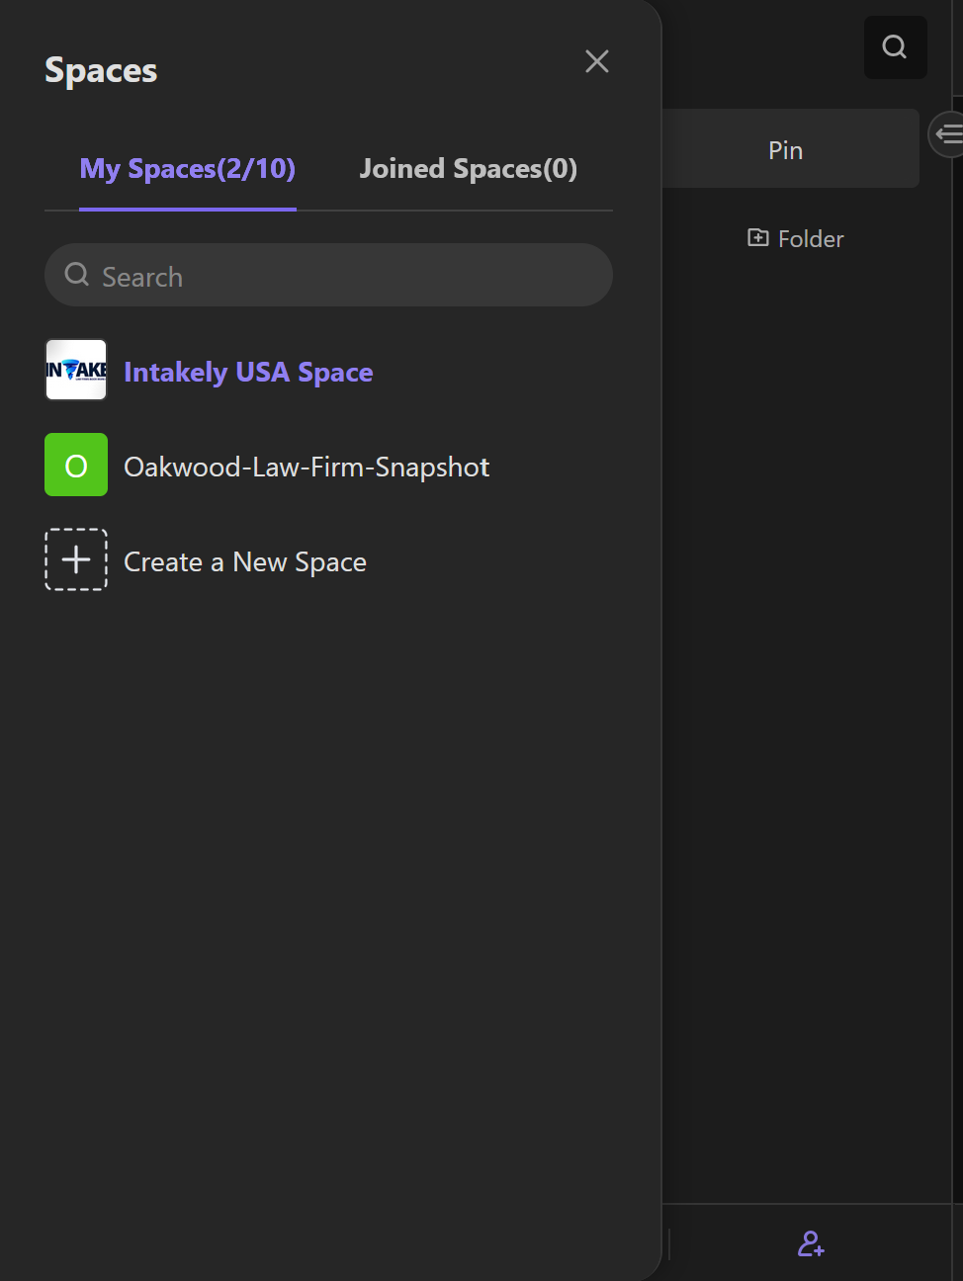  
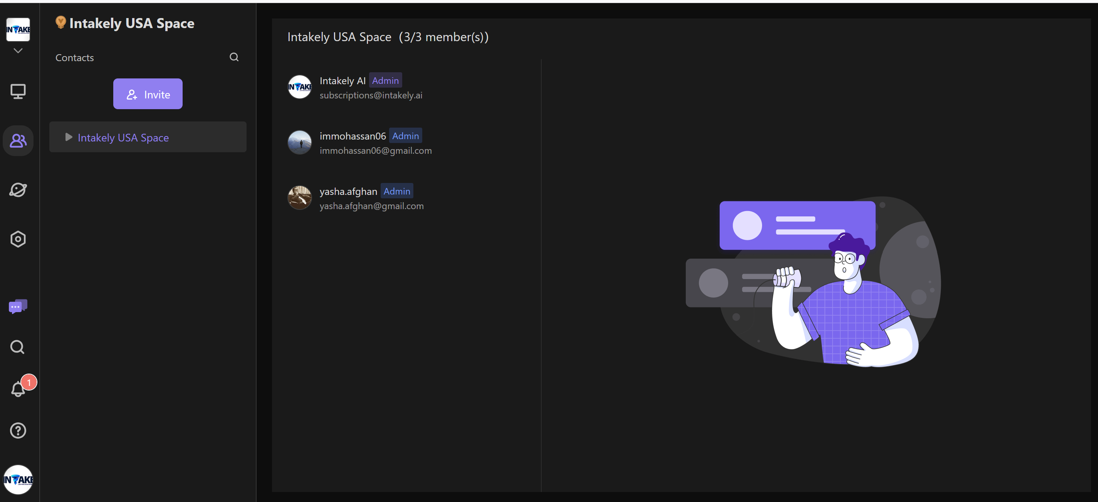

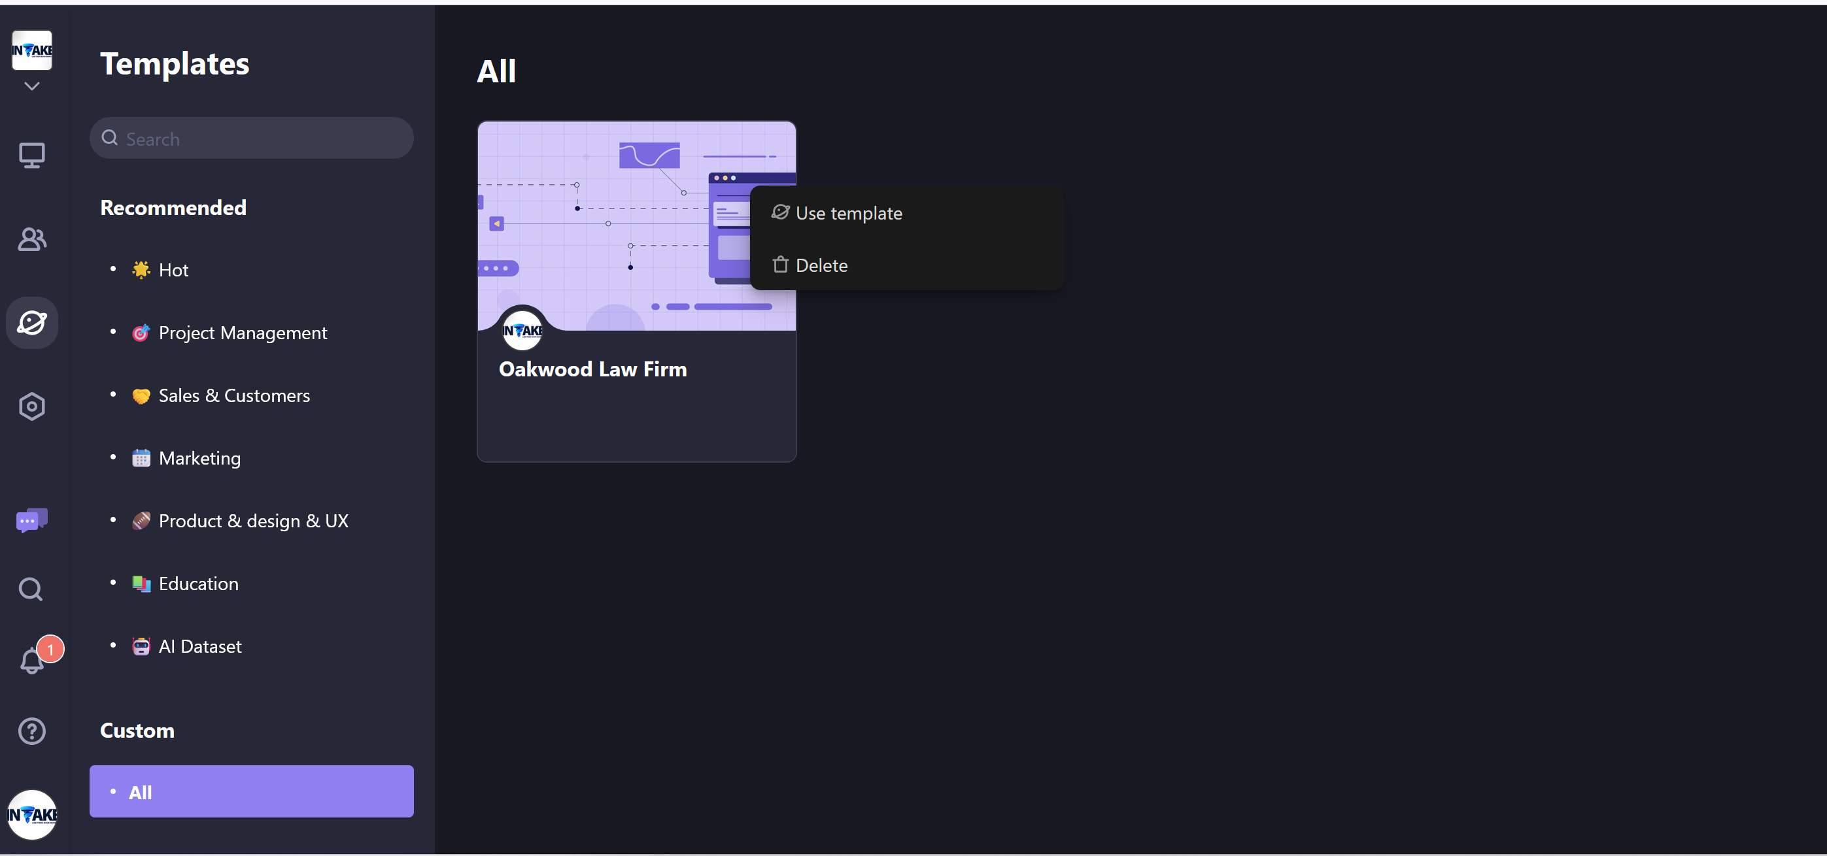

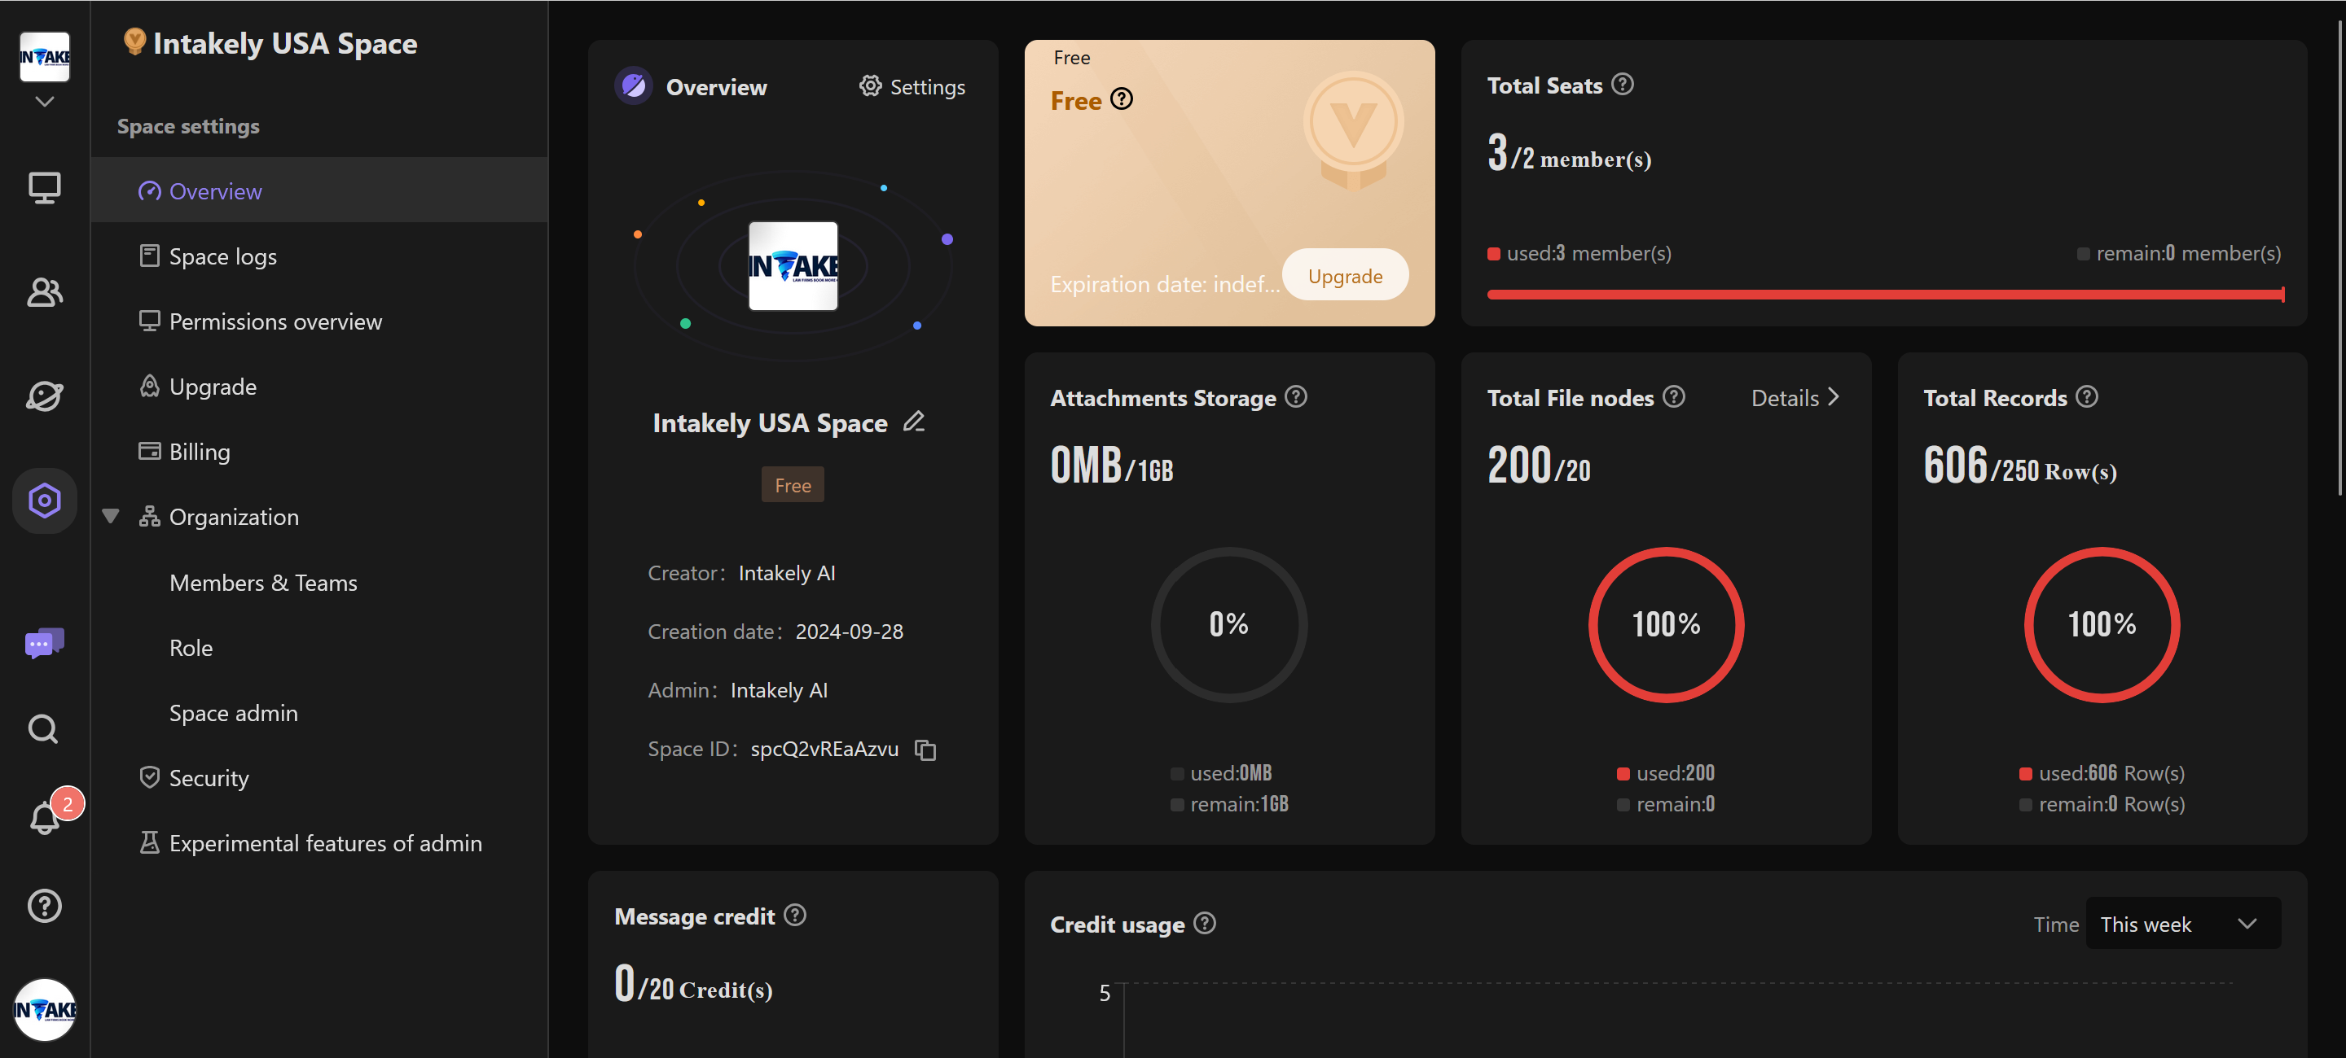

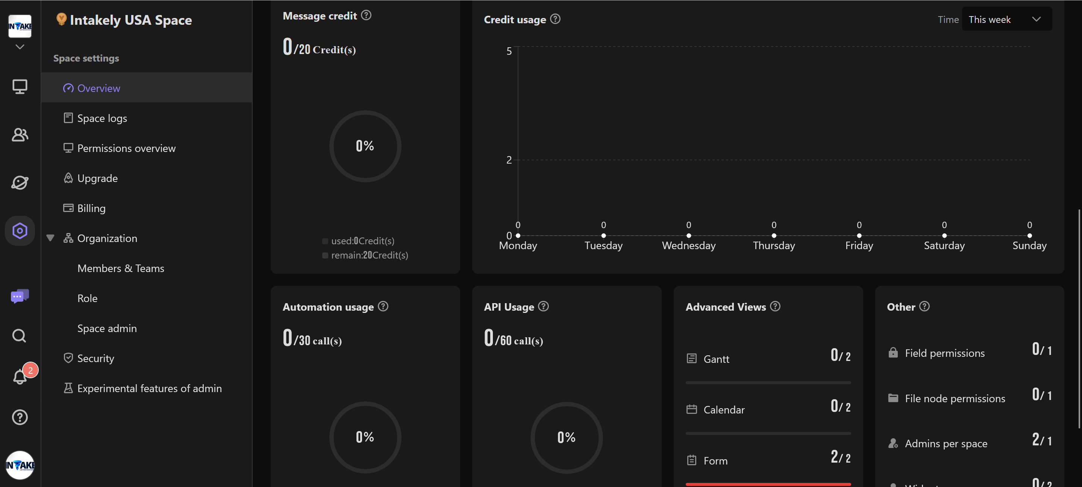

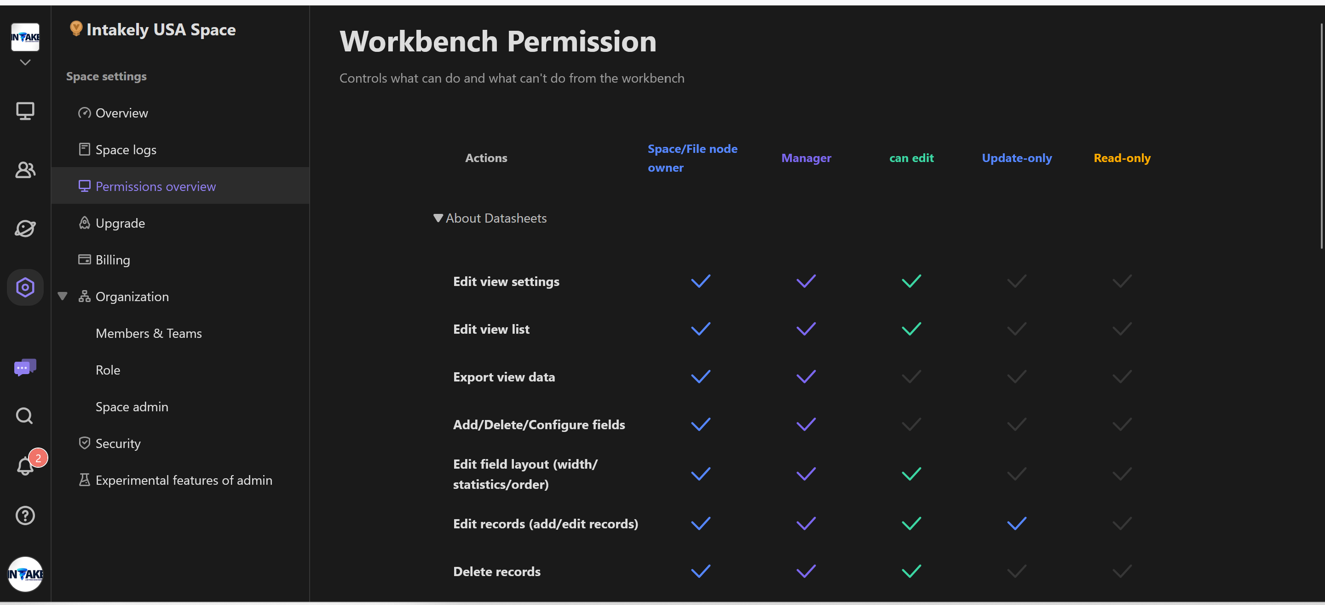

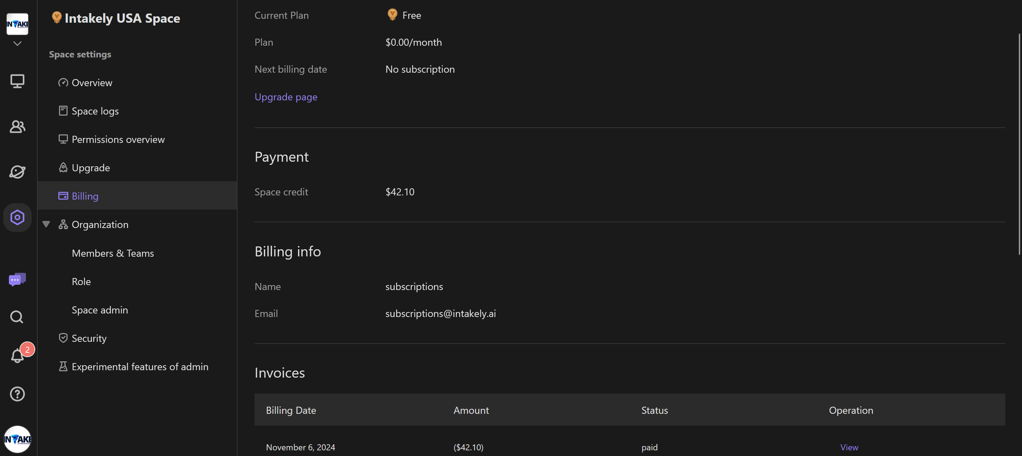

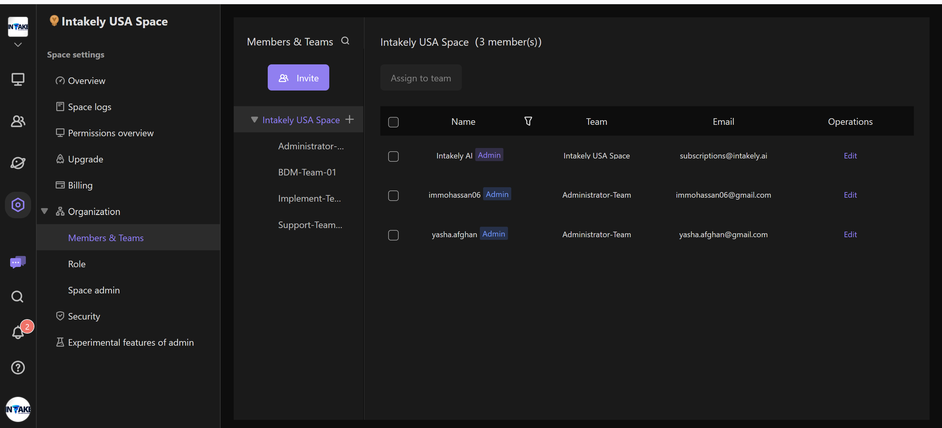

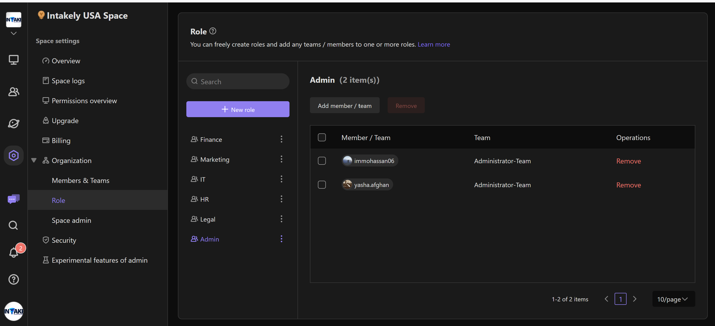

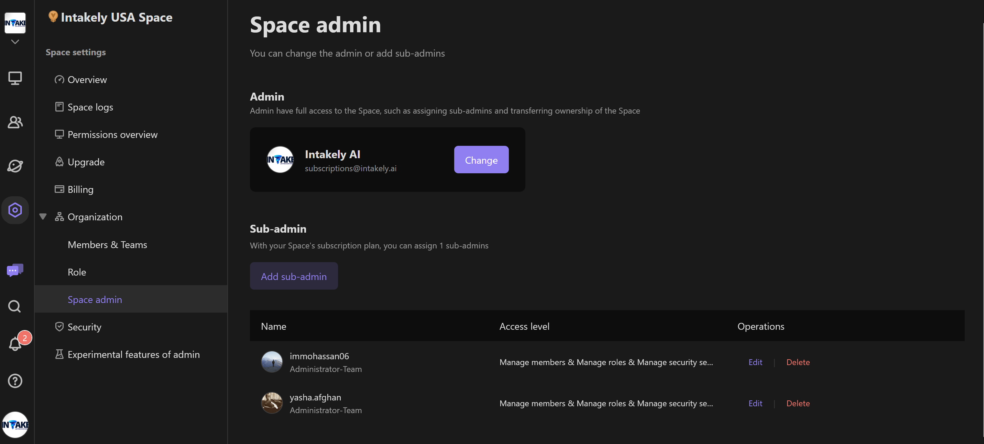  
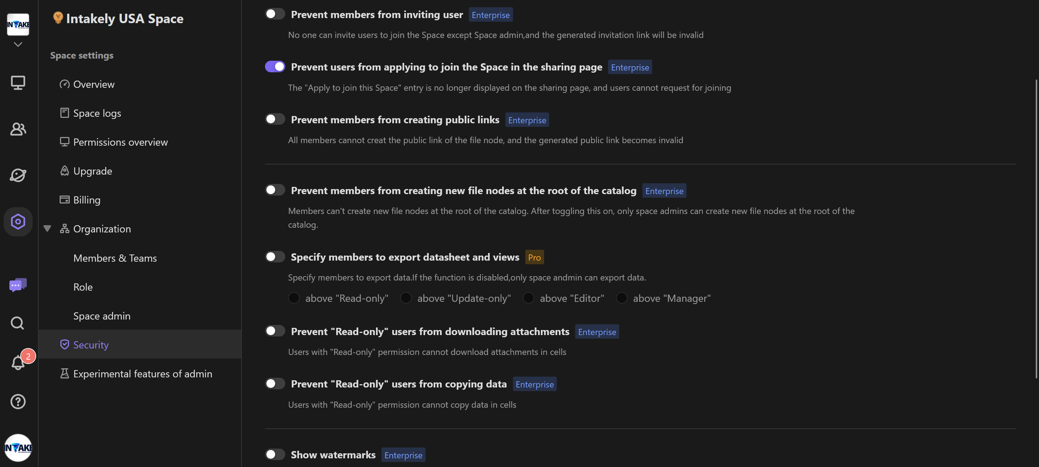

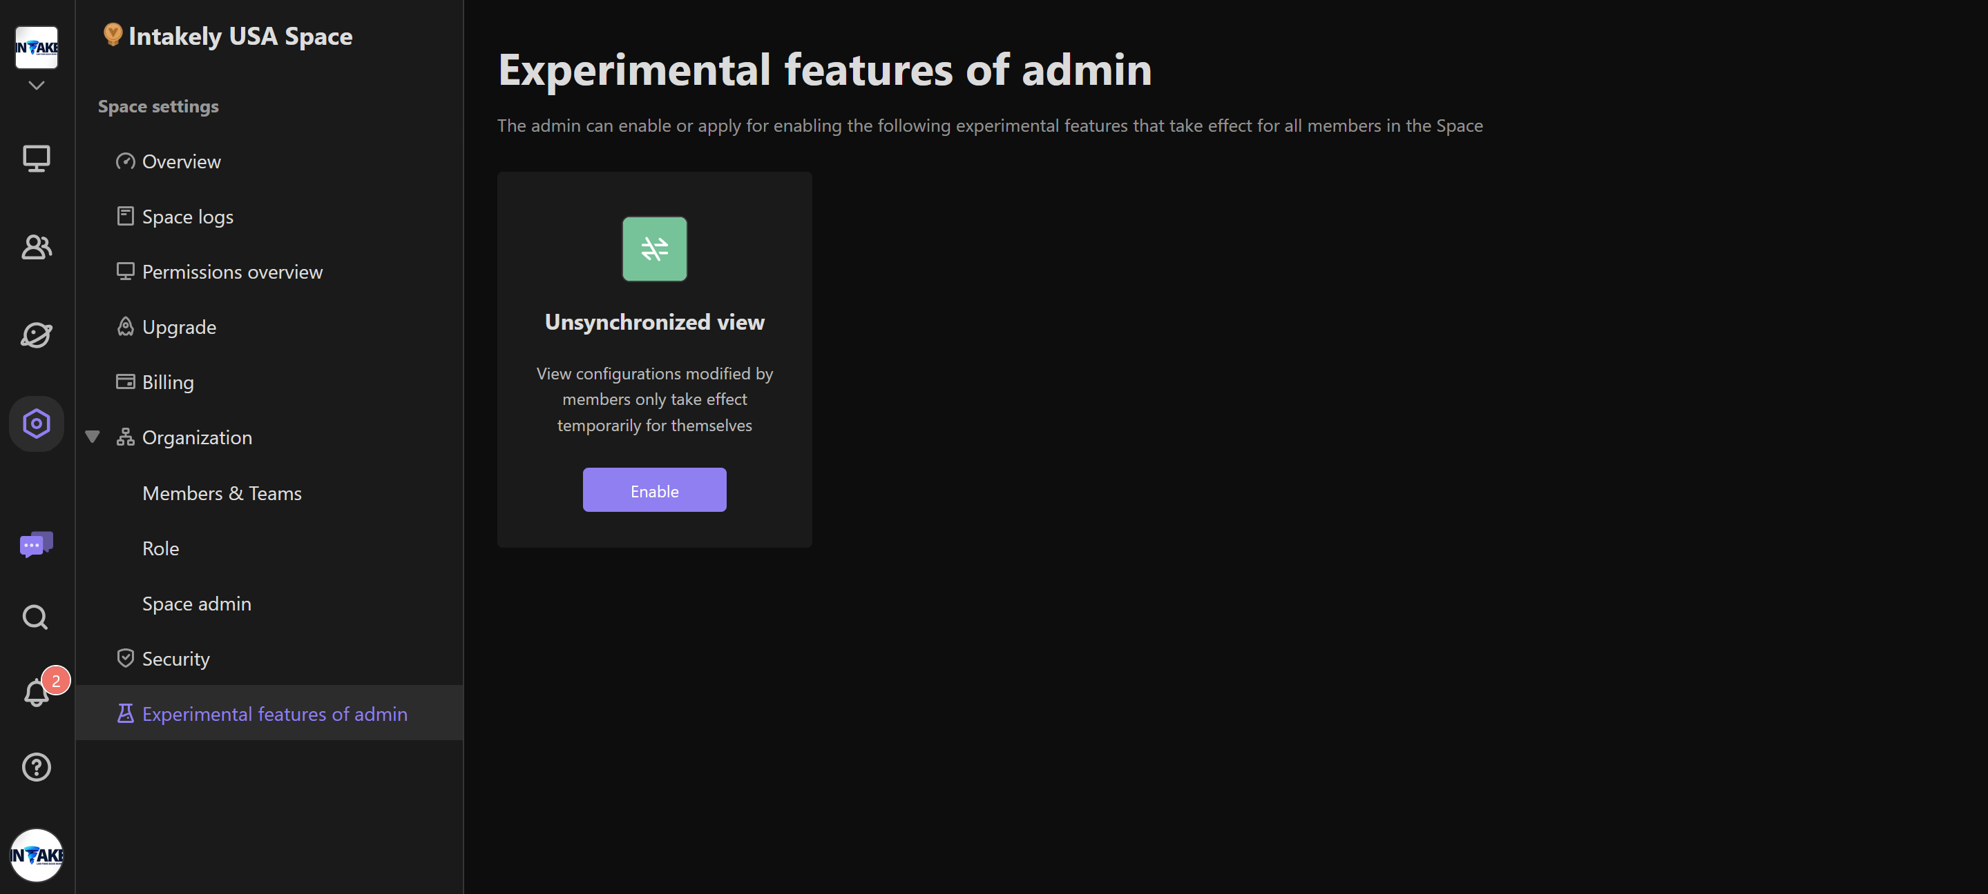

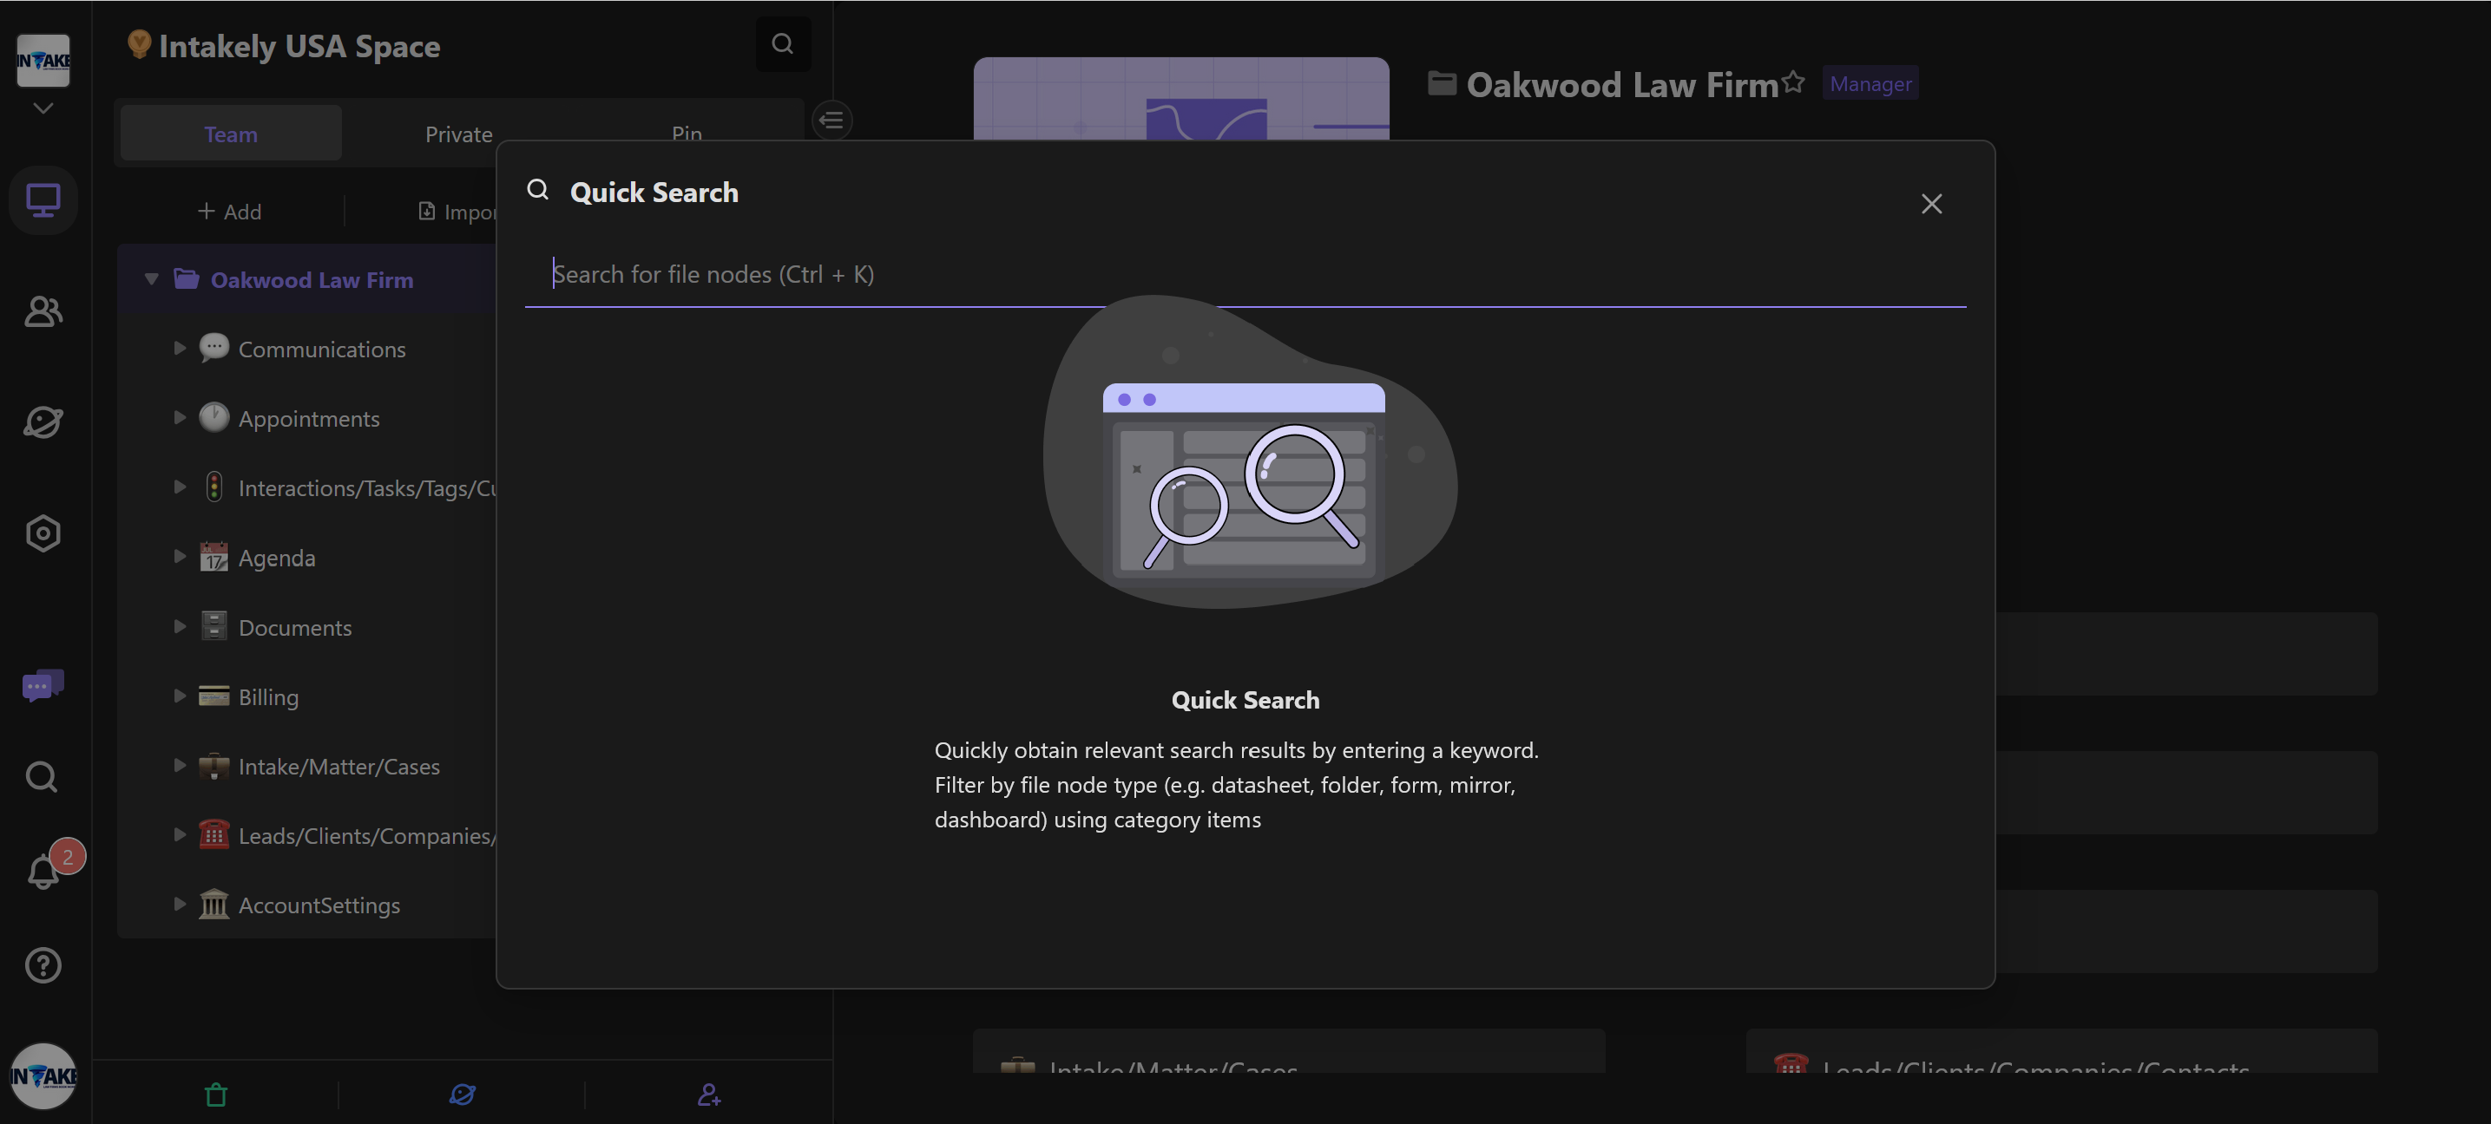  
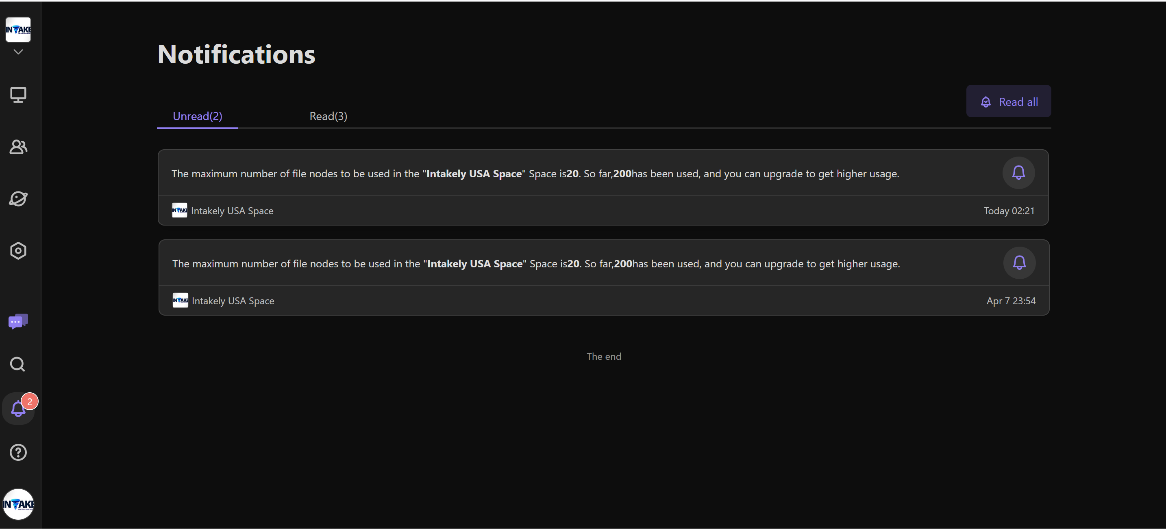

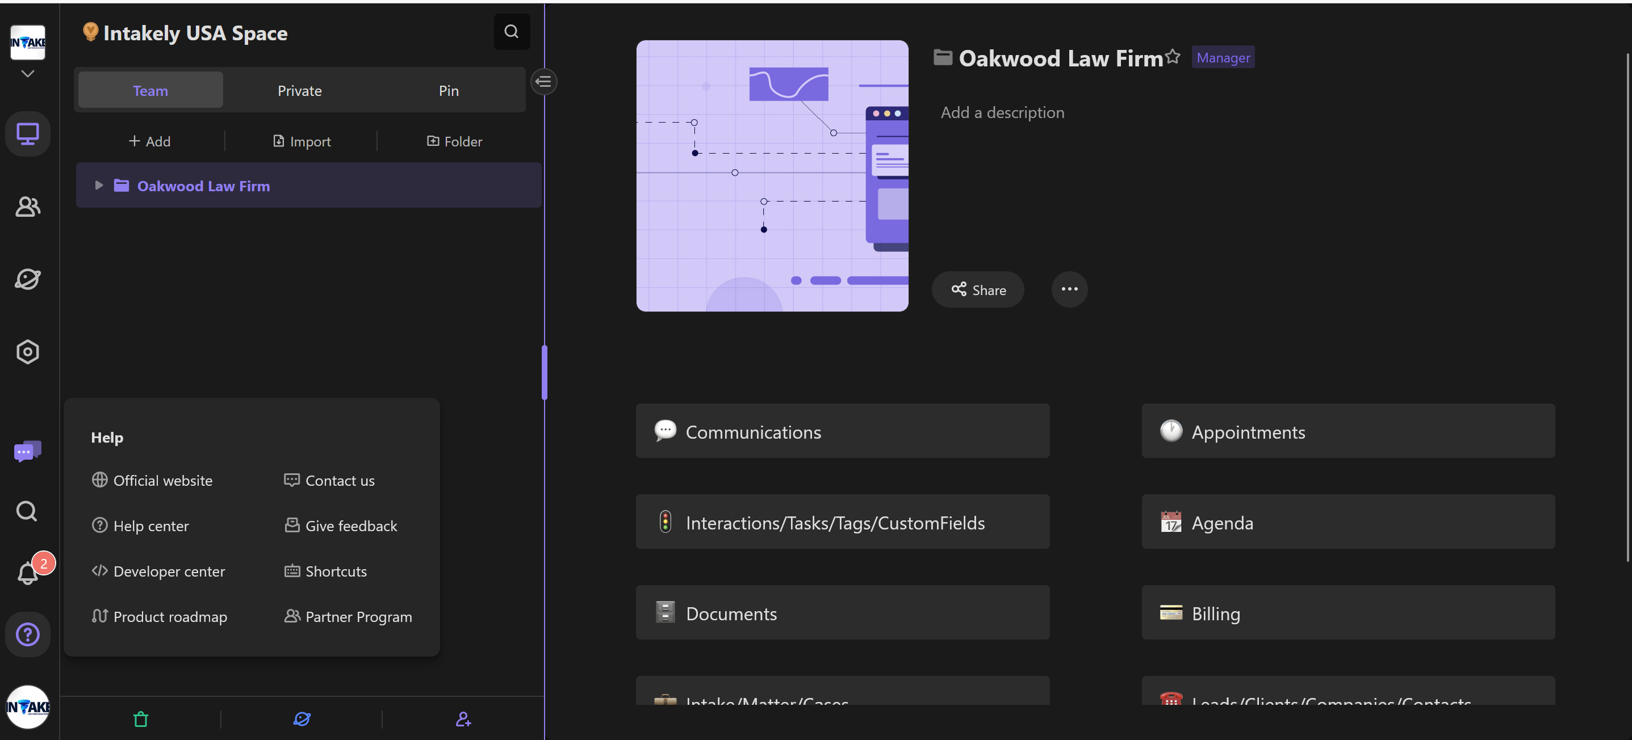

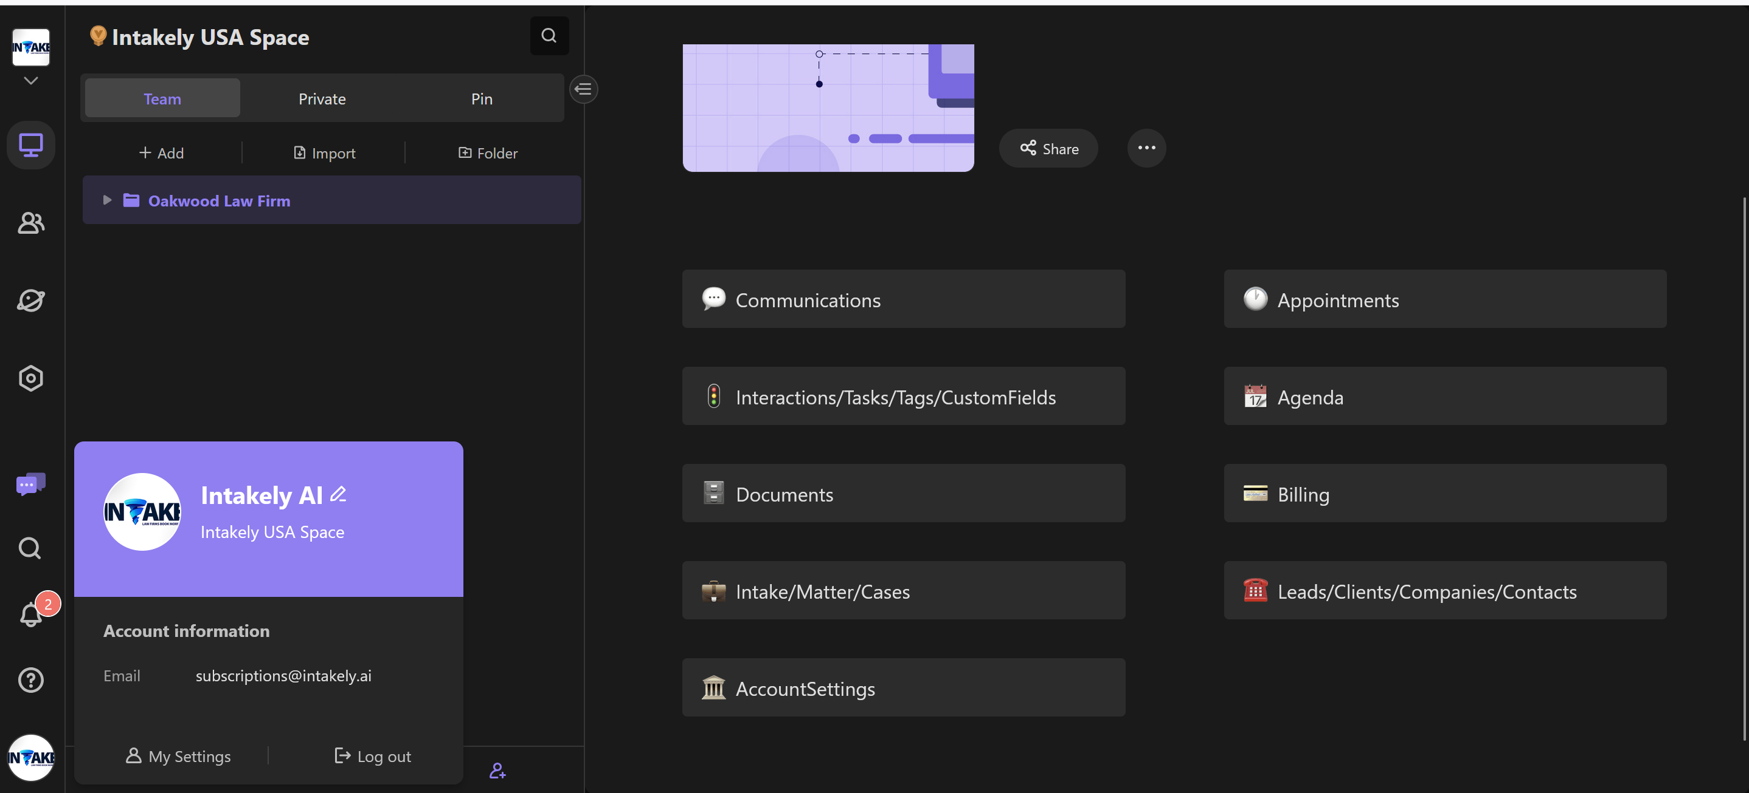

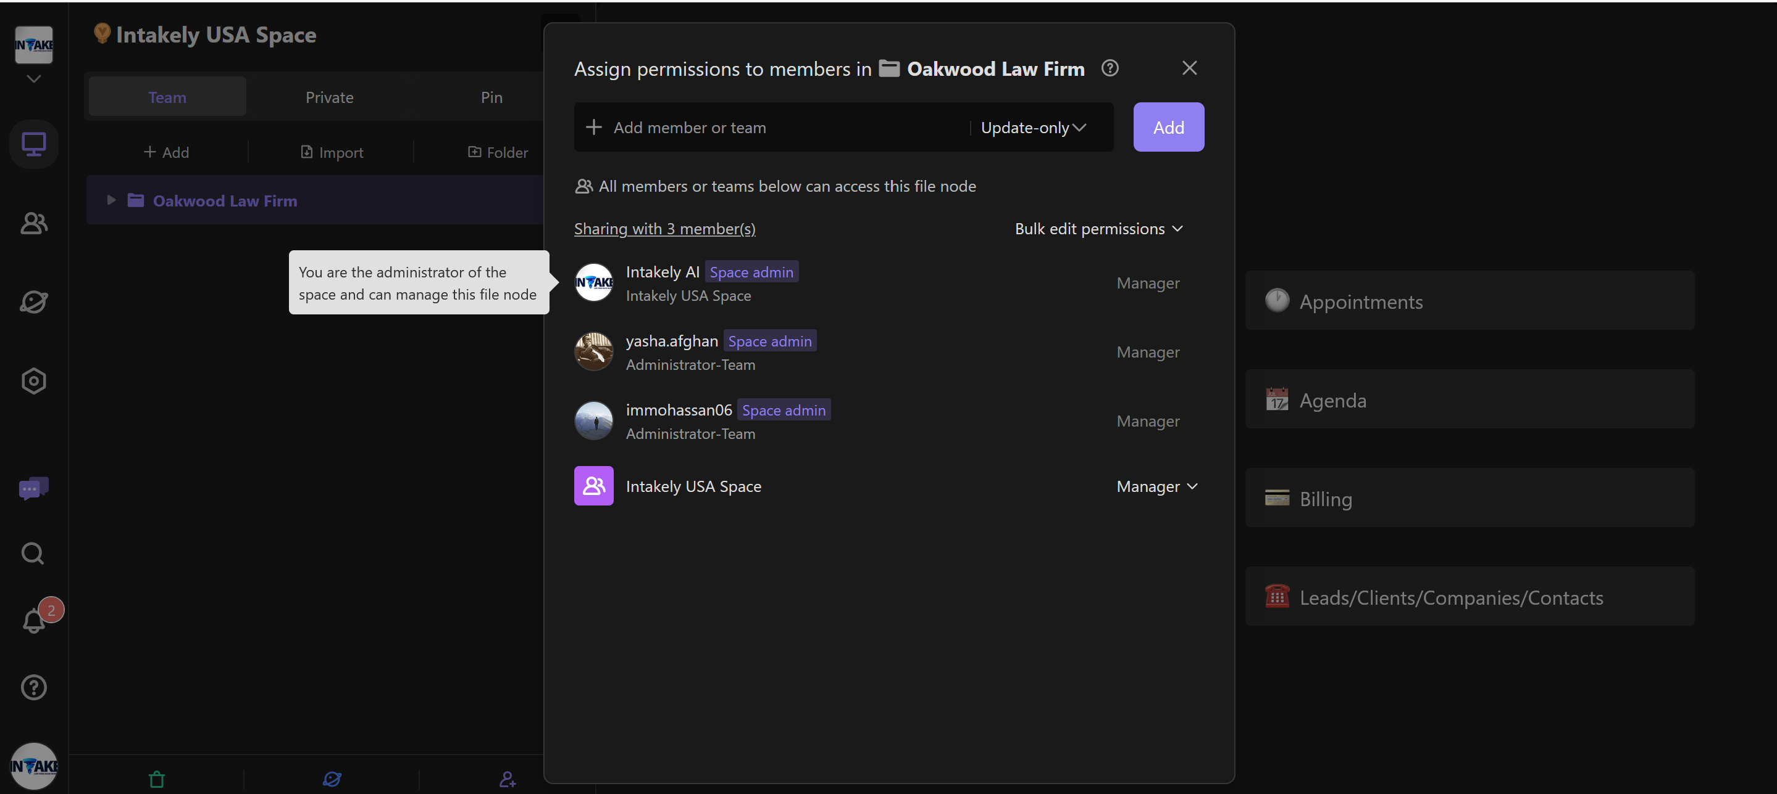

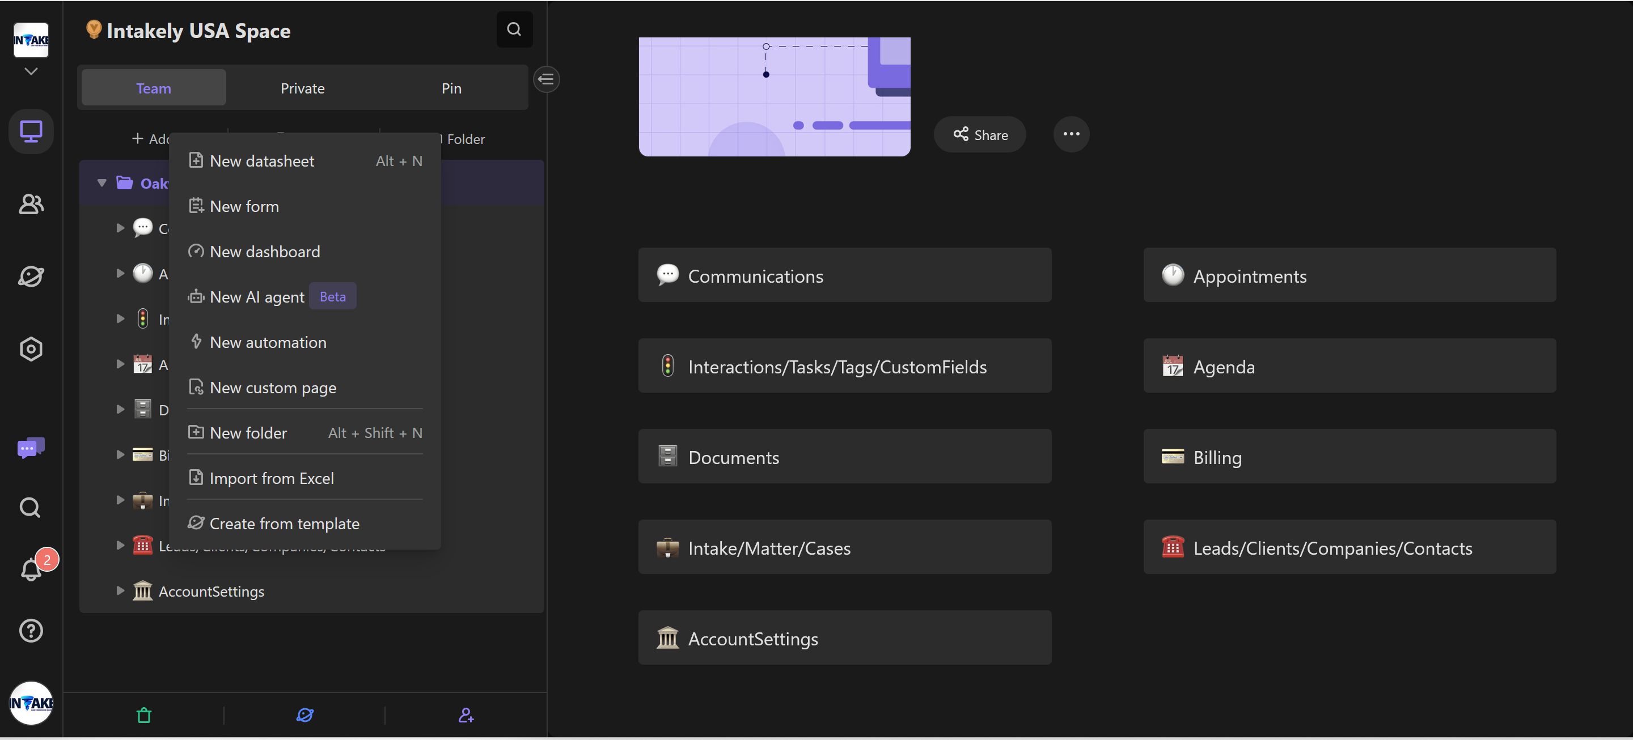

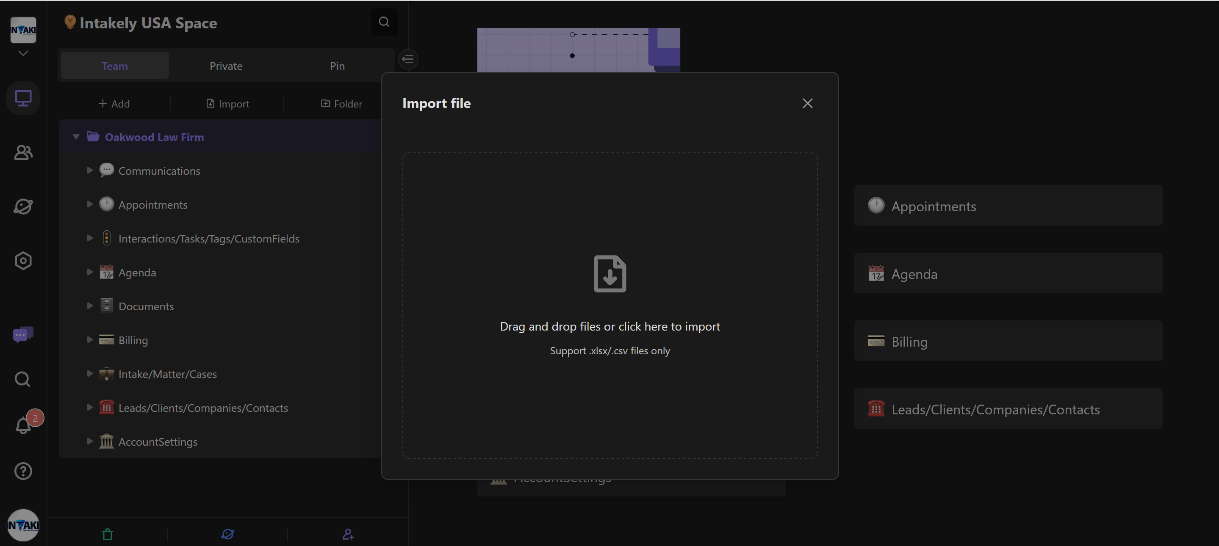

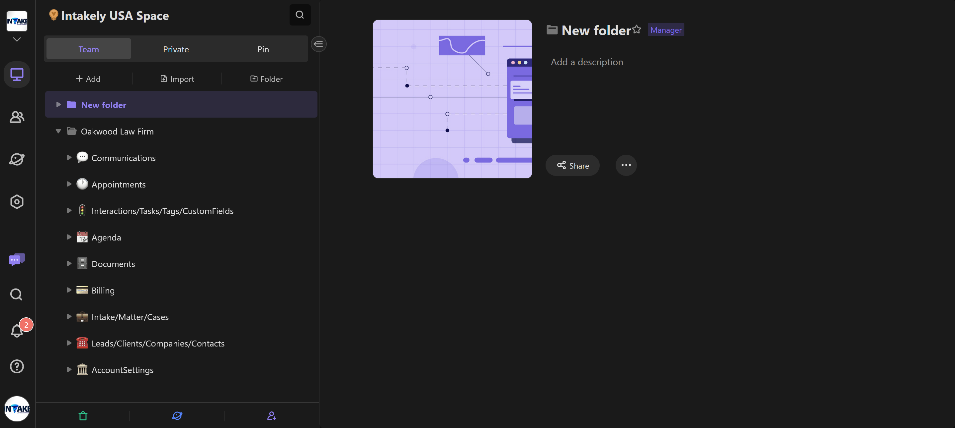

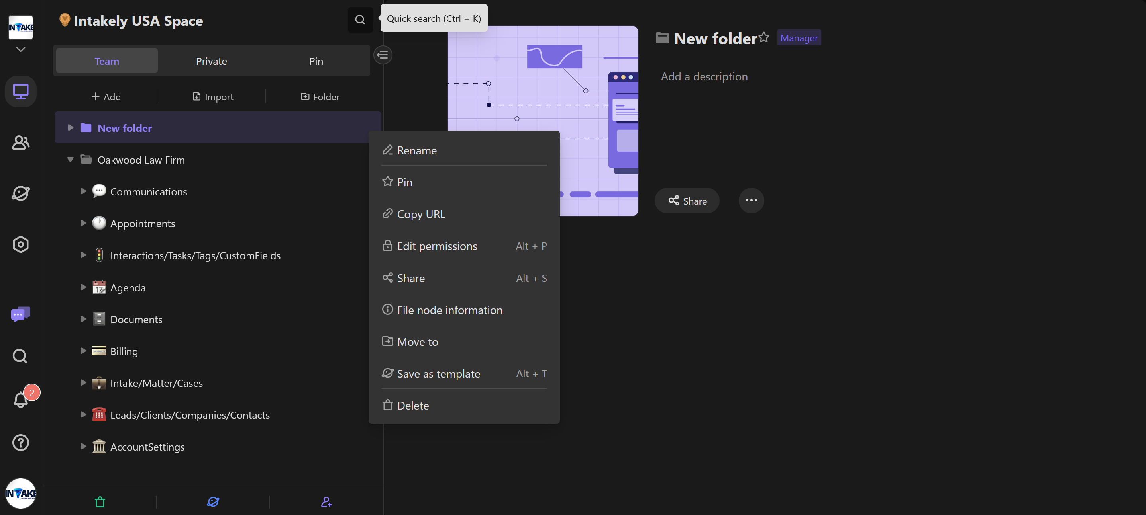

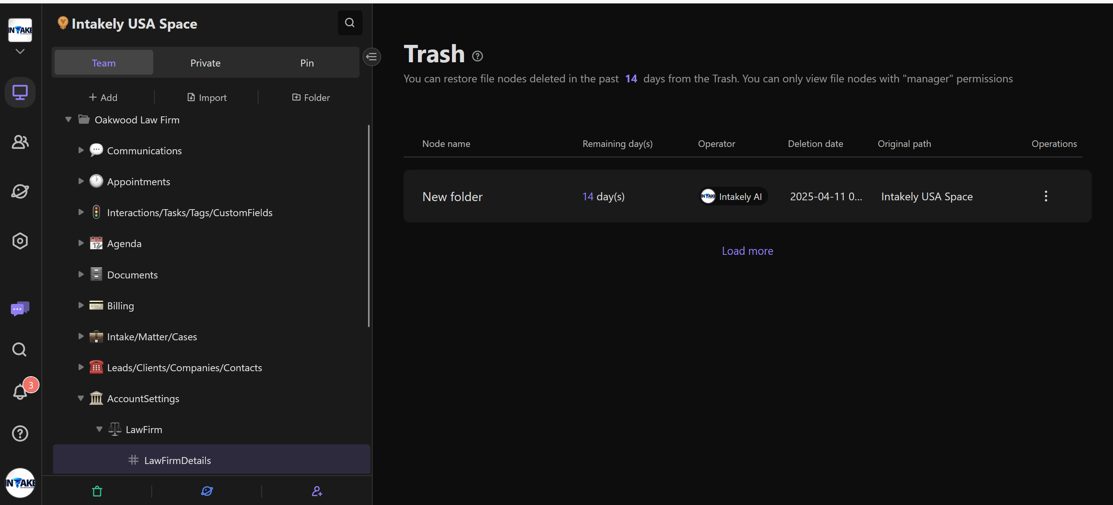

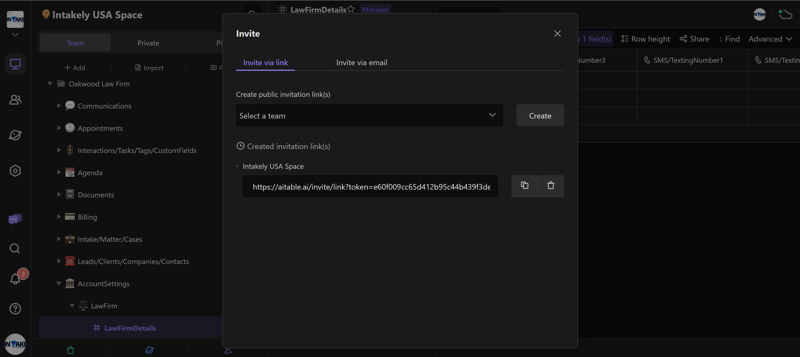

MAIN WORKING AND INPUT AND TABLE WINDOW UI SAMPELS  
  
